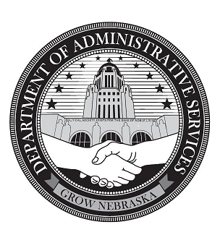

Shared Services New Teammate

Welcome Packet

[DAS.HumanResources@Nebraska.gov](mailto:DAS.HumanResources@Nebraska.gov)

[DAS.MyPayroll@Nebraska.gov](mailto:DAS.MyPayroll@Nebraska.gov)

Table of Contents

Welcome Statement…………………………………………………………………………….……………03

Shared Services Teammate OnBoarding Checklist………………………………….………….04

Teammate Landing Page (link.nebraska.gov) Guide……………………………….………….05

Wellness Benefits Information……………………………………………………………….…..06 - 11

Retirement Information…………………………………………………………………………………….12

HR Team Contacts……………………………………………………………………………………………..13

Workday Help……………………………………………………………………………………………………14

**Welcome Statement from Shared Services – Human Resources**

Teammate,

Welcome to the State of Nebraska! We are extremely excited that you chose to join our team. The State of Nebraska is the largest employer within Nebraska and has the great privilege of serving its people, the taxpayers, and citizens of this State. As a team, State Agencies work together to provide necessary services to the citizens to “Grow Nebraska”. We aim to create opportunities through more efficient, effective, customer-focused State Government. Our Values-Driven culture fosters a working environment focused on treating others with dignity and respect, acting ethically in all situations, and regarding our customers as the highest priority.

We are all here to support you as you transition into your new role. Do not hesitate to contact any of the members of the Shared Services – Human Resources team if you have any questions or comments!

Sincerely,

Your Shared Services – Human Resources Team

**Shared Services Teammate OnBoarding Checklist**

To assist you with the transition into your new position, the below guide has been created. Follow the steps below throughout the first few weeks of employment to verify that all New Hire tasks are completed in an efficient manner. A personalized, digital copy of the checklist with hyperlinks to resources will be provided to you via email within your first two days!

**Step 1:** Test and reset all your login information on the following sites (usernames and passwords can be found in your Welcome Packet!).

* Payroll and Financial Center (PFC)
* Employee Work Center (EWC/Workday)
* Employee Development Center (EDC)

**Step 2:** Log into the Employee Development Center and complete your New Teammate Orientation curriculum **within your first 3 days**

**Step 3:** Log into the Employee Work Center and complete the following **within your first week**:

* Enter your Direct Deposit Information. This ensures you are paid!
* Enter your Emergency Contact Information
* Verify your Personal Contact Information
* Complete your New Hire Benefit Enrollment event **within your first 30 days**

**Step 4 (Optional):** Complete the following forms, if applicable or desired:

* Nebraska Public Employees Retirement System (NPERS) [Beneficiary Designation Form](https://npers.ne.gov/SelfService/public/forms/) (this will record who will receive your retirement monies should you pass away).
* Nebraska Public Employees Retirement System (NPERS) [Vesting Credit Form](https://npers.ne.gov/SelfService/public/forms/) (if you have prior public or government employment that you would like to apply to have added to your vesting credit) **within your first 180 days**
* [Monthly Parking Agreement and Employee Deductions Form](https://das.nebraska.gov/building/parking.html), if you desire to be placed on the Preferred Parking list for a State-owned parking spot in Downtown Lincoln or Omaha.

**Teammate Landing Page (link.nebraska.gov) Guide**

The Teammate Landing Page is the home of all personnel system applications that

will be important for you to be familiar with as you begin in your new role. This

site includes:

1. P**ayroll and Financial Center (PFC/E1):** This site will be used to review your accrued leave balances, request leave from your supervisor, enter your timesheet (note: some agencies use a different system), and receive your yearly W2 form for taxes.
2. **Employee Work Center (EWC/Workday):** This system will be used for many personnel purposes, such as: completing your New Hire Benefit Enrollment, entering your Direct Deposit information, enter emergency contact information, update your contact information (as necessary), submit Help tickets to HR/Payroll, and access resource guides created by the HR team for frequently asked questions in the Help Center.
3. **Employee Development Center (EDC):** This system is our current online training module center. You will be assigned a New Teammate training curriculum to complete within your first week, your supervisor may assign you additional trainings, and you may also elect additional trainings yourself! Further, most agencies use this system to complete Probationary and Annual Performance Reviews.

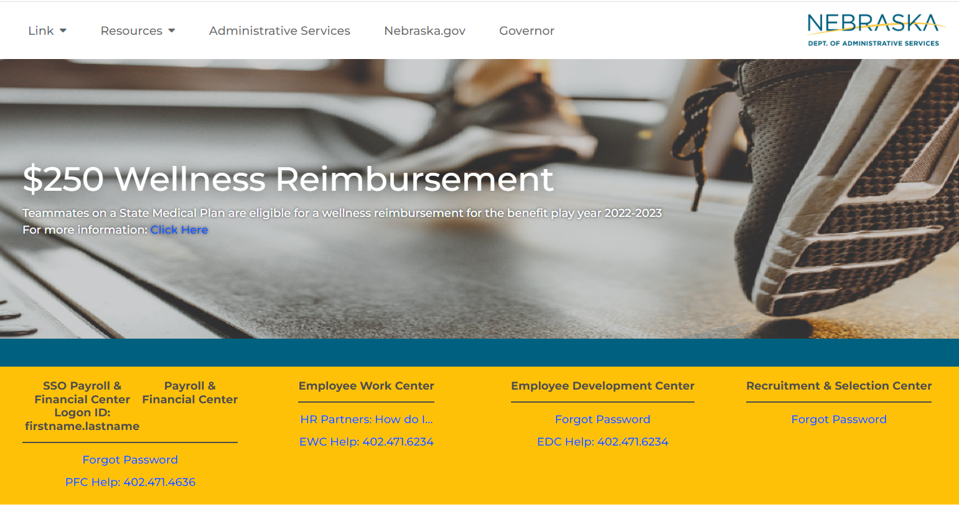

**Wellness Benefits Information**

Within your first 30 days of employment (including your start date), you will be required to enter the Employee Work Center and complete your New Hire Benefits Enrollment Event. During this event, you will have the opportunity to waive or elect whichever benefit options you would like.

Elected benefit options will become effective the first of the month following your first 30 days of employment.

Outside of the New Hire Benefit Enrollment period, the only other opportunity to change your Benefit options occurs during Annual Open Enrollment in the month of May each year. This is, however, unless you experience a Qualifying Life Event. Qualifying Life Events include, but are not limited to: birth/death of a child, marriage/divorce, loss of other credible coverage, etc. If you experience one of these events, you must enter the Employee Work Center and initiate a Qualifying Life Event.

**All information and resources related to the State of Nebraska Wellness and Benefits offerings can be located on the Teammate Landing Page (link.nebraska.gov) under ‘My Benefits’**

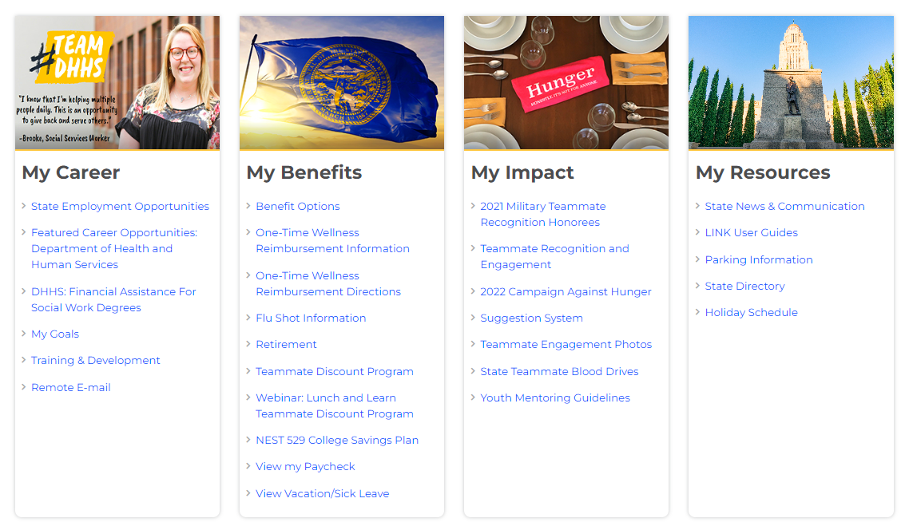

**Wellness Benefits Information, continued**

The 2022-23 Plan Year offers two new one-time Benefit perks!

**$250 Wellness Reimbursement:**

For teammates enrolled in a State of Nebraska medical plan for the benefit plan year 2022-2023, the State of Nebraska is offering up to a **$250 Wellness Reimbursement** for approved wellness purchases. This one-time reimbursement is only available upon submission of receipts for approved items. Items must be purchased between July 1, 2022, and June 30, 2023, to qualify.

**Approved wellness items include:**

• Gym Membership (can include annual cost/receipt for 12 months)

• Personal/Home physical fitness equipment that only includes:

o Treadmill

o Stationary exercise bike

o Elliptical machine

o Weight set(s)

o Resistance band(s)

**$500 FSA or HSA Employer-Contribution:**

If you are a State of Nebraska teammate on one of our UHC medical plan as of 7/1/2022 you will be eligible to receive a one-time only employer contribution to your HSA/FSA. You are welcome to elect your own deduction in addition to the one-time contribution for any total that does not exceed the IRS annual limit, but no less than $0.01/paycheck. If you receive funds for an FSA and do not use them by the deadline, those funds will be forfeited back to the plan.

Review the 2022 – 2023 Options Guide for more information!

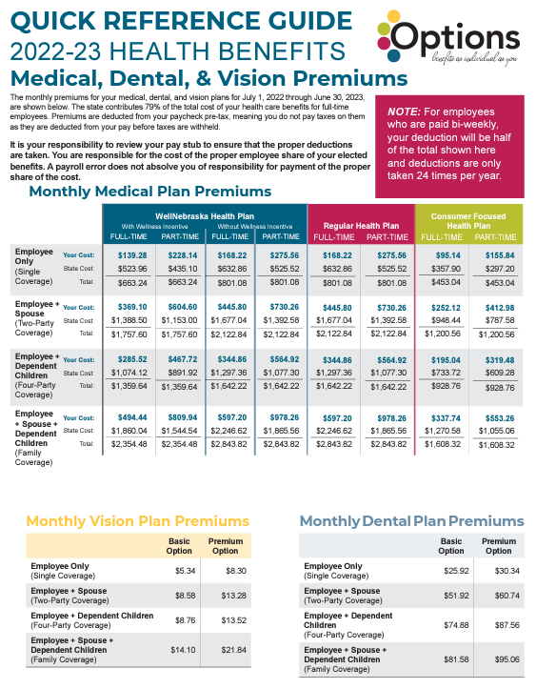

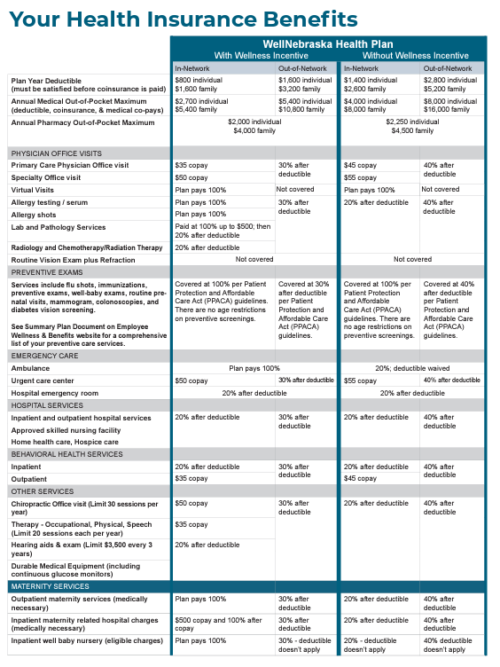

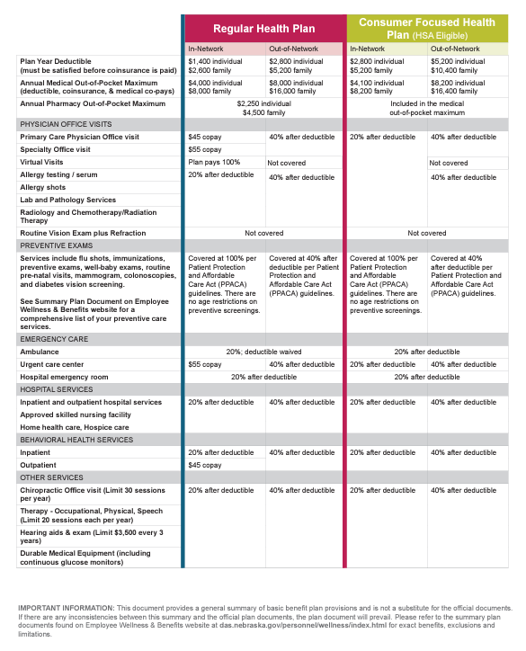

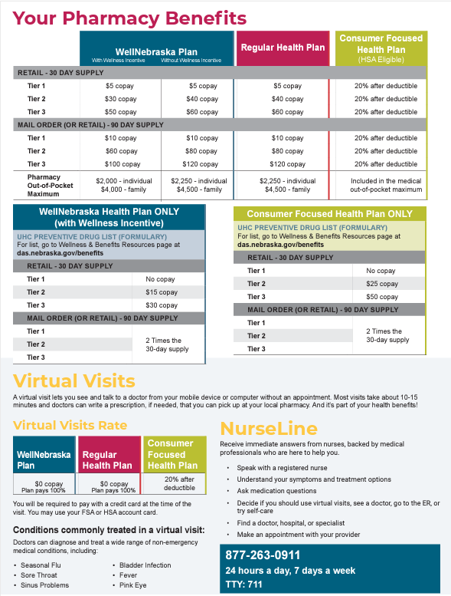

**Retirement Benefits Information**

**State Retirement Plan (mandatory):**

New plan members participate in the mandatory Cash Balance benefit immediately upon employment. Participation is voluntary for permanent, part-time employees age 18 or older and permanent part-time seasonal employees age 18 or older. Members contribute 4.8% of their salary pre-tax and the state matches contributions at 156%. Members are “vested” after a total of three years of plan participation (36 full months of contributions). Member accounts receive an “interest credit rate” (rate of return) based on the federal mid-term rate plus 1.5% and are guaranteed a minimum annual rate of return of 5%. Members have multiple payment options of their account at retirement. For more information, please refer to the plan handbook on the NPERS.ne.gov website!

**Deferred Compensation Plan (DCP):**

State of Nebraska employees may use the Employee Work Center (Workday) access to enroll in this tax-sheltered, voluntary retirement plan, even if employed on a temporary or part-time basis. Participants may set and change contribution amounts or cease and resume contributions. The minimum contribution is $25 per month. Taxes on the contributions and earnings are deferred until disbursement. Plan participants choose their own investments from multiple funds. This is a long-term retirement plan, not a short-term savings plan. Members cannot remove funds until they cease employment. For more information, please refer to the plan handbook and the Annual Investment Report on the NPERS.ne.gov website!

**Beneficiary Designation Form:** Upon the death of a plan member, NPERS needs to know who should receive the funds remaining in his/her retirement account. Complete this form and be sure to update as needed. Please be aware that when you select beneficiaries online during your New Hire Benefit Enrollment event, it is for your life insurance, NOT your retirement account. Beneficiary forms may be printed from our NPERS.ne.gov website.

**Application for Vesting Credit:** If you have participated in another Nebraska governmental plan, that participation may count toward the three years required to vest in the State Plan. To qualify, you must complete this form and submit to NPERS within 180 days of your date of hire.

**Shared Services – Human Resources Contact Information**

|  |  |
| --- | --- |
| **Mandy Clark**  HR Business Partner II | 402-840-0017  Mandy.Clark@nebraska.gov |
| **Kevin Halvorson**  HR Business Partner II | 531-207-3602  Kevin.Halvorson@nebraska.gov |
| **Nicole Nath**  HR Business Partner II | 402-417-3396  Nicole.nath@nebraska.gov |
| **Nicole Prososki** Payroll Manager | 402-890-0306  Nicole.Prososki@nebraska.gov |

**Shared Services – Human Resources team:** [DAS.humanresources@nebraska.gov](mailto:DAS.humanresources@nebraska.gov)

**Shared Services – Payroll team:**

[DAS.mypayroll@nebraska.gov](mailto:DAS.mypayroll@nebraska.gov)

**Workday Help**

We are very excited to share that you now have a new Workday feature to support your Human Resources and Payroll needs through an automated request system! Through our continuous process improvement initiatives, Shared Services has launched “**Workday Help**” available to you. This new feature can be found by logging in to your existing [Workday](https://gcc02.safelinks.protection.outlook.com/?url=https%3A%2F%2Fwww.myworkday.com%2Fwday%2Fauthgwy%2Fson%2Flogin.htmld&data=05%7C01%7CNicole.Nath%40nebraska.gov%7C53512b5f4fd04580bd6f08da4d4e11ab%7C043207dfe6894bf6902001038f11f0b1%7C0%7C0%7C637907294974373252%7CUnknown%7CTWFpbGZsb3d8eyJWIjoiMC4wLjAwMDAiLCJQIjoiV2luMzIiLCJBTiI6Ik1haWwiLCJXVCI6Mn0%3D%7C3000%7C%7C%7C&sdata=0JAbkj6d7QHkcJkjQ6vHpLTra445Q7iBjQouLqRcXBw%3D&reserved=0) account and allows you to engage with our team and our information in two new ways!

**Help Articles:**

To best serve you in an efficient manner, our team has created an entire library of self-service guides and resources called Help Articles. You now have access to over 35 HR Help Articles that answer Frequently Asked Questions about common topics such as updating your W4 withholdings, updating your Direct Deposit information, the Tuition Reimbursement program, Family and Medical Leave, and more!

Check out the entire Help Article library by clicking on “View all Apps” on your Workday dashboard, then navigating to the “Help” icon. Interested in a particular subject? Try typing in a keyword in the search bar of Workday to have it direct you to any relevant Help Article that we’ve already created for you.

**Help Cases:**

Unable to answer your question through the Help Articles we’ve created? Interact with us by submitting a Case! Cases can be submitted for a wide variety of reasons such as: Recruitment requests, Pay Adjustments/In-Grades, Reasonable Accommodations, Workplace Injuries, FMLA, and more. Creating a Case in Workday allows us to provide you with a real-time, transparent view of who is handling your inquiry, what action is being taken on the request or inquiry, and if we require anything additional from you to resolve your request/inquiry.

Create a Case with our team by clicking on “View all Apps” on your Workday dashboard, then navigating to the “Help” icon. Click the blue “Create Case” button at the bottom of the screen to submit a case to the HR/Payroll team to assist. You can also type “Create Case” into the search bar within Workday!