Finding Help Center Articles
Table of Contents
Overview 1
Finding Help Center Articles in the Library 1
Finding Help Center Articles via Search Bar 2
Further Assistance 3

Overview
Help Center Articles are resource documents created by Shared Services HR Partners to assist Teammates answer frequently asked questions and topics related to HR functional areas. This guide covers how Teammates navigate the Workday Help Center to locate the Help Center Article library and locate Help Center Articles using the search bar at the top of Workday.

Finding Help center artciles in the library
The steps below walk through how to find Help Center Articles in the Help Center Library:
- Log into the Employee Work Center (“EWC”) by going to https://link.nebraska.gov and clicking on the Employee Work Center option.
- After logging in, click the “Menu” button in the upper left-hand side of the Welcome page.
- Click the “Help” icon to go to the Help Center, where you can review Help Articles and create Help Cases.
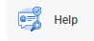
- Review the library of Help Articles to see if your specific question is already answered by clicking on and Article that shows or by clicking “View More.”
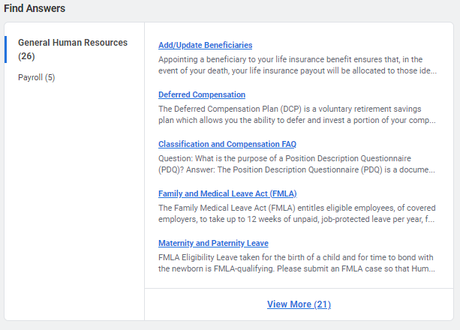
- If your question is not answered by the Help Articles, proceed to creating a Help Case by clicking the “Create Case” button in the Help Center.
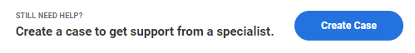

Finding help center articles via Search Bar
The steps below walk through checking a Help Case that you’ve previously made for updates:
- Log into the Employee Work Center (“EWC”) by going to https://link.nebraska.gov and clicking on the Employee Work Center option.
- After logging in, use the search bar at the top of the Workday page to search for a key word related to the topic you are interested in learning more about. (i.e. retirement, resignation, medical leave, timecard, paystub, etc.)

- Ensure that your filters on the left-hand side of the page include “Articles.” If it does not, click on “More Categories” to locate Articles related to your key word. You can also click “configure search” to adjust the categories on the left-hand side of your screen permanently.
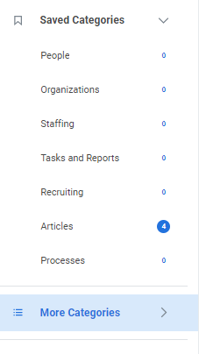
- Click on the Article that you are interested in learning more about. A brief preview of the Article contents will appear below the title.
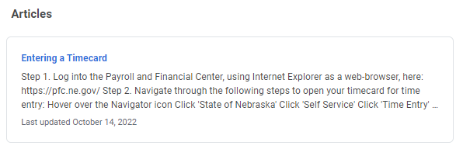

Further Assistance
For further assistance you can reach out to your HR team or the LINK help desk:
- For assistance logging into and navigating the Employee Work Center, contact the LINK help desk at as.linkhelp@nebraska.gov.
- For assistance with specific matters related to a Help Case, reach out to your HR support team.

