Update Business Units

This application may be used only with business unit types:
CA, CD, CP, GB, GO, GP, GS, GX, GY, IS, MT, OT, PA, PD, PE, PF, PR and UN.
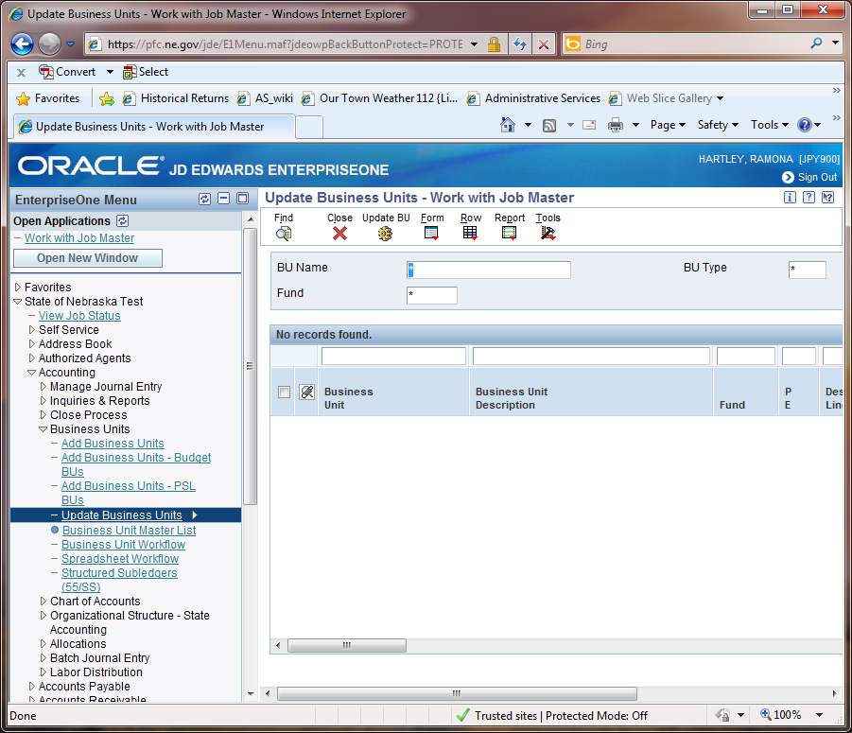
The path is State of Nebraska > Accounting > Business Units > Update Business Units.
Scenario 1 – To enter same value in the column(s) for the entire group of business units selected.
An example would be dates, where you wish to change all values in a column of the selected business units to be the same value. Enter your changes in the first row below the grid where the description reads “ENTER VALUE TO BE UPDATED HERE”. When using this feature to update all values within the selected column(s) enter values only in the first row, you may enter values in multiples columns.
- Enter a grant number or something to bring up the items you want to change.
- Click Find
- Click the Update BU icon. [Notice that the screen has changed and includes the “ENTER VALUE TO BE UPDATED HERE” in the first line below the grid. You will need to expand your grid to the end if you have more lines than are displayed or you will not have the “Update All Grid” icon.
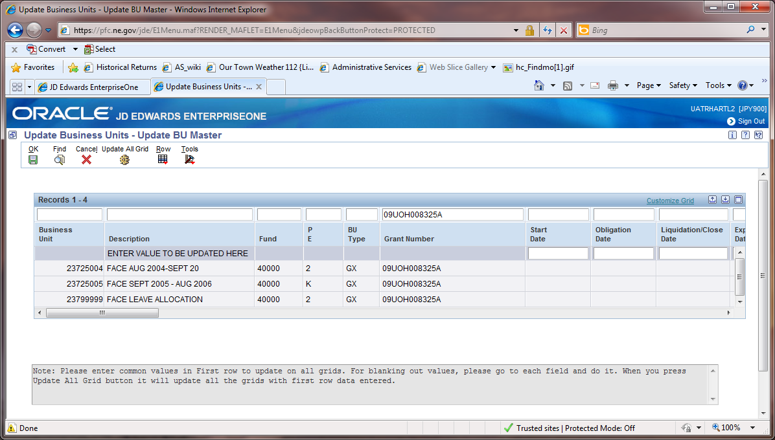
- Enter your changes in the first row below the grid where the description reads “ENTER VALUE TO BE UPDATED HERE”. When using this feature to update all values within the selected column(s) enter values ONLY in this row.
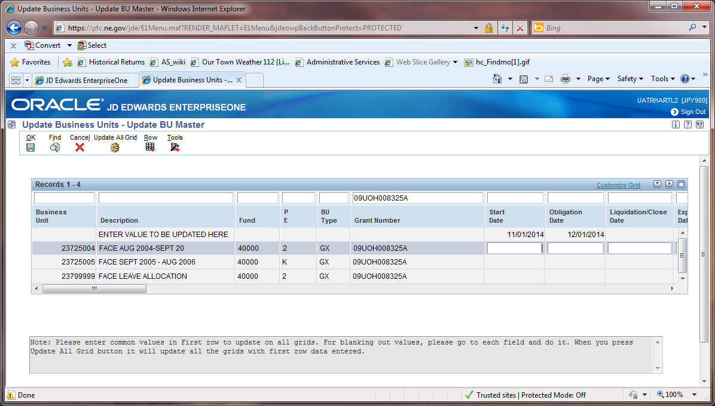
- Click the Update All Grid icon
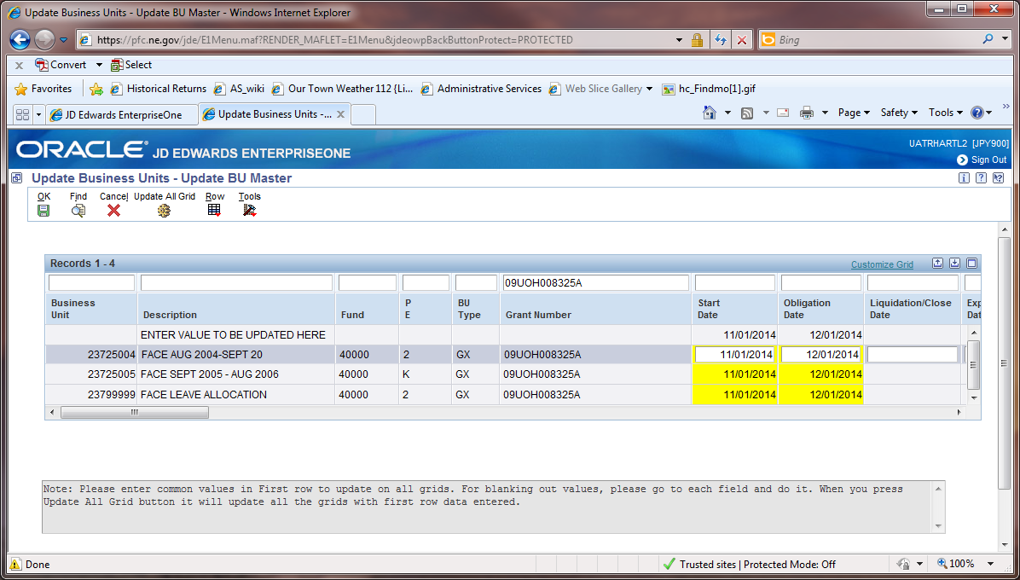
- You will receive a yellow warning. Check number of records – is it what your expected?
- If the changes are as you intend Click the Ok icon. Caution – these are global changes, make sure you are changing ONLY what you want to change and not something across fund 10000 or 40000.
If the changes in yellow are not what you intended click Cancel.
- Click Cancel to return to the selection screen.
- Click Close to exit the Update Business Units – Update BU Master.

Scenario 2 – To enter multiple changes in various fields not consistently across any single column.

The path is State of Nebraska > Accounting > Business Units > Update Business Units. Enter a grant number or something to bring up the items you want to change.
- Enter a grant number or something to bring up the items you want to change.
- Click Find
- If you will need to expand your grid to the end if you have more lines than are displayed or you will not have the “Update All Grid” icon.
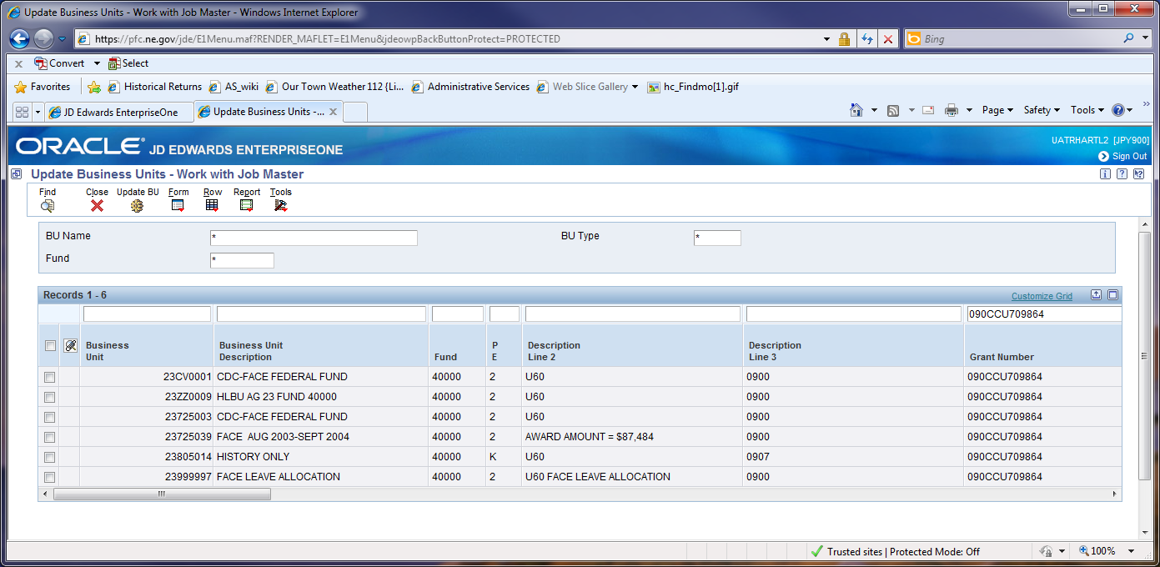
- Click Click the Update BU icon. [Notice that the screen has changed and includes the “ENTER VALUE TO BE UPDATED HERE “in the first line below the grid.
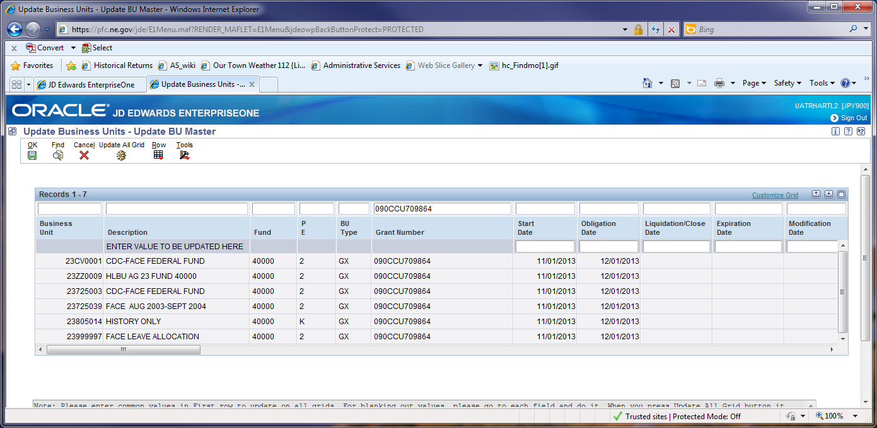
- Change ONLY the values you wish to change in the individual cells of each individual business unit, NOT in the ENTER VALUE TO BE UPDATED HERE line.
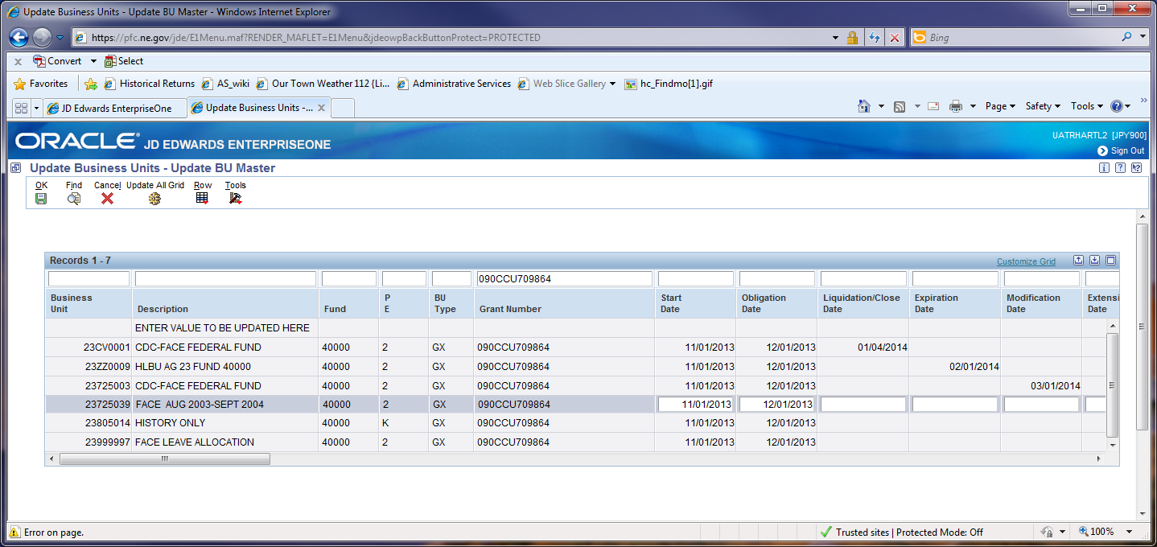
- Click OK – The changes will take place.
- Click Cancel
- Click Close

Items which an agency can change from this screen include:
[Note you may need to request to have previously unused values added to the appropriate tables]
- Date fields
- Agency Use 07, 12, 13, 14, 16, 17, 18, 19, 20, 25
- Cat 28
- Year
- Div
- Grants
- Mgmt Group
For other changes continue to submit your request to as.stateaccounting@nebraska.gov using the subject line of: Business Units or Grants or Business Units, Grants as appropriate.
Date Descriptions have been redefined:
- D1J “Start Date” This represents the start date for the grant.
- D2J “Obligation Date” This represents the date by which all funds must be encumbered to be eligible expenditures for the grant.
- D3J “Liquidation/Close Date” This is the completion date, (generally this is some number of days after the Expiration Date (D4J).
- D4J “Expiration Date” This is the completion date. NO expenditures are allowed to be initiated beyond this date.
- D5J “Modification Date” This is the date that we received notice that authority to spend funds has changed; either in amount, or by virtue of a change in Liquidation, Expiration and or Extension Date.
- D6J “Extension Date” This is the new Expiration Date when an extension is approved.

The Business Unit Master List Report – R550006
This report may be utilized. It can be run for a large variety of criteria. Dates and date ranges are some of the items that you can use as criteria to run your report.
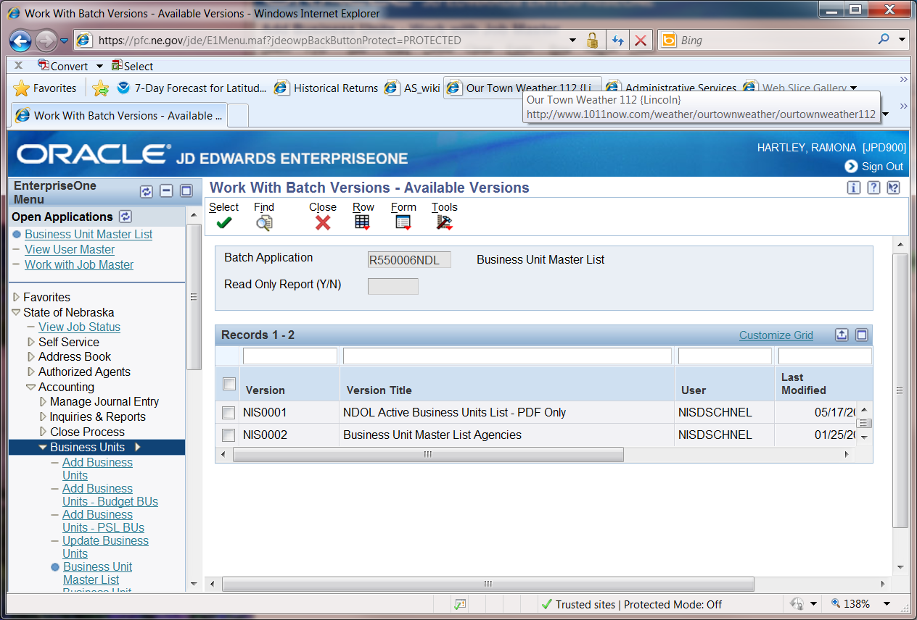
Use version NIS0002 .
Possible criteria would be agency number for a begin date or for a date range.
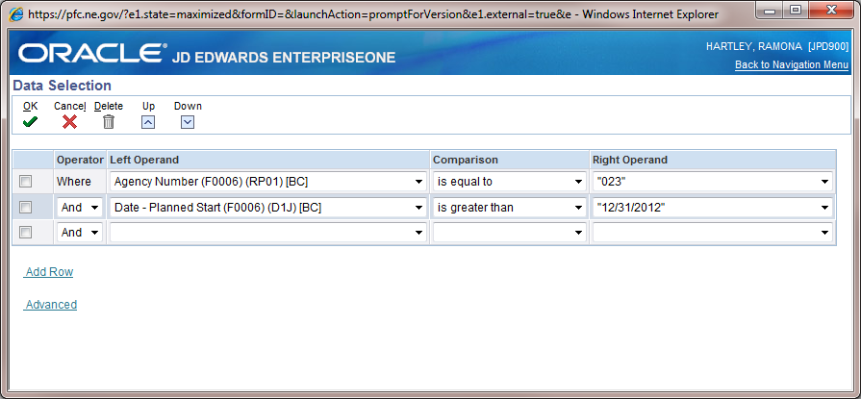

For large grants you might want run it for Description 04 to see values updated within a grant.
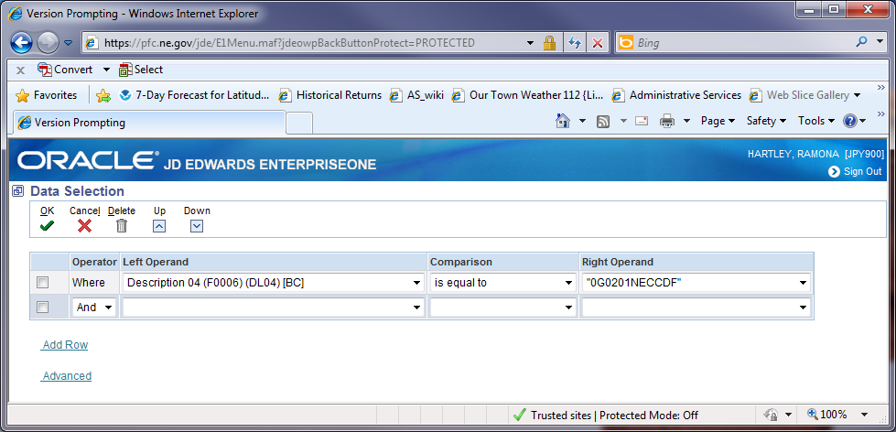
This report runs in CSV and you will probably need to import it so that all fields are properly expanded.
