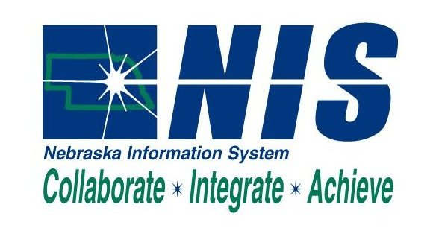

NIS Additional Citrix User Application Form

This form is needs to be filled out for each employee requesting use of a Citrix license for access to NIS. Please fill in the requested information below and have the proper person with budgetary authority sign and date below.

The following application commits the applicant’s agency to pay $21 per month for a total of three years. This amount will be billed in quarterly installment payments by DAS. This rate will be reviewed annually to determine if the rate needs adjustment based on actual expenses.

First Name:

Last Name:

NIS User ID:
User Address Book Number:
Name of Agency and Business Unit Number:

User Phone Number:

User Email Address:

If you need help signing into NIS Citrix, support is available through the IMS Help Desk. They can be contacted by phone, 471-4636, 1-800-982-2468, or by email ihelp@notes.state.ne.us

_______________________________________________ ________________________
Applicant’s Signature (Authorized Agency Representative) Date

