Pre-Requisitions and Requisitions

Before purchasing a commodity or service, please ensure you are familiar with the Procurement Manual and Policies on the AS Materiel Division, State Purchasing Bureau website to determine what processes and restrictions may apply to your procurement.

This guide will go over the different methods of generating both pre-requisitions and requisitions, as well as how to make edits and changes to a generated pre-requisition or requisition.

To view the steps of a specific process from the guide contents below, expand the steps by clicking the dropdown arrow. To collapse sections, click the dropdown arrow again.
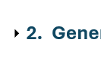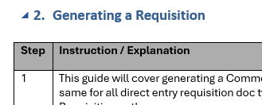
Collapse
Expand
- Enter a Pre-Requisition
Step | Instruction / Explanation
Choose a Menu Selection/Pathway Option:
State of Nebraska > Purchasing > Pre-Requisition
- Enter Pre-Requisition (O7)

Click the green plus button
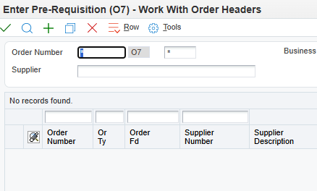
Enter Header Information.
- Supplier - Enter the Address Book number (AB#) of the vendor being purchased from.
  - Should typically be a “V” (Vendor) “AG” (Agency) or “VP” (Political Subdivision) Address Book search type.
  - NOTE: This should NEVER be an "E" or "FD" Address Book search type
- Ship To - Enter the Address Book number of the address where the goods are to be delivered, or services are to be performed.
  - The Ship To Address Book number will automatically populate the Send Invoice To field.
  - Should typically be an “F” Address Book search type.
- Buyer - Enter the Address Book number for the individual primarily responsible for the document at the AGENCY.
- Send Invoice To - Enter the Address Book number of the address where invoices should be sent.
  - Automatically populates from the Ship To field but can be overwritten.
  - Should typically be an “F” Address Book search type.
- Business Unit - Enter the Business Unit (BU) responsible for the pre-requisition.
- Entered Date - Current date will automatically populate.
- Requested Date - Enter the desired date the pre-requisition is to be filled or delivered.
- Promised Delivery - Enter the date the supplier promised to deliver this order.
- Cancel Date - DO NOT ENTER A CANCEL DATE

Example of Filled Order Header

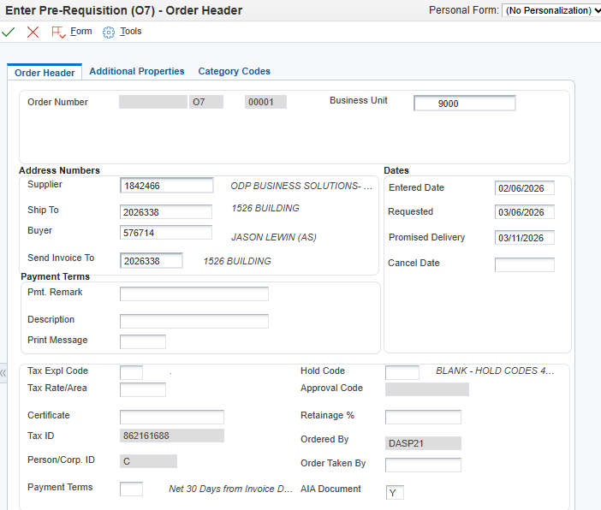
Use Agency BU
Click the Additional Properties tab and complete as needed or desired.
- Document Description - Enter the description of goods/services being procured (this information will print on reports).
  - NOTE: This field is limited to 30 alpha/numeric characters.
- Document Location - Enter the Address Book number for the facility where the purchase order was established.
  - Should typically be an “F” Address Book type.
- Document Contact - Enter the Address Book number for the primary person responsible for the commodity or service purchase order.
  - Must be either a “B”, “E”, or “N” Address Book type.

Example of Filled Additional Properties
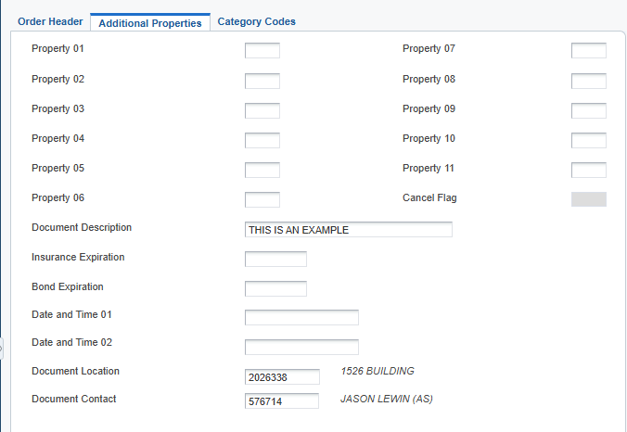
Click the Category Codes tab and complete as needed or desired.
- New/Renew - Enter “N” for ‘new’ purchase order.
- Funding - Make a selection using the visual assist icon if tracked funds are being utilized (e.g., ARRA or COVID19)
- 84-602.04 Exempt - Used to indicate if exempt from inclusion in the State Contracts Database. Enter “E” for ‘Exempt’ if appropriate.
- Nebraska Vendor - Used to indicate a Nebraska vendor. Enter “Y” or “N”.
- Agency - Used to indicate the three-digit Agency number.

Example Filled Category Codes
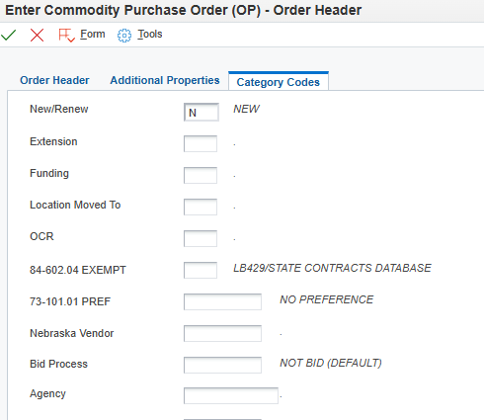
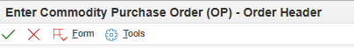
Verify all information is correct and click the green checkmark at the top of the screen.
Make note of the newly generated Pre-Requisition number listed in the Order Number field for reference.
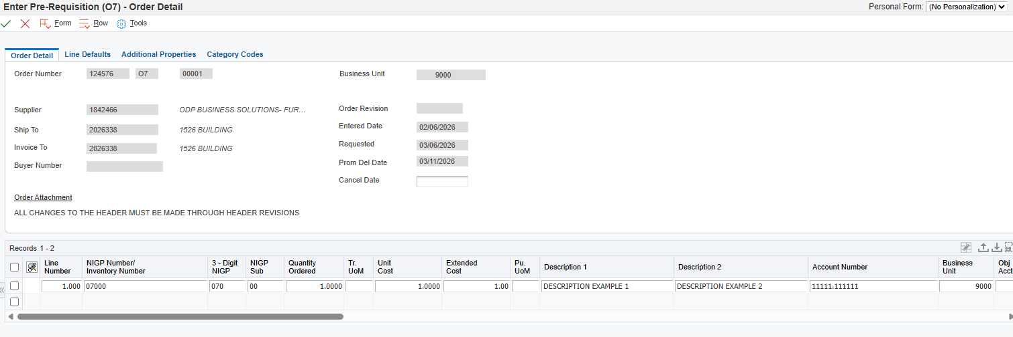
Click into the Detail Line and fill in at least 1 detail line to ensure a proper save of the newly created purchase order.
Detail Line Information
- NIGP Number/Inventory Number - Enter the NIGP code for items/services to be purchased. All applicable 5-digit codes for Services will be > 90000. All Commodity Codes will be < 90000. This field will not print on the purchasing documents.
NOTE: At least the first 3 digits of an NIGP code are required.
  - 3 Digit NIGP - Will populate from the NIGP Number/Inventory Number; this is the three-digit prefix to a NIGP code.
  - NIGP Sub - Will populate from the NIGP Number/Inventory Number; this is the two-digit NIGP code suffix.
  - See National Institute of Governmental Purchasing (NIGP) Codes.
- Quantity Ordered - Enter the quantity being ordered.
  - If Unit of Measure is $, enter total amount
- Tr. UoM - Enter the Transaction Unit of Measure.
  - System defaults to EA. Additional options can be viewed using the visual assist icon.
- Unit Cost - Enter the cost per unit price.
  - If Unit of Measure is $, enter 1.
- Extended Cost - The system will automatically populate the Extended Cost based on the Quantity Ordered and Unit Cost fields (Quantity Ordered x Unit Cost = Extended Cost).
  - Ensure total value is accurate for document approvals and receiving purposes.
- Description 1 - Enter the description of commodity/service
  - Field is limited to 30 alpha/numeric characters
- Description 2 - Enter the continued commodity/service description
  - Field is limited to 30 alpha/numeric characters
- Account Number - Enter valid Business Unit and Object Code from Chart of Accounts (e.g., 65060012.534700)
- Ln Ty – Line Type - Defaults to “J” for Non-Inventory or Non-Stock Item and represents the G/L (General Ledger) account number from which the funds will be drawn for the purchase
  - NOTE: This will rarely be modified

Example Completed Detail Line
Click the green checkmark at the top of the screen to save.
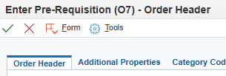
Generate a Pre-Requisition: Complete
Click the Red X to close.

- Generating a Requisition
Step | Instruction / Explanation
Choose a Menu Selection/Pathway Option:
State of Nebraska > Purchasing > Requisitions > Gen Requisition
  - Enter Agency Processed RFP Requisition (O3)
  - Enter SPB Processed RFP Requisition (O5)
  - Enter Service Exempt Requisition (Z6)
  - Enter Commodity Requisition (OR)
  - Enter Commodity Exempt Requisition (Z5)
  - Enter Exception Request (O8)
State of Nebraska > Purchasing > Requisitions > Gen Requisition > Restricted Item Requisitions
  - Enter Restricted Item/Trade In Requisition (OW)
  - Enter Exception Request (O8)
  - Enter IT Commodity/Services Requisition (ON)
  - Enter Motor Vehicle Requisition (OI)
  - Enter Communications Equipment Requisition (OT)
  - Enter SPB Authorized Requisition (OO)

The process is the same for all direct entry requisition doc types.

This example will demonstrate direct entering a commodity requisition (OR)

NOTE: Exception Requisition (O8) has an additional required detail to be entered as listed in Step 9 under the “Detail Line Information” section.

NOTE: Communication Requisitions (OT) has an additional step listed in Step 3.1

Click the green plus button
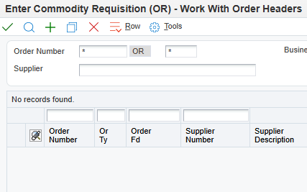
 | Enter Header Information
3.1 | Supplier - Enter the Address Book number (AB#) of the vendor being purchased from.  Should typically be a “V” (Vendor) “AG” (Agency) or “VP” (Political Subdivision) Address Book search type.  If supplier is unknown, use “999999” for “Best Source.” (Best Source – Generic Supplier AB# ) when total value is estimated to be greater than $50,000 and acquiring bids  OT requisitions for IT communications items must route through OCIO. To do this enter “557759” into the supplier field.  NOTE: This should NEVER be an "E" or "FD" search type Address Book record
3.2 | Ship To - Enter the Address Book number of the address where items are to be delivered, or services are to be performed.  The Ship To Address Book number will automatically populate the Send Invoice To field.  Should typically be an “F” Address Book search type.  If there are multiple ship to locations, 559783 (FACILITY, MULTIPLE ADDRESSES) can be used
3.3 | Buyer - Enter the Address Book number for the individual primarily responsible for the document at the AGENCY.  NOTE: If the Purchase Requisition is required to go through AS Materiel, State Purchasing Bureau, the State Purchasing Bureau will revise this field with the Address Book number of the Buyer who is responsible for bidding the requisition.
3.4 | Send Invoice To - Enter the Address Book number of the address where invoices should be sent.  Automatically populates but can be overridden.  Should typically be an "F" Address Book search type.
3.5 | Business Unit - Enter the Business Unit responsible for the Requisition.
3.6 | Entered Date - Current date will automatically populate.
3.7 | Requested Date - Enter the desired date the requisition is to be filled or delivered.
3.8 | Promised Delivery - Enter the date the supplier promised to deliver this requisition.  NOTE: If delivery date is unknown, use best estimate.
3.9 | Cancel Date - DO NOT ENTER A CANCEL DATE.
Example of Filled Order Header
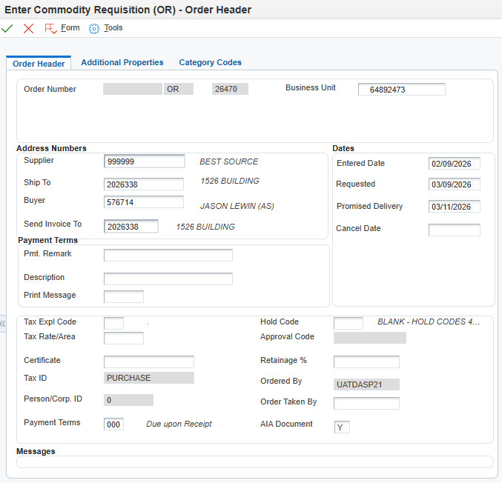
Use Agency BU
 | Click the Additional Properties tab.
 | Data on the Additional Properties tab provides information about the document: Document Description, Document Location, and Document Contact.
5.1 | Document Description - Enter the description of goods/services being procured (this information will print on reports).  NOTE: This field is limited to 30 alpha/numeric characters.
5.2 | Document Location - Enter the Address Book number for the facility where the requisition was established.  This field can be pulled from the Address Book and must be an Address Book Search Type of “F” – facility.

5.3 | Document Contact - Enter the Address Book number for the primary person responsible for the commodity or service requisition.  This field can be pulled from the Address Book and must be an Address Book Search Type of “B, E, N, or X”.
Example Filled Additional Properties
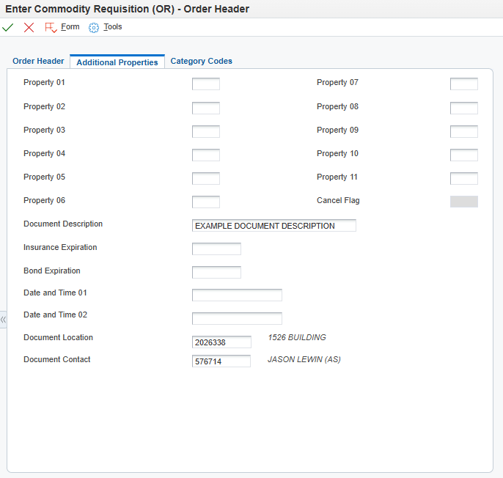
 | Click the Category Codes tab.
 | Data on the Category Codes tab provides additional information to be completed as needed or desired.
Category Codes Information
- New/Renew - Enter “N” for ‘new’ requisition.
- Funding - Make a selection using the visual assist if tracked funds are being utilized (e.g., ARRA or COVID19)
- 84-602.04 Exempt - Used to indicate if exempt from inclusion in the State Contracts Database. Enter “E” for ‘Exempt’ if appropriate.
- Nebraska Vendor - Used to indicate a Nebraska vendor. Enter “Y” for ‘Yes’ and “N” for ‘No’.
- Agency - Used to indicate three-digit Agency number.
- Bid Process – Used to indicate the bid process of the requisition. Enter “C” for ‘Competitively Bid’.

Example Filled Category Codes
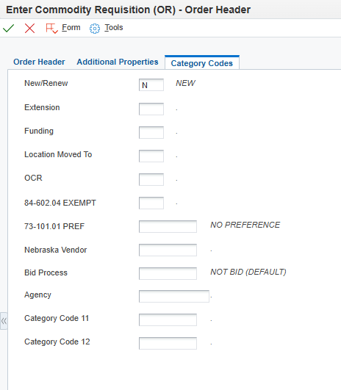
8. | Verify all information is correct and click the green checkmark at the top of the screen.  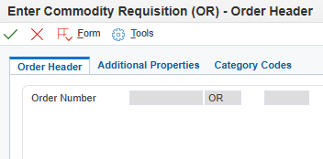

9. | Make note of the newly generated requisition number listed in the Order Number field for reference and fill in at least 1 detail line to ensure a proper save of the newly created requisition document.  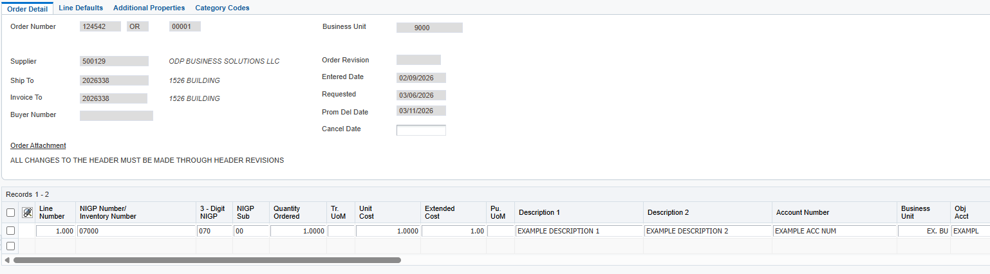
Detail Line Information
- NIGP Number/Inventory Number - Enter the NIGP code for items/services to be purchased. All applicable 5-digit codes for Services will be > 90000. All Commodity Codes will be < 90000. This field will not print on the purchasing documents.
NOTE: At least the first 3 digits of an NIGP code are required.
  - 3 Digit NIGP - Will populate from the NIGP Number/Inventory Number; this is the three-digit prefix to a NIGP code.
  - NIGP Sub - Will populate from the NIGP Number/Inventory Number; this is the two-digit NIGP code suffix.
  - See National Institute of Governmental Purchasing (NIGP) Codes.
- Quantity Ordered - Enter the quantity being ordered.
  - If Unit of Measure is $, enter total amount
- Tr. UoM - Enter the Transaction Unit of Measure.
  - System defaults to EA. Additional options can be viewed using the visual assist.
- Unit Cost - Enter the cost per unit price.
  - If Unit of Measure is $, enter 1.
- Extended Cost - The system will automatically populate the Extended Cost based on the Quantity Ordered and Unit Cost fields (Quantity Ordered x Unit Cost = Extended Cost).
  - Ensure total value is accurate for document approvals and receiving purposes.
- Description 1 – Enter the description of commodity/service
  - Field is limited to 30 alpha/numeric characters
- Description 2 – Enter the continued commodity/service description
  - Field is limited to 30 alpha/numeric characters
- Account Number - Enter valid Business Unit and Object Code from Chart of Accounts (e.g., 65060012.534700)
- Ln Ty – Line Type - Defaults to “J” for Non-Inventory or Non-Stock Item and represents the G/L (General Ledger) account number from which the funds will be drawn for the purchase
  - NOTE: This will rarely be modified

Example Completed Detail Line
10. | Click the green checkmark at the top of the screen to save.  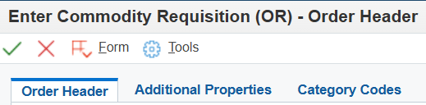
Generate a Requisition: Complete
Click the Red X to close

- Generating a Requisition from a Pre-Requisition
Step | Instruction / Explanation
Choose a Menu Selection/Pathway Option:
State of Nebraska > Purchasing > Requisitions > Gen Requisitions from Pre-Requisitions
  - Gen Agency Processed RFP (O3) from Pre-Requisition (O7)
  - Gen IT Commodity/Service Requisition (ON) from Pre-Requisition (O7)
  - Gen Service Exempt Requisition (Z6) from Pre-Requisition (O7)
  - Gen Commodity Requisition (OR) from Pre-Requisition (O7)
  - Gen Commodity Exempt Requisition (Z5) from Pre-Requisition (O7)
  - Gen Exception Request (O8) from Pre-Requisition (O7)
  - Gen Restricted Item/Trade In Requisition (OW) from Pre-Requisition (O7)
  - Gen SPB Processed RFP (O5) from Pre-Requisition (O7)
  - Gen Motor Vehicle Requisition (OI) from Pre-Requisition (O7)
  - Gen Communications Equipment Requisition (OT) from Pre-Requisition (O7)

THE FOLLOWING IS ONLY VISIBLE TO SPB PERSONNEL:
  - Gen SPB Authorized Requisition (OO) from Pre-Requisition (O7)

The process is the same for generating all requisition document types from a Pre-Requisition.

This example will demonstrate generating a commodity requisition (OR) from a pre-requisition (O7)

NOTE: For instructions on how to add attachments to a requisition or pre-requisition see Adding Attachments to a Requisition or Pre-Requisition
Enter the Pre-Requisition number into the order number field and click the “Find” button (magnifying glass).
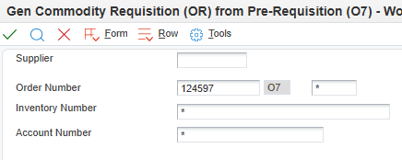
If the requisition has multiple lines, be sure to select all appropriate lines and click the green checkmark.

NOTE: If there are more than 10 lines, you must expand all the lines. If you do not expand all the lines, clicking the “select all” option will only select the lines visible on screen, and will not pull from the unexpanded lines.
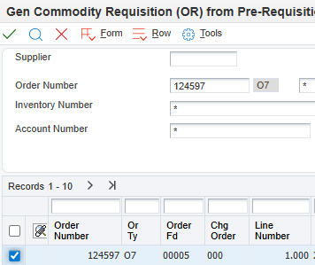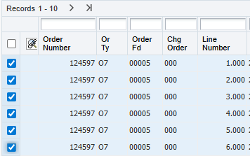
Select All
Select All
Multiple Lines
Single Line
Expand all lines

Check the release quantity to ensure it lists the correct amount to be released from the requisition. By default, the entire amount on the line will release unless adjusted.
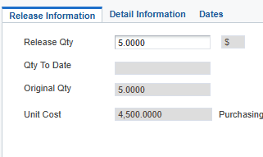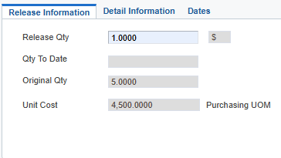
Full Amount
Adjusted Amount

Once you have adjusted the quantity (if needed), click the green checkmark.

If releasing multiple lines, adjust the quantity amounts as necessary and click the green checkmark for each individual line. The next line’s “release” screen will automatically cycle from line to line when the green checkmark has been clicked until all selected lines have been released.

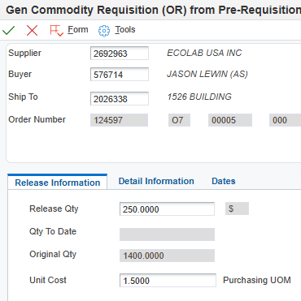

To review your order, Click the “Form” tab, and click the “Review Order(s)” option.
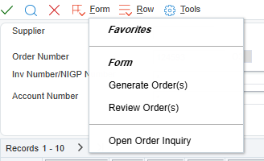
Next, click the “Row” tab, and click the “Details” option.
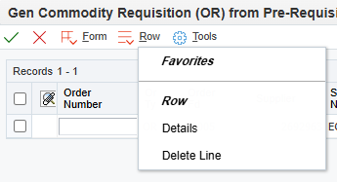
Review the quantities and adjust if necessary. Once the review is complete and any adjustments are made, click the green checkmark.
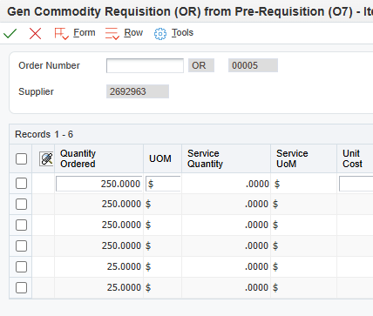
Click the “Form” tab, then click “Generate Order(s).”
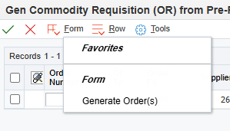
Write down your newly created requisition number.
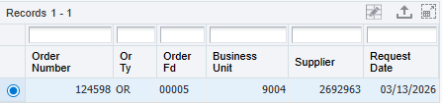
Generate a Requisition from a Pre-Requisition: Complete
Click the Red X to close.

- Generating a Requisition from a Requisition
Step | Instruction / Explanation
Choose a Menu Selection/Pathway Option:
State of Nebraska > Purchasing > Requisitions > Gen Requisition from Requisition
- Gen Agency Processed RFP (O3) from IT Commodity/Service Requisition (ON)
THE FOLLOWING ARE ONLY VISIBLE TO SPB PERSONNEL:
- Gen Agency Processed RFP (O3) from Exception Request (O8)
- Gen SPB Processed RFP (O5) from Exception Request (O8)
- Gen SPB Processed RFP (O5) from IT Commodity/Service Requisition (ON)
- Gen Service Exempt Requisition (Z6) from Exception Request (O8)
- Gen Commodity Requisition (OR) from Exception Request (O8)
- Gen Commodity Requisition (OR) from IT Commodity/Service Requisition (ON)
- Gen Commodity Requisition (OR) from Restricted Item/Trade In Requisition (OW)
- Gen Commodity Requisition (OR) from Motor Vehicle Requisition (OI)
- Gen Commodity Requisition (OR) from Communications Equipment Requisition (OT)
- Gen Exception Request (O8) from IT Commodity/Service Req (ON)
- Gen IT Commodity/Service Requisition (ON) from Exception Request (O8)
- Gen SPB Authorized Requisition (OO) from Restricted Item/Trade In Req (OW)
- Gen SPB Authorized Requisition (OO) from Commodity Requisition (OR)
- Gen SPB Authorized Requisition (OO) from Exception Request (O8)

The process is the same for generating all requisition doc types from requisition doc types.

This example will demonstrate generating an agency processed RFP (O3) from an IT commodity/service requisition (ON)

NOTE: For instructions on how to add attachments to a requisition see Adding Attachments to Requisition or Pre-Requisition

Enter the contract number into the Order Number field and click the “Find” button (magnifying glass).
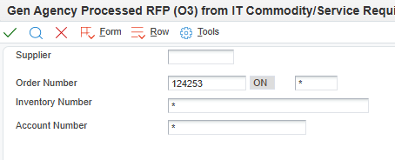
If the contract has multiple lines, be sure to expand all lines to view all available lines on the contract. Select the line or lines from which the requisition is to be generated from. and click the green checkmark.

NOTE: If you do not expand all the lines, clicking the “select all” option will only select the lines visible on screen, and will not pull from the unexpanded lines.
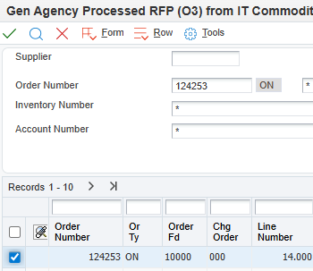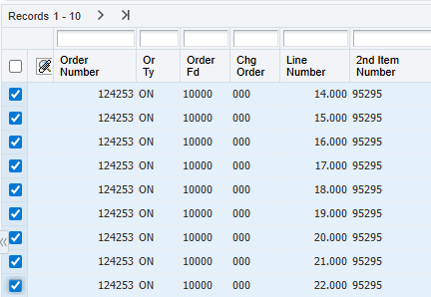
Select
All
Expand all lines
Select
All
Multiple Lines
Single Line

Check the release quantity to ensure it lists the correct amount that you want to release from the original requisition for the new requisition. By default, the entire amount on the line will release unless adjusted.

If you are releasing multiple lines, you will need to adjust the quantity amounts if necessary and click the green check for each individual line. The next line’s “release” screen will automatically cycle from line to line when the green check has been clicked until all selected lines have been released.

Once you have adjusted the quantity (if needed), click the green check.

Full Amount
Adjusted Amount

If releasing multiple lines, adjust the quantity amounts as necessary and click the green checkmark for each individual line. The next line’s “release” screen will automatically cycle from line to line when the green checkmark has been clicked until all selected lines have been released.

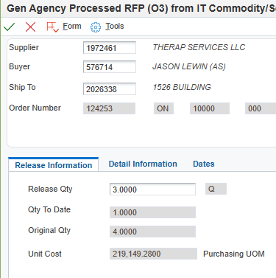

 | To review your order, Click the “Form” tab, and click the “Review Order(s)” option.
Next, click the “Row” tab, and click the “Details” option.
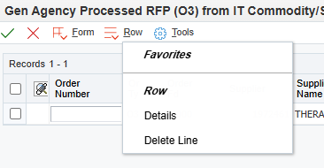
This is where you can review quantities, and make adjustments if necessary. Once your review is finished and/or adjustments are made, click the green check mark.
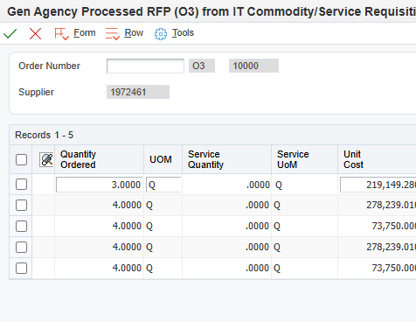
Click the “Form” tab, and click “Generate Order(s).”
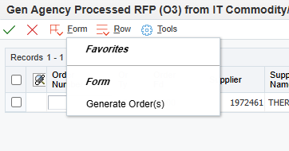
Make note of the newly created requisition number.
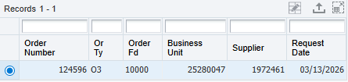
Generate a Requisition from a Requisition: Complete
Click the Red X to close.

- Working with a Requisition or Pre-Requisition
Step | Instruction / Explanation
Choose the Menu Selection/Pathway Option:
State of Nebraska > Purchasing > Requisition > Work with Requisition

The process is the same for working with all requisition or pre-requisition document types.

This example will demonstrate how to work with an agency process RFP (O3)

For instructions on how to add attachments to a requisition or pre-requisition, see Adding Attachments to a Requisition and Pre-Requisition
Enter the requisition or pre-requisition number you would like to work with in the Order Number field and click the “Find” button (magnifying glass).
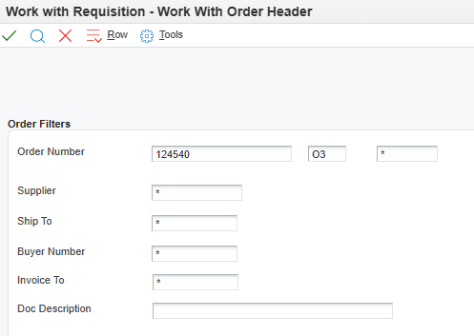
To make updates to the Order Header, such as changing the “Ship To,” “Buyer,” “Send Invoice to,” or any Date fields, click the “Header Revisions” button.

The “Additional Properties” and “Category Codes” tabs of the Header can also be viewed from this selection.

NOTE: To make Detail Revisions only, click the “Detail Revisions” button, and go to step 9.
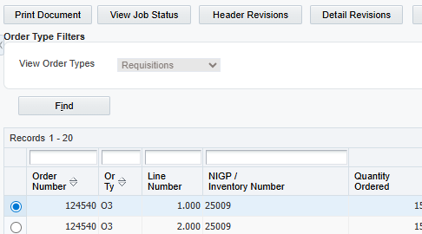
4. | Make edits to fields as necessary.  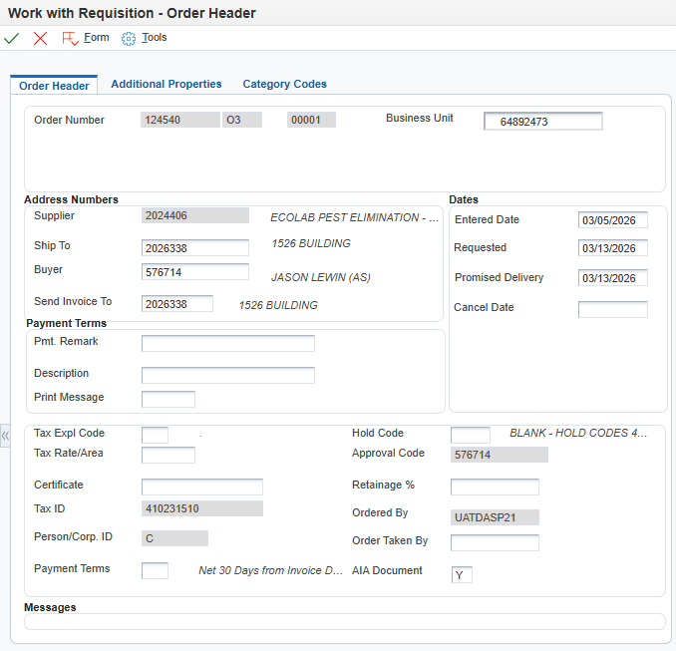
5. | The Additional Properties tab allows changes to the document such as the Document Description, the Document Location, and the Document Contact.  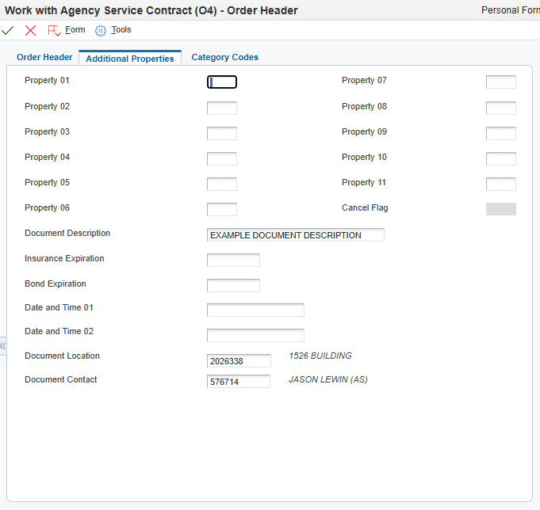
6. | The Category Codes tab allows changes to the available fields.  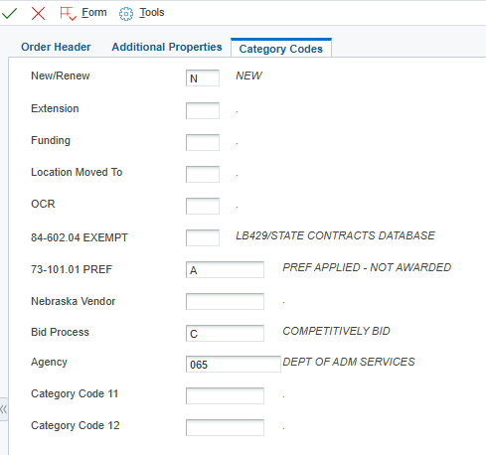
7. | Click the green checkmark to continue to the “Detail Revisions” screen.  ERROR NOTE: An “Evaluated Receipt Error” may display if changing a supplier from “Best Source” (999999) to another Supplier number.  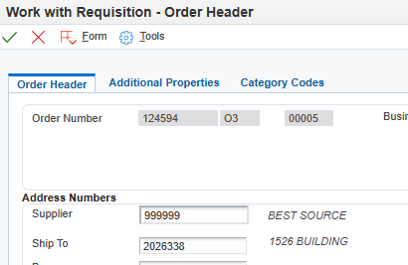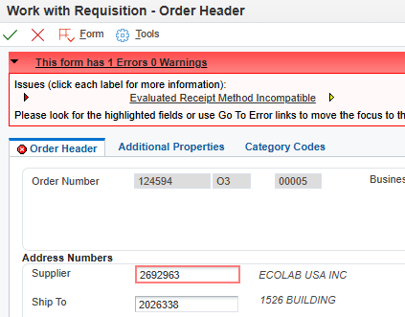  Evaluated Receipt Error  999999 “Best Source”  In this situation, email nis.security@nebraska.gov with the following to resolve the Evaluated Receipt Error:  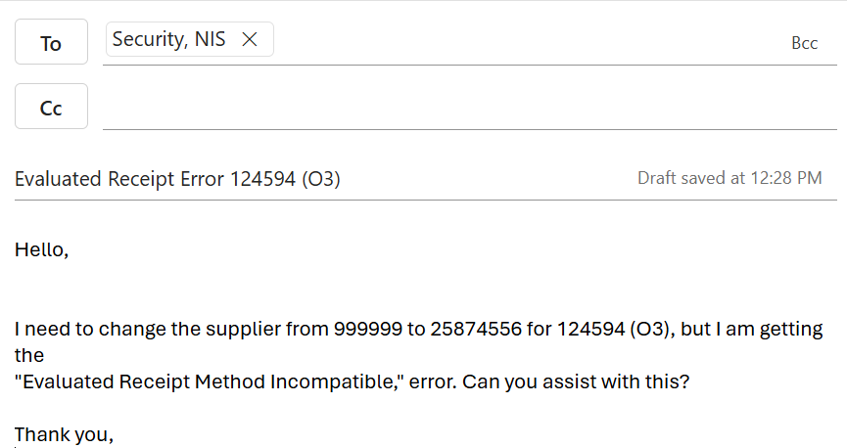
8. | Click the green checkmark to save Header Revisions and continue to Detail Revisions.  NOTE: If making no detail revisions, click the green checkmark again to return to the “Work With Requisition” home screen.
9. | Make edits to the detail lines as necessary.
ERROR NOTE: If making edits to requisitions or pre-requisitions from previous fiscal years, an error may result regarding the G/L (General Ledger) date.
To resolve this error, change the field to the day the edits were made.
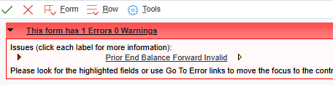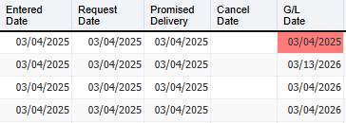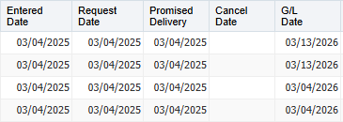
G/L Date Error Unresolved
“Prior End Balance” Error
G/L Date Error Resolved

10. | Click the green check mark to save revisions.
11. | Any revisions made to detail lines will result in the population of a text box. Enter the details describing all revisions made, date and initials showing who made the revision(s).  NOTE: It is crucial to note revisions as this allows for the most accurate tracking of revisions made over the life of the requisition or pre-requisition.  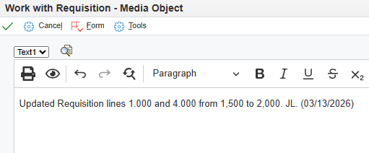
Work with Pre-Requisition and Requisition: Complete
Click the Red X to close.

- Adding Attachments to a Requisition and Pre-Requisition
Step | Instruction / Explanation
Choose the Menu Selection/Pathway Option:
State of Nebraska > Purchasing > Requisitions > Work with Requisition

The process is the same for all requisition and pre-requisition document types.

This example demonstrates adding a document file and a text attachment to an agency processed RFP (O3) in E1. To add a Line Attachment, follow steps 1 thru 3, then jump to step 10.
 | Enter the requisition or pre-requisition order number to which the document is going to be attached to in the Order Number field the doc type in the blank field to the right of the Order Number field and click the “Find” button (magnifying glass).
Next, select the pre-requisition or requisition and either click the green checkmark, or click the “Header Revisions” button, to get to the Order Header screen. To only add Line Attachments, click the “Detail Revisions” button and skip to step 10.
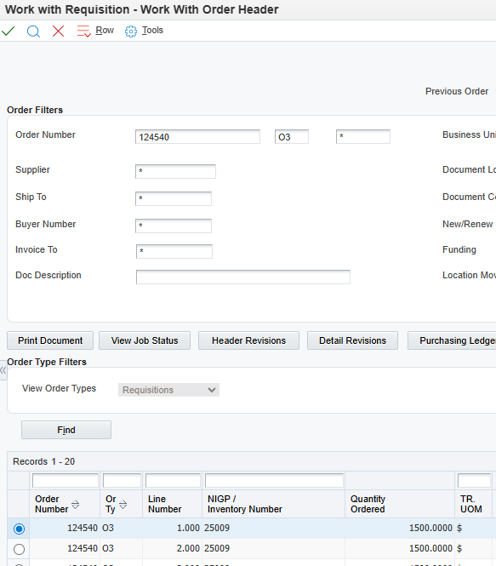
The Order Header screen will open. Click the “Form” tab and choose the “Attachments” option.
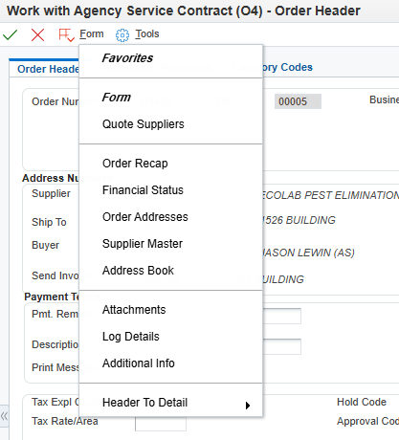
To attach a document, click the “File” icon. To add a Text Attachment, click the “Text” Option.
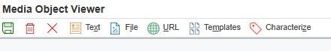
Text Attachments are free-text fields that can include any additional information for the requisition or pre-requisition. The first Text Attachment will print out on the requisition or pre-requisition header.
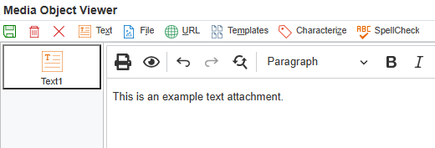
To attach a document file, drag the file to be attached into the dotted rectangle, or search for the document by clicking the “Choose File” option.

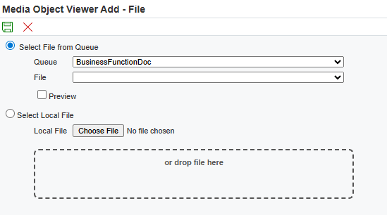

NOTE: File names with punctuation in them will result in an Administrator error. To avoid this, use naming conventions that do not include punctuation.

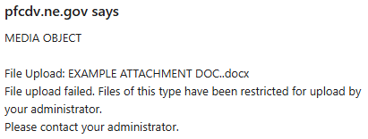

Once your document has been selected, click the green save icon.

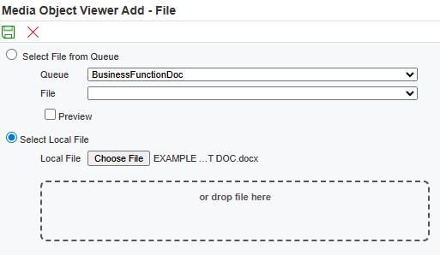
Document that has been added will show here
Green Save Icon
Verify the correct document is attached, and click the green save button.
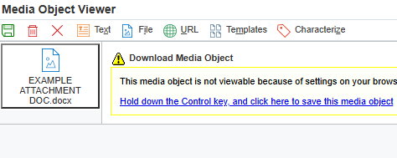
Attached Document

Text Attachment
 | To attach more documents, repeat steps 5 thru 7.
Click the green checkmark to continue to the Detail Revisions screen.

NOTE: If making no detail revisions, click the green checkmark again to return to the “Work With Requisition” home screen.
The only difference between adding a line attachment and a header attachment is where the attachment is placed.

Click the “line attachments section” of the line to add an attachment. Another option is to click the “Row” button and click the “line attachment” option. Follow steps 5 thru 7. to add an attachment.
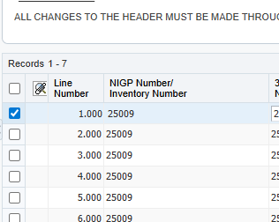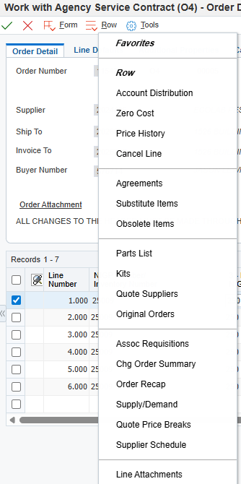
Click here
Line Text Attachment

Adding Attachments to a Requisition or Pre-Requisition: Complete
Click the Red X to close

- Import/Export Detail Lines
Step | Instruction / Explanation
1. | Choose the Menu Selection/Pathway Option:  State of Nebraska > Purchasing > Requisitions > Work with Requisition  The process is the same for all requisition and pre-requisition document types.  This example demonstrates importing/exporting detail lines to an agency processed RFP (O3).
2. | Enter the requisition or pre-requisition order number to which the document is going to be attached to in the Order Number field the doc type in the blank field to the right of the Order Number field and click the “Find” button (magnifying glass).
3. | Select the “Detail Revisions” tab.  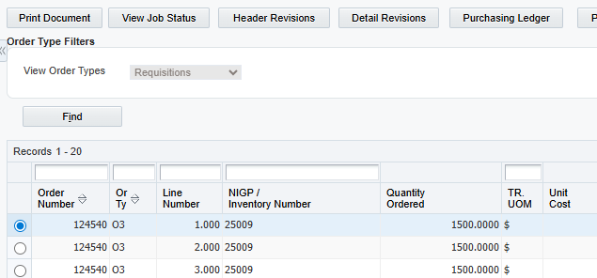
4. | Expand the lines if necessary, select the lines you will be exporting data from, and click the “Export Grid Data” button.  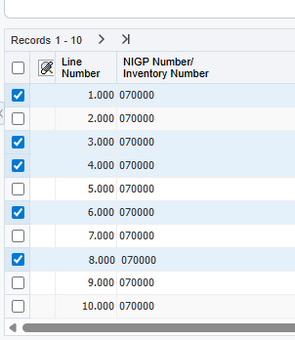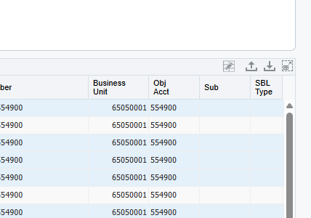  Selected lines  “Export Grid Data” Button  Expand all Lines
5. | Data can be exported in 4 ways: To an Excel spreadsheet, to a Word document, to CSV, or to clipboard. This example will show exporting to Excel. If choosing a Word or Excel file, The document will pop up in the downloads of the browser (upper right corner). Once selected, click the “Continue” button.  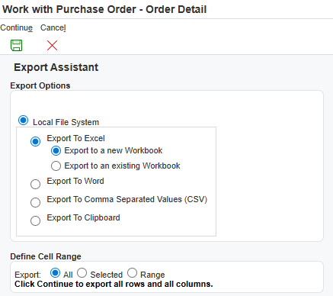
Matching Header Columns from Export for use of Import.
If the headers row of your import spreadsheet does not match what is in E1 exactly when importing, E1 will not be able to correctly import any data from the spreadsheet. A good practice to avoid importing issues is to export a line from the desired document, delete the line info, and use the spreadsheet headers as a template. This will ensure the headers match exactly.
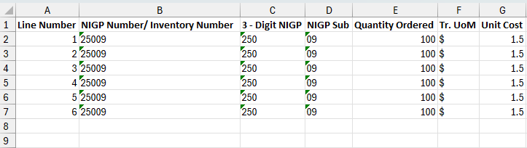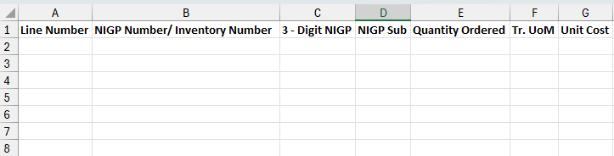
Spreadsheet ready to be used as template for import
Original Exported spreadsheet
6. | To import data into the detail lines of a requisition, follow steps 1 thru 3, and select the “Import Grid Data” option.  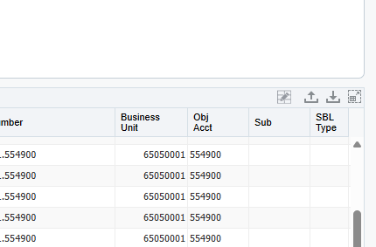  “Import Grid Data” Button
7. | Select the “Browse” option.  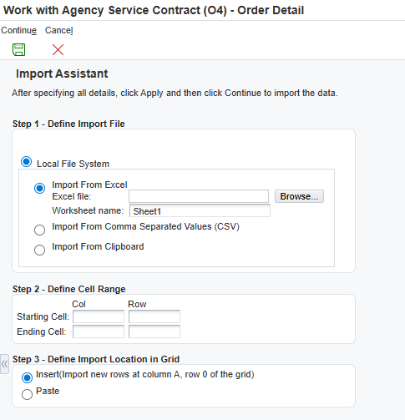
8. | Click the “Choose File” option, select your Excel spreadsheet, and click the “Upload” button. Once you have selected/uploaded an Excel spreadsheet, the green continue icon will become available. Select the green continue icon to go on.  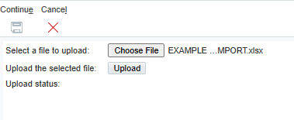  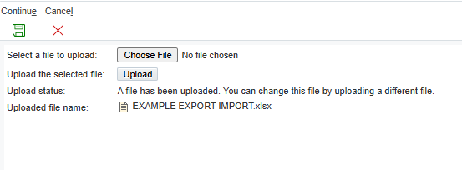
9. | The next step will be selecting the starting/ending cells in the Excel document you will be importing. Once you have entered the starting/ending cells, click the “Apply” button.  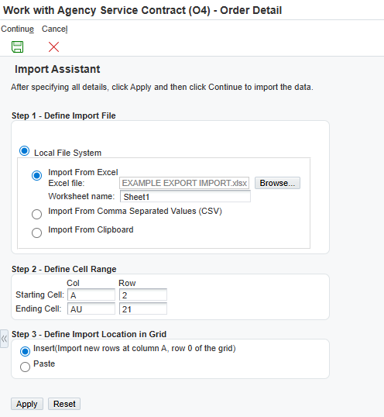
10. | Check that the data pulled from the Excel sheet is correct, and click the continue icon. NOTE: If you need to adjust the cell range, you can simply make the changes and click apply to have E1 re-import te selections.  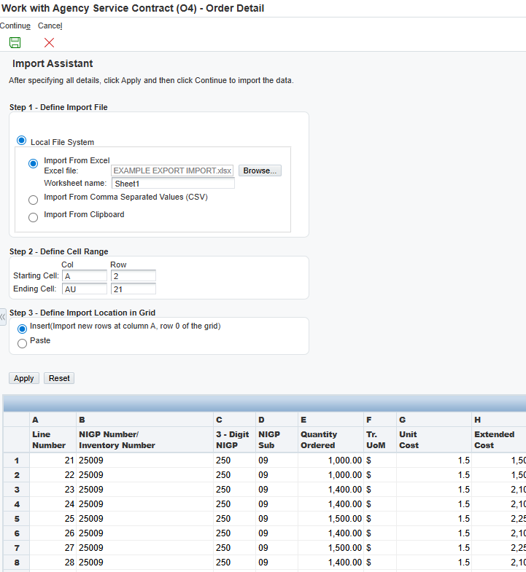
11. | Your newly imported lines will now be populated to your requisition. Click the green check at the top of the screen to conitnue.  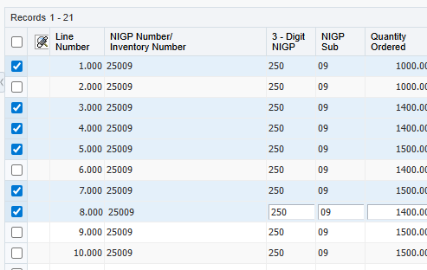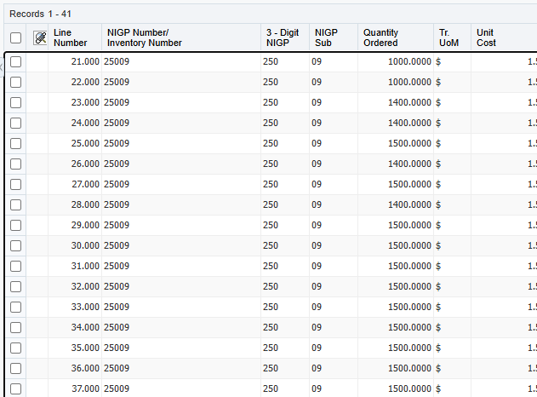  Ending line amount: 41  Starting line amount: 21  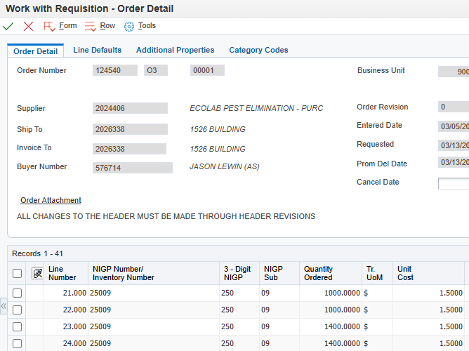
12. | A text box will open. Enter the details describing all revisions made, date and initials showing who made the revision(s).  NOTE: It is crucial to note revisions as this allows for the most accurate tracking of revisions made over the life of the requisition or pre-requisition.  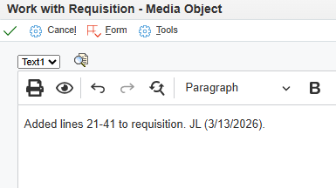
Import/Export Detail Lines in E1: Complete
Click the Red X to close.

