Receiving

This guide explains how to enter a receipt against a purchase order and how to reverse a receipt.

To view the steps of a specific process from the guide contents below, expand the steps by clicking the dropdown arrow. To collapse sections, click the dropdown arrow again.
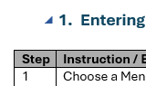
Collapse
Expand

Entering Receipts by Purchase Order
Step | Instruction / Explanation
Choose a Menu Selection/Pathway Option:
State of Nebraska > Purchasing > Receiving
- Enter Receipts by Purchase Order

The process is the same for receiving all purchase order doc types. This guide will demonstrate receiving a commodity purchase order (OG)
Enter the purchase order (PO) number to be received in the “Order Number” field, including the doc type, and click the “Find” button (magnifying glass).
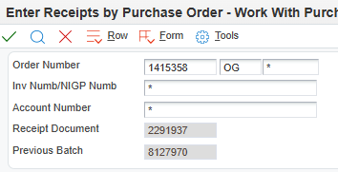
 | 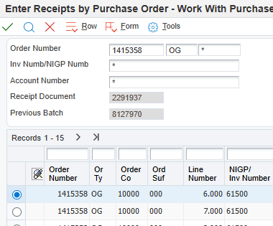
If the purchase order has more than 10 lines, all lines must be expanded. If all the lines are not expanded, E1 will not properly display the entire purchase order.
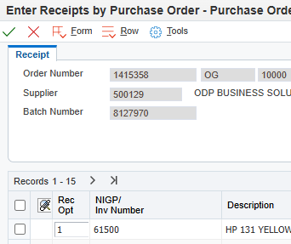
Expand all lines
In the “Rec Opt” field choose the appropriate “Receipt Option” (shown below). All lines will default to option “1” – to receive such line(s) unless modified. Make any necessary changes to the receipt option field for each line as appropriate.

Leave the receipt option blank to take no receipting action on a particular line.

- 1 – for all or a partial receipt
- 4 – to receive into multiple locations
- 7 – to receive a partial quantity and close out the remaining quantity
- 9 – to cancel a purchase order line

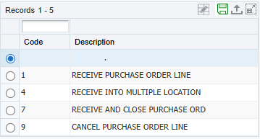
Once the proper selections have been made in the “Rec Opt” field, confirm and input the quantities to be received in the “Quantity” field, and click the green checkmark.
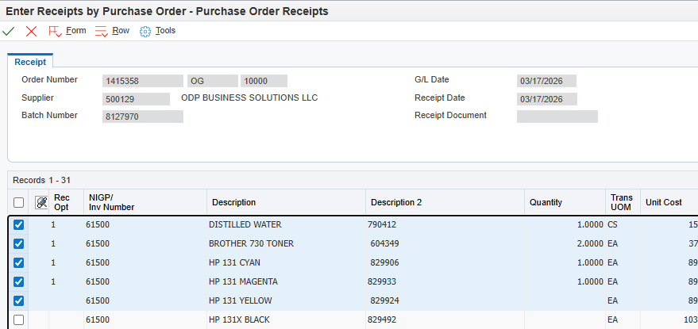

Note the resulting Receipt Document Number and Previous Batch Number for the receipt just generated. These receipt and batch numbers are used in the Accounts Payable process to pay the vendor for the goods/services received.
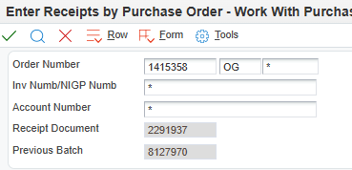
NOTE: The receipt batch will require approval and posting before the payment process can proceed.
Receiving a Purchase Order: Complete
Click the Red X to close.

Open Receipts by Supplier – Reversal (Reverse Receipting)
If a receipt has been entered incorrectly, it is possible to reverse the receipt. Steps to reverse begin on the next page. Below are some scenarios that may occur during the receipting process and may require reverse receipting.

Scenario 1: The receipt has been entered, but cannot be posted because it has failed budget checking

Contact State Accounting at as.stateaccounting@nebraska.gov with “O Batches” in the Subject line.

Scenario 2: The receipt has been entered and posted, but no voucher batch has been entered.
- Reverse the receipt
- Post the reverse receipt batch
- Either re-receipt the Purchase Order correctly or cancel the lines on the PO
- If the Purchase Order is re-received, post the receipt batch. If the lines on the Purchase Order are cancelled, no further action is required
Scenario 3: The receipt has been entered and posted, and a voucher batch has been entered, but is not posted.
- Delete the unposted voucher with PO
- Reverse the receipt
- Post the reverse receipt batch
- Either re-receipt the Purchase Order correctly or cancel the lines on the PO
- If the Purchase Order is re-received, post the receipt batch. If the lines on the Purchase Order are cancelled, no further action is required
Scenario 4: The receipt has been entered and posted and a voucher batch has been posted but is unpaid.
- Void the voucher batch
- Immediately post the void in the general ledger
- Reverse the receipt
- Post the reverse receipt batch
- Either re-receipt the Purchase Order correctly or cancel the lines on the PO
- If the Purchase Order is re-received, post the receipt batch. If the lines on the Purchase Order are cancelled, no further action is required
Scenario 5: The receipt has been entered and posted and a voucher batch has been posted and paid.
- Void the warrant - contact State Accounting
- Void the voucher batch
- Immediately post the void in the general ledger
- Reverse the receipt
- Post the reverse receipt batch
- Either re-receipt the Purchase Order correctly or cancel the lines on the PO
If the Purchase Order is re-received, post the receipt batch. If the lines on the Purchase Order are cancelled, no further action is required
Step | Instruction / Explanation
1 | Choose a Menu Selection/Pathway Option:  State of Nebraska > Purchasing > Receiving  - Open Receipts by Supplier – Reversal  The process is the same for reversing the receipt of all purchase order doc types.  This guide will demonstrate how to reverse a receipt if necessary.  NOTE: All related receipt batches must be posted in order to create a reverse receipt batch. Best practice is to wait at least 30 minutes after creating a receipt batch before attempting to reverse the receipt.
2 | Enter the related Purchase Order (PO) number in the “Order Number” field, which has the receipt to be reversed, and click the magnifying glass to search.  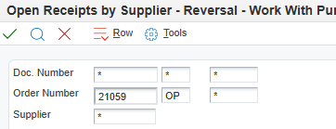
3 | Select the line (or lines) to reverse the receipt.  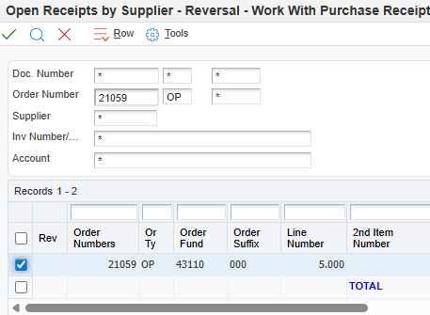
4 | Click the “Row” tab, select “Reversal,” and “Reverse Receipt.”  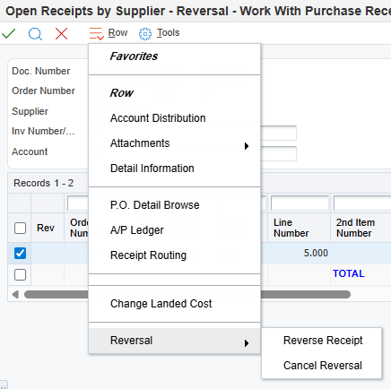
5 | Click the “Confirm Reversal” button  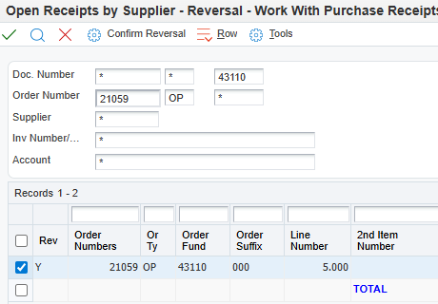
6 | Click the “OK” button.  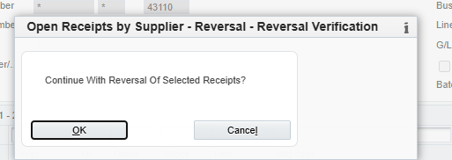
7 | The reversed line of the purchasing document is now awaiting receipt or is available for revision. An unposted batch has been created, which needs to be posted. A purchase order cannot be re-receipted until the batch is posted.  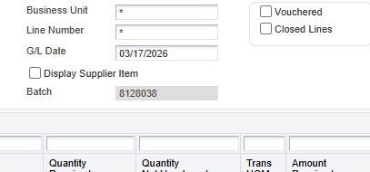
Reversing a Receipt: Complete
Click the Red X to close.

