Purchasing Ledger Inquiry

The Purchasing Ledger inquiry is a tool to review the progression of a Procurement Document from creation/generation through closure. It includes information specific to the User ID performing the action, the date and time an action was completed, and the Last Status and Next Status of the line at the time of the action.

The statuses of the procurement documents vary based upon document type. For example, a Purchase Order will include information specific to approvals of the purchase order and receipts against the purchase order.

Purchasing Ledger Inquiry
Step | Instruction / Explanation
The Purchasing Ledger can be accessed through the "Work With" options for Requisitions, Purchase Orders, and Contracts. The process is the same for all procurement document types.

Choose a Menu Path Selection:
State of Nebraska > Purchasing > Requisitions
- Work with Requisition

State of Nebraska > Purchasing > Purchase Orders
- Work with Purchase Order

State of Nebraska > Purchasing > Contracts > Commodity Contract Management
- Work with Agency Commodity Contact (CC)

THE FOLLOWING IS ONLY VISIBLE TO SPB PERSONNEL:
- Work with SPB Commodity Contact (OC)

State of Nebraska > Purchasing > Contracts > Service Contract Management
- Work with Agency Service Contact (O4)

THE FOLLOWING IS ONLY VISIBLE TO SPB PERSONNEL:
- Work with SPB Service Contact (P4)

This guide accesses the Purchasing Ledger through the "Work with Purchase Order "option:
State of Nebraska > Purchasing > Purchase Orders
- Work with Purchase Order

Enter the document number in the Order Number field and click the “Find” button (magnifying glass).
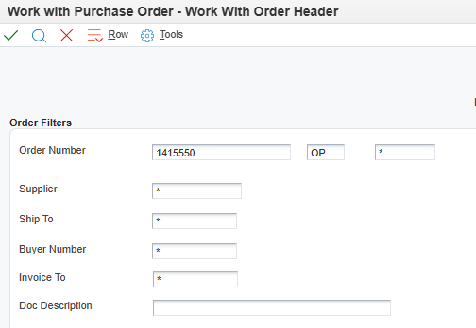
Click the “Purchasing Ledger” button.
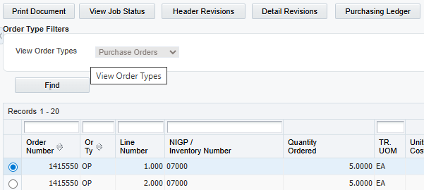
Click the “Find” (magnifying glass) button.
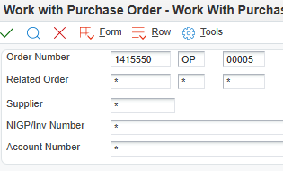
Expand all lines if given the option.
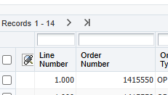
Use the QBE (Query by Example) Line Number field to search for the desired specific line and press “Enter.”
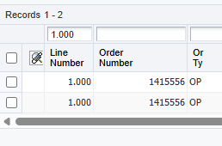

Scroll through the grid data to review.

Quantity Ordered - Quantity ordered on procurement document
Quantity Received - Populates when a receipt is made against a purchase order
Amount Ordered - Dollar amount of the line
Amount Received - Dollar amount of goods or services received
Last Status/Next Status - Vary by procurement document type
Last Status - 999 indicates the line is complete
Order Fund - Account used for purchase
Business Unit - Agency specific number used for purchasing
Ship To Number - The Address Book number of the address where items are to be delivered, or services are to be performed.
Receive Date - Date the good or service was received
Cancel Date - Purchase Orders should never have a cancel date
Promised Delivery Date - Date the supplier promised to deliver this order
Request Date - Date the commodity/service is requested from the agency to be delivered

To view specific details about a line of information, select a line and click the green checkmark.
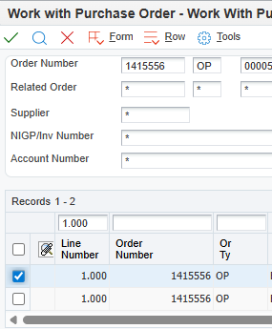
Review Additional Information for data specific to the procurement document line.
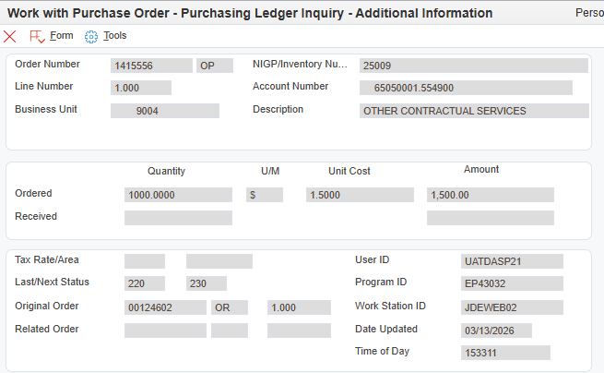
Purchasing Ledger Inquiry: Complete
Click the Red X to close

