Purchase Orders

Before purchasing a commodity or service, please ensure you are familiar with the Procurement Manual and Policies on the AS Materiel Division, State Purchasing Bureau website to determine what processes and restrictions may apply to your procurement.

This guide explains how to generate a purchase order (either a direct entry, generating from a requisition, or generating from a contract) and how to revise a purchase order.

In order to generate a purchase order from an existing requisition or contract, the requisition or contract MUST be fully approved in the system (E1). Any revisions to a requisition or contract will resend the document for approvals.

To view the steps of a specific process from the guide contents below, expand the steps by clicking the dropdown arrow. To collapse sections, click the dropdown arrow again.
Collapse
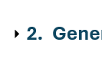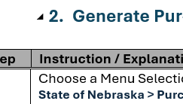
Expand

Generate Purchase Order (Direct Entry)
Step | Instruction / Explanation
Choose a Menu Selection/Pathway Option:
State of Nebraska > Purchasing > Purchase Orders > Generate Purchase Order
- Enter Service Purchase Order - (OM) (Three Way Match)
- Enter Service Purchase Order - Two Way Match (Z9)
- Enter Commodity Purchase Order (OP)
- Enter CSI Purchase Order (OH)

THE FOLLOWING IS ONLY VISIBLE TO SPB PERSONNEL:
- Enter SPB Authorized Purchase Order (ZO)

The process is the same for all direct entry purchase order doc types. This example will demonstrate entering a commodity purchase order (OP)

NOTE: For instructions on how to add attachments to a purchase order, see Adding Attachments to Purchase Order.
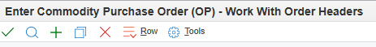
Click the green plus button.
Enter Header Information as necessary.
- Supplier - Enter the Address Book number (AB#) of the vendor being purchased from.
  - Should typically be a “V” (Vendor), “AG” (Agency), or “VP” (Political Subdivision) Address Book type.
  - NOTE: This should NEVER be an “E” or “FD” Address Book type.
- Ship To – Enter the Address Book number of the address where items are to be delivered or services are to be performed.
  - The Ship To Address Book number will automatically populate the Send Invoice To field.
  - Should typically be an “F” Address Book type.
- Buyer - Enter the Address Book number for the individual primarily responsible for the document at the Agency.
- Send Invoice To - Enter the Address Book number for the address where invoices should be sent.
  - Automatically populates but can be overwritten.
  - Should typically be an “F” Address Book type.
- Business Unit- Enter the Business Unit responsible for the purchase order.
- Entered Date – Current date will automatically populate.
- Requested Date - Enter the desired date the purchase order is to be filled or delivered.
- Promised Delivery - Enter the date the Supplier promised to deliver this order.
- Cancel Date – DO NOT ENTER A CANCEL DATE
  - NOTE: Purchase orders should never have a cancel date. If not removed, the funds will remain encumbered even if the purchase order is canceled.

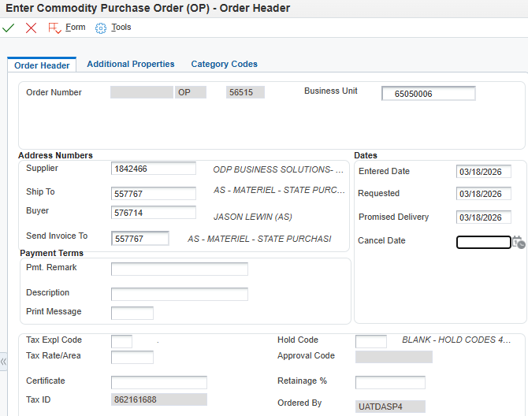
Example of Filled Order Header
Click the Additional Properties tab and complete as needed or desired.
- Document Description - Enter the description of goods/services being procured (this information will print on reports).
  - NOTE: This field is limited to 30 alpha/numeric characters.
- Document Location - Enter the Address Book number for the facility where the purchase order was established.
  - Should typically be an “F” Address Book type.
- Document Contact - Enter the Address Book number for the primary person responsible for the commodity or service purchase order.
  - Must be either a “B”, “E”, or “N” Address Book type.

Example of Filled Additional Properties
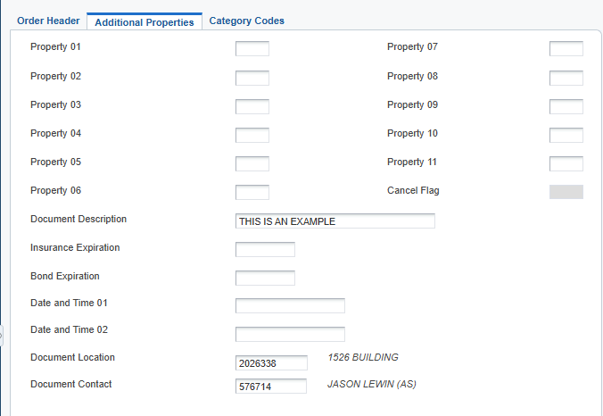
Click the Category Codes tab and complete as needed or desired.
- New/Renew - Enter “N” for ‘new’ purchase order.
- Funding - Make a selection using the visual assist icon if tracked funds are being utilized (e.g., ARRA or COVID19)
- 84-602.04 Exempt - Used to indicate if exempt from inclusion in the State Contracts Database. Enter “E” for ‘Exempt’ if appropriate.
- Nebraska Vendor - Used to indicate a Nebraska vendor. Enter “Y” or “N”.
- Agency - Used to indicate the three-digit Agency number.

Example Filled Category Codes
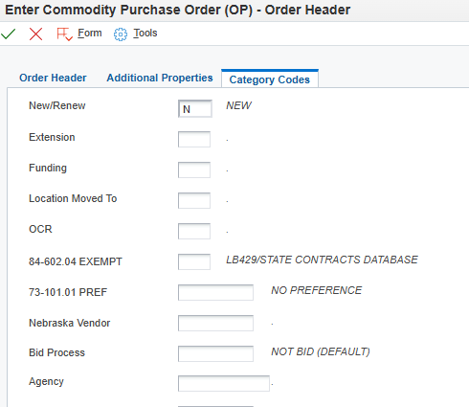
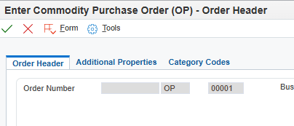
Verify all information is correct and click the green checkmark at the top of the screen.
Make note of the newly generated Purchase Order Number listed in the Order Number field for reference.
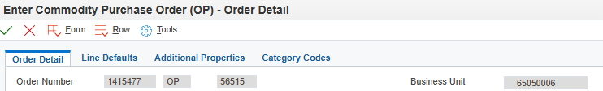
Click into the Detail Line and fill in at least 1 detail line to ensure a proper save of the newly created purchase order.
Detail Line Information
- NIGP Number/Inventory Number - Enter the NIGP code for items/services to be purchased. All applicable 5-digit codes for Services will be > 90000. All Commodity Codes will be < 90000. This field will not print on the purchasing documents.
NOTE: At least the first 3 digits of an NIGP code are required.
  - 3 Digit NIGP - Will populate from the NIGP Number/Inventory Number; this is the three-digit prefix to a NIGP code.
  - NIGP Sub - Will populate from the NIGP Number/Inventory Number; this is the two-digit NIGP code suffix.
  - See National Institute of Governmental Purchasing (NIGP) Codes.
- Quantity Ordered - Enter the quantity being ordered.
  - If Unit of Measure is $, enter total amount
- Tr. UoM - Enter the Transaction Unit of Measure.
  - System defaults to EA. Additional options can be viewed using the visual assist icon.
- Unit Cost - Enter the cost per unit price.
  - If Unit of Measure is $, enter 1.
- Extended Cost - The system will automatically populate the Extended Cost based on the Quantity Ordered and Unit Cost fields (Quantity Ordered x Unit Cost = Extended Cost).
  - Ensure total value is accurate for document approvals and receiving purposes.
- Description 1 - Enter the description of commodity/service
  - Field is limited to 30 alpha/numeric characters
- Description 2 - Enter the continued commodity/service description
  - Field is limited to 30 alpha/numeric characters
- Account Number - Enter valid Business Unit and Object Code from Chart of Accounts (e.g., 65060012.534700)
- Ln Ty – Line Type - Defaults to “J” for Non-Inventory or Non-Stock Item and represents the G/L (General Ledger) account number from which the funds will be drawn for the purchase
  - NOTE: This will rarely be modified

Example Completed Detail Line
 | Click the green checkmark at the top of the screen to save.
Generate Purchase Order: Complete
Click the Red X to close

Generate Purchase Order from a Requisition
Step | Instruction / Explanation
Choose a Menu Selection/Pathway Option:
State of Nebraska > Purchasing > Purchase Orders > Generate Purchase Order from Requisition
- Gen Service Purchase Order (OM) from Agency Processed RFP (O3)
- Gen Service Purchase Order (OM) from IT Commodity/Service Requisition (ON)
- Gen Service Purchase Order - Two Way Match (Z9) from Agency Processed RFP (O3)
- Gen Service PO - Two Way Match (Z9) from IT Commodity/Service Requisition (ON)
- Gen Commodity Purchase Order (OP) from Commodity Requisition (OR)
- Gen Commodity Purchase Order (OP) from Motor Vehicle Requisition (OI)
- Gen Commodity Purchase Order (OP) from IT Commodity/Service Requisition (ON)
- Gen SPB Authorized Purchase Order (ZO) from Exception Request (O8)
- Gen SPB Authorized Purchase Order (ZO) from SPB Authorized Requisition (OO)

THE FOLLOWING IS ONLY VISIBLE TO SPB PERSONNEL:
- Gen SPB Authorized PO (ZO) from Restricted Item/Trade-In Requisition (OW)

The process is the same for all purchase order-from-requisition doc types. This example will demonstrate generating a commodity purchase order (OP) from a commodity requisition (OR)

NOTE: For instructions on how to add attachments, see Adding Attachments to Purchase Order
Enter the Requisition number into the order number field and click the “Find” button (magnifying glass).
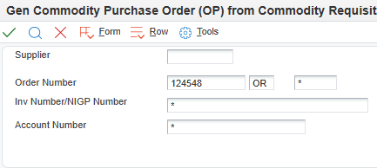
If the requisition has multiple lines, be sure to select all appropriate lines and click the green checkmark.

NOTE: If there are more than 10 lines, all lines must be expanded. If all lines are not expanded, clicking the “select all” option will only select the lines visible on screen and will not pull from the unexpanded lines.
Expand all lines
Select All
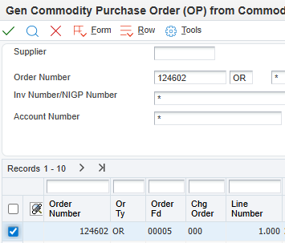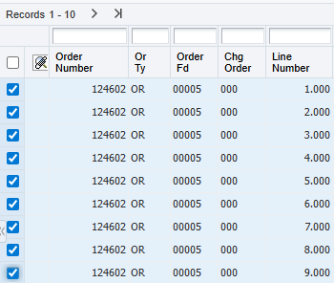
Multiple Lines
Single Line
Select All
Check the release quantity to ensure it lists the correct amount to be released from the requisition. By default, the entire amount on the line will be released unless adjusted.
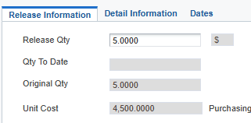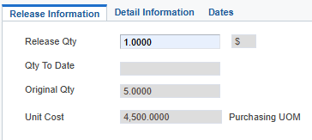
Adjusted Amount
Full Amount

Once the quantity is adjusted (if needed), click the green checkmark.

If releasing multiple lines, adjust the quantity amounts as necessary and click the green checkmark for each individual line. The next line’s “release” screen will automatically cycle from line to line when the green checkmark has been clicked until all selected lines have been released.
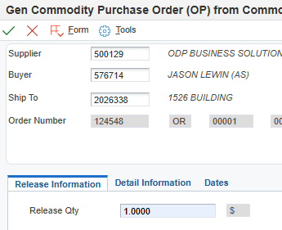
To review the order, click the “Form” tab and click the “Review Order(s)” option.
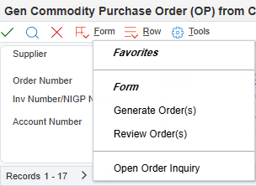
Next, click the “Row” tab, and click the “Details” option.
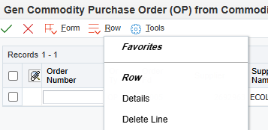
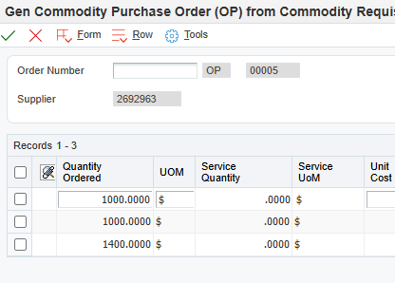
Review the quantities and adjust if necessary. Once the review is complete and any adjustments are made, click the green checkmark.
Click the “Form” tab and click “Generate Order(s).”
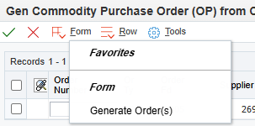
Make note of the newly created purchase order number.
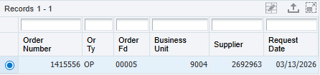
Generate Purchase Order from Requisition: Complete
Click the Red X to close.

Generate Purchase Order from a Contract
Step | Instruction / Explanation
Choose a Menu Selection/Pathway Option:
State of Nebraska > Purchasing > Purchase Orders > Generate Purchase Order from Contract
- Gen Service Purchase Order (O9) from Agency Service Contract (O4)
- Gen Service Purchase Order-Two Way Match (Z8) from Agency Service Contract (O4)
- Gen Service Purchase Order (O9) from SPB Service Contract (P4)
- Gen Service Purchase Order - Two Way Match (Z8) from SPB Service Contract (P4)
- Gen Commodity Purchase Order (OG) from Agency Commodity Contract (CC)
- Gen Commodity Purchase Order (OG) from SPB Commodity Contract (OC)
- Gen IT Commodity/Service Purchase Order (O6) from Agency Service Contract (O4)
- Gen IT Commodity/Service Purchase Order (O6) from Agency Commodity Contract (CC)
- Gen IT Commodity/Service Purchase Order (O6) from SPB Service Contract (P4)
- Gen IT Commodity/Service Purchase Order (O6) from SPB Commodity Contract (OC)
- Gen Motor Vehicle Purchase Order (OU) from SPB Commodity Contract (OC)
- Gen Motor Vehicle - Exempt Purchase Order (OK) from SPB Commodity Contract (OC)

The process is the same for all purchase order-from-contract doc types. This example will demonstrate generating a service purchase order (O9) from an agency service contract (O4)

NOTE: For instructions on how to add attachments to a purchase order see Adding Attachments to Purchase Order
Enter the contract number into the Order Number field and click the “Find” button (magnifying glass).
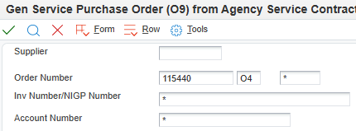
If the contract has multiple lines, be sure to expand all lines to view all available lines on the contract. Select the line or lines from which the purchase order is to be generated and click the green checkmark.
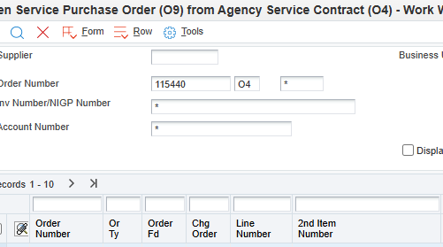
Expand All Lines
Review and update Header Information as necessary.
- Supplier - Enter the Address Book number (AB#) of the vendor being purchased from.
  - Should typically be a “V” (Vendor), “AG” (Agency), or “VP” (Political Subdivision) Address Book type.
  - NOTE: This should NEVER be an “E” or “FD” Address Book type.
- Ship To – Enter the Address Book number of the address where items are to be delivered or services are to be performed.
  - The Ship To Address Book number will automatically populate the Send Invoice To field.
  - Should typically be an “F” Address Book type.
- Buyer - Enter the Address Book number for the individual primarily responsible for the document at the Agency.
- Business Unit- Enter the Business Unit responsible for the purchase order.

Once the quantity is adjusted (if needed), click the green checkmark.

- If releasing from multiple lines, adjust the quantity amounts as necessary and click the green checkmark for each individual line. The next line’s “release” screen will automatically cycle from line to line when the green checkmark has been clicked until all selected lines have been viewed.

Example of Header & Order Release Information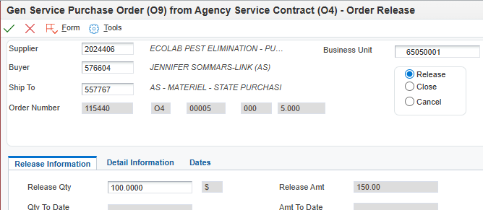
Check the Release Quantity field and adjust it to the quantity to be released for the Purchase Order. By default, the entire amount on the line will be released unless adjusted.
Adjusted Amount
Full Amount

Click the Detail Information tab and update the Account Number.
- Account Number - Enter valid Business Unit and Object Code from Chart of Accounts (e.g., 65060012.534700)
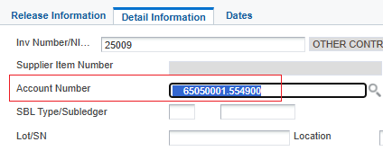
 | Click the green checkmark at the top of the screen
 | Repeat Steps 4 through 7 as necessary.
To review the order, click the “Form” tab, and click the “Review Order(s)” option.
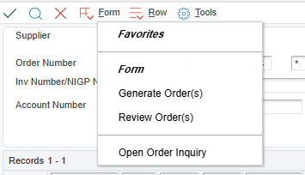
Next, click the “Row” tab, and click the “Details” option.
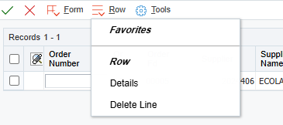
Review the quantities and adjust if necessary. Once the review is complete and any adjustments are made, click the green checkmark.
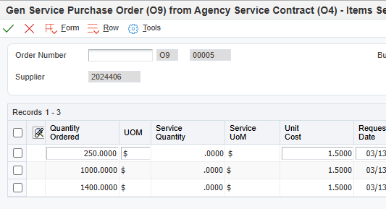
Click the “Form” tab, and click “Generate Order(s).”
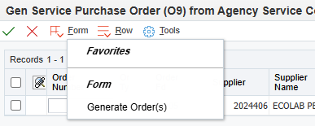
Make note of the newly created purchase order number.
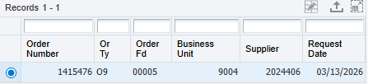
Click the “Row” tab and click the “Open Order Inquiry” option.
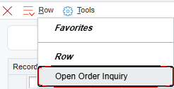
 | Select a row in the grid for the Purchase Order and click the green checkmark to open the Document Header.
Review Header Information.
- Cancel Date – DO NOT ENTER A CANCEL DATE
NOTE: Purchase orders should never have a cancel date. If not removed, the funds will remain encumbered even if the purchase order is canceled.

Example Order Header
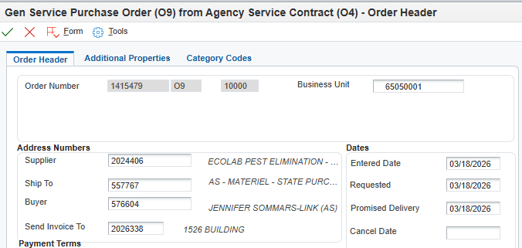
Click the Additional Properties tab and complete/revise as needed or desired.
- Document Description - Enter the description of goods/services being procured (this information will print on reports).
  - NOTE: This field is limited to 30 alpha/numeric characters.
- Document Location - Enter the Address Book number for the facility where the purchase order was established.
  - Should typically be an “F” Address Book type.
- Document Contact - Enter the Address Book number for the primary person responsible for the commodity or service purchase order.
  - Must be either a “B”, “E”, or “N” Address Book type.

Example of Filled Additional Properties
Click the Category Codes tab and complete as needed or desired.
- New/Renew - Enter “N” for ‘new’ purchase order.
- Funding - Make a selection using the visual assist icon if tracked funds are being utilized (e.g., ARRA or COVID19)
- 84-602.04 Exempt - Used to indicate if exempt from inclusion in the State Contracts Database. Enter “E” for ‘Exempt’ if appropriate.
- Nebraska Vendor - Used to indicate a Nebraska vendor. Enter “Y” or “N”.
- Agency - Used to indicate the three-digit Agency number.

Example Filled Category Codes
 | Click the green checkmark at the top of the screen to save.
Make any revisions to detail lines as needed. (Contract description is likely generic and not detailed enough to properly identify what is being purchased. Revise the line description so it is clear what item or service is being purchased.)

Example of Line Detail
 | Click the green checkmark at the top of the screen to save.
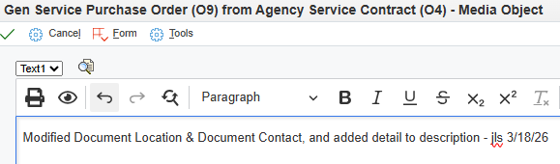
A text box will open. Enter the details of what was “revised” since the original generation, followed by the date and initials of the person who made the revision.
NOTE: It is crucial to note revisions as this allows for the most accurate tracking of revisions made over the life of the purchase order.
 | Click the green checkmark to save.
Generate Purchase Order from Contract: Complete
Click the Red X to close.

Work with Purchase Order
Step | Instruction / Explanation
Choose the Menu Selection/Pathway Option:
State of Nebraska > Purchasing > Purchase Orders > Work with Purchase Order

The process is the same to revise all purchase order document types. This example will demonstrate how to revise a commodity purchase order (OP).

NOTE: For instructions on how to add attachments to a purchase order see Adding Attachments to Purchase Order

Enter the purchase order number in the Order Number field and click the “Find” button (magnifying glass).
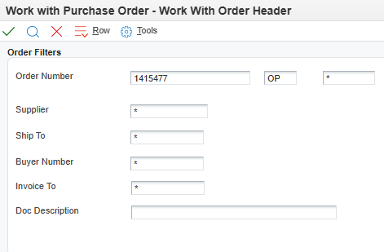
To make updates to the Order Header, such as changing the “Ship To,” “Buyer,” “Send Invoice to,” “Business Unit,” or any Date fields, click the “Header Revisions” button.

The “Additional Properties” and “Category Codes” tabs of the Header can also be viewed from this selection.

NOTE: To make updates to the Detail Lines only, click the “Detail Revisions” button, and go to step 9.
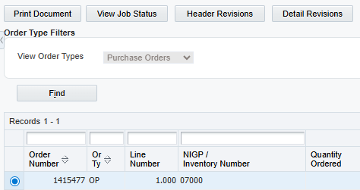
Make edits to the fields as necessary.

NOTE: Do not modify the Supplier number if the purchase order was generated from a contract, unless it is the generic “Best Source” supplier (999999), the contract uses authorized dealers, or if the contract has specific instructions with parent-child setups.
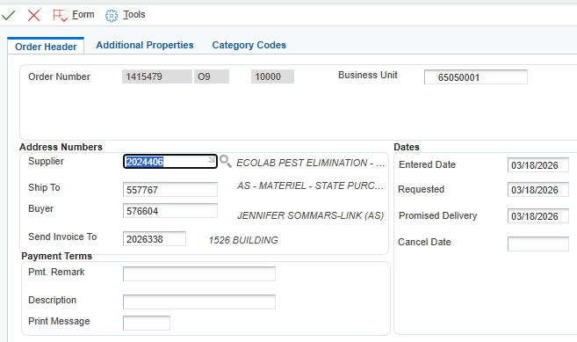
The Additional Properties tab allows changes to the document, such as the Document Description, the Document Location, and the Document Contact.
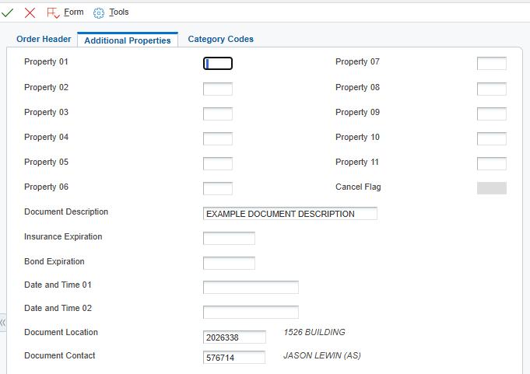
The Category Codes tab allows changes to the available fields.
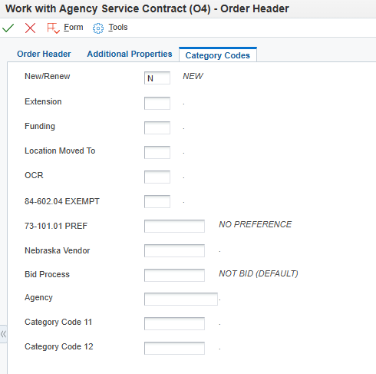
Click the green checkmark to continue to the “Detail Revisions” screen.

ERROR NOTE: An “Evaluated Receipt Error” may display if changing a supplier from “Best Source” (999999) to another Supplier number.
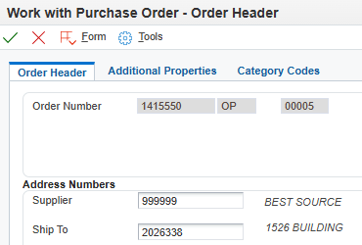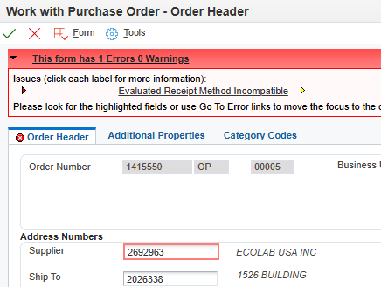
Evaluated Receipt Error
999999 “Best Source”

In this situation, email nis.security@nebraska.gov to resolve the Evaluated Receipt Error:
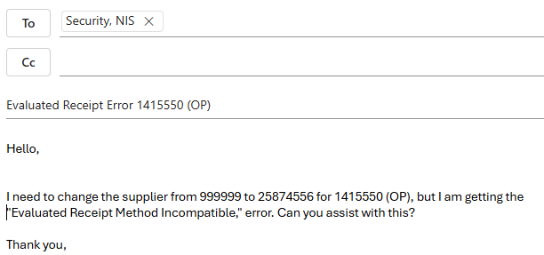
Click the green checkmark to save Header Revisions and continue to Detail Revisions.

NOTE: If making no detail revisions, click the green checkmark again to return to the “Work with Purchase Order” home screen.
Make edits to the detail lines as necessary.

ERROR NOTE: If making edits to Purchase Orders from previous fiscal years, a “Prior End Balance Error” may result regarding the G/L (General Ledger) date.

To resolve this error, change the G/L Date field to the day the edits were made.
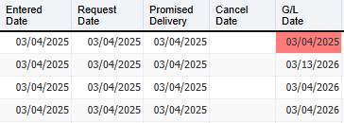
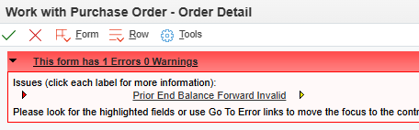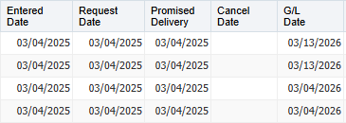
G/L Error Resolved
G/L Date Error Unresolved
 | Click the green checkmark to save revisions.
A text box will open. Enter the details of what was “revised” since the original generation, followed by the date and initials of the person who made the revision(s).

NOTE: It is crucial to note revisions as this allows for the most accurate tracking of revisions made over the life of the purchase order.
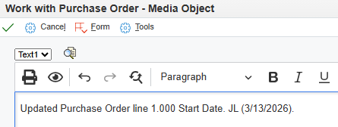
Work with Purchase Order : Complete
Click the Red X to close.

Adding Attachments to Purchase Order
Step | Instruction / Explanation
Choose the Menu Selection/Pathway Option:
State of Nebraska > Purchasing > Purchase Orders > Work with Purchase Order

The process is the same for all purchase order document types. This example demonstrates adding a document file attachment and text attachment to a Commodity Purchase Order (OP).
 | Enter the purchase order number to which attachments will be added in the Order Number field and the doc type in the blank field to the right of the Order Number field and click the “Find” button (magnifying glass).
Next, select the purchase order.
- To add attachments to the header, either click the green checkmark, or click the “Header Revisions” button, to get to the Order Header screen.
- To add attachments to a detail line, click the “Detail Revisions” button and skip to step 10.
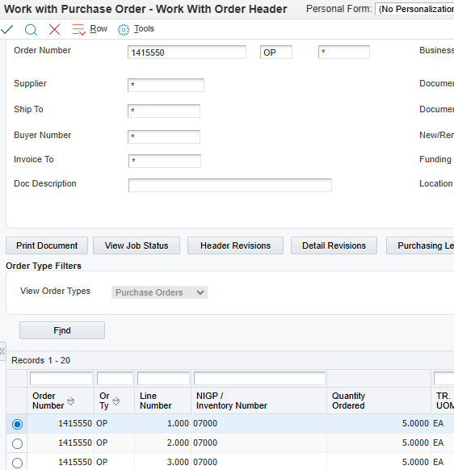
The Order Header screen will open. Click the “Form” tab and choose the “Attachments” option.
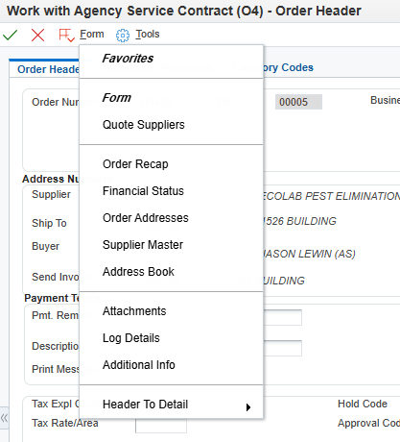
To attach a document, click the “File” icon. To add a text attachment, click the “Text” icon.
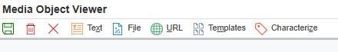
Text attachments are free-text fields that can include any additional information for the purchase order. The first text attachment (and only the first) will print out on the purchase order, whether on a header or detail line.
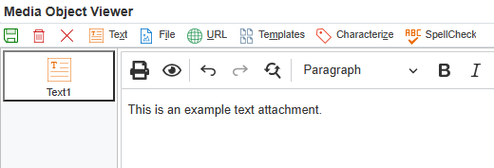
To attach a file or document, drag the file to be attached into the “drop file here” area or browse for the document by clicking the “Choose File” option.
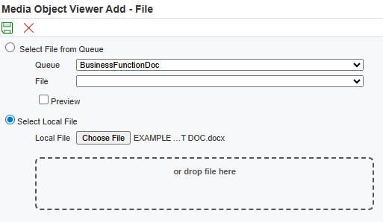
Once the text is completed or the document has been selected, click the green save button.

ERROR NOTE: File names with punctuation in them will result in an Administrator error. To avoid this, use naming conventions that do not include punctuation.
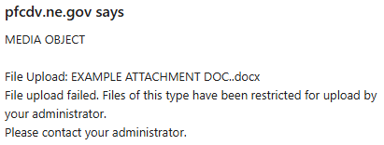
Verify the text or file attachment and click the green save button.

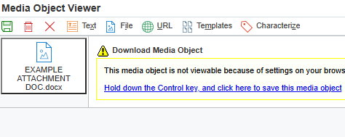
Attached Document
Document that has been added will show here
Green Save button

Text Attachment
 | To add additional attachments, repeat steps 4 thru 7.
Click the green checkmark to continue to the Detail Revisions screen.

NOTE: If making no detail revisions, click the green checkmark again to return to the “Work with Purchase Order” home screen.
The only difference between adding a line attachment and a header attachment is where the attachment is placed.

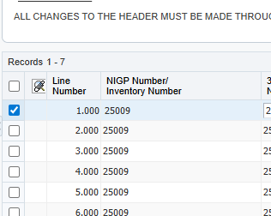
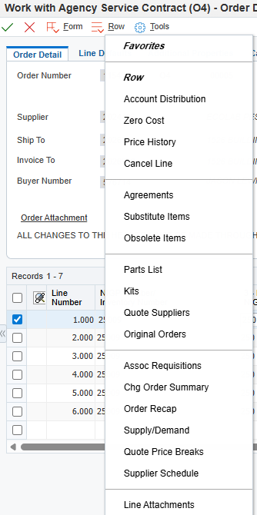
For any row or line, click the blank space in the column under the “paperclip” icon to add an attachment or click the “Row” button and click the “Line attachments” option. Follow steps 5 thru 7 to add an attachment.
Click here OR
Line Text Attachment
Adding Attachments to Purchase Order: Complete
Click the Red X to close

Import/Export Detail Lines
Step | Instruction / Explanation
Choose the Menu Selection/Pathway Option:
State of Nebraska > Purchasing > Purchase Orders > Work with Purchase Order

The process is the same for all purchase order document types. This example demonstrates importing/exporting detail lines to a commodity purchase order (OP).
Enter the purchase order number in the Order Number field, the doc type in the blank field to the right of the Order Number field and click the “Find” button (magnifying glass).
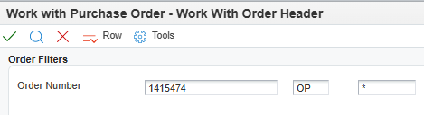
Select the “Detail Revisions” tab.
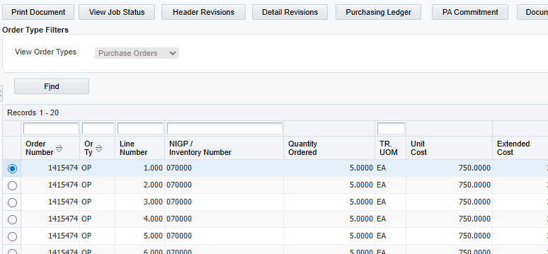
Expand the lines if necessary, select the lines to be exported, and click the “Export Grid Data” button.
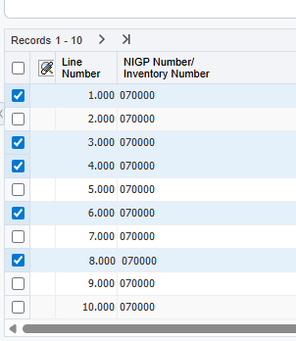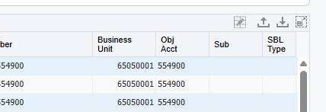
“Export Grid Data” Button
Expand all Lines
Selected lines
Data can be exported in 4 ways: To an Excel spreadsheet, to a Word document, to a CSV document, or to the clipboard. This example will show exporting to Excel. If choosing a Word or Excel file, the document will pop up in the downloads of the browser (upper right corner).
Once selected, click the “Continue” button.
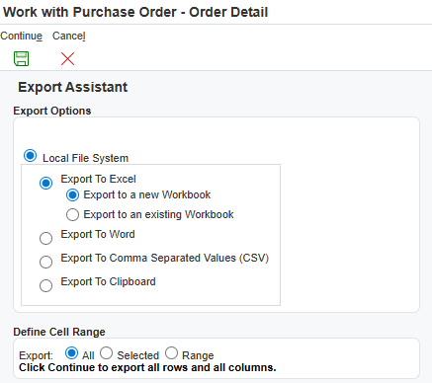
Match Header Columns from Export for use of Import.

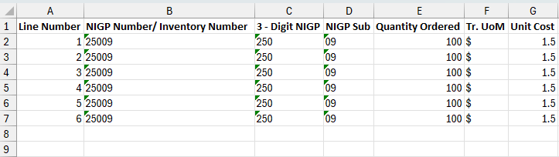
If the header row of the spreadsheet to be imported does not match E1 exactly when importing, E1 will not be able to correctly import any data from the spreadsheet. The best practice to avoid importing issues is to export a line from the desired document, delete the line info, and use the spreadsheet headers as a template. This will ensure the headers match exactly.
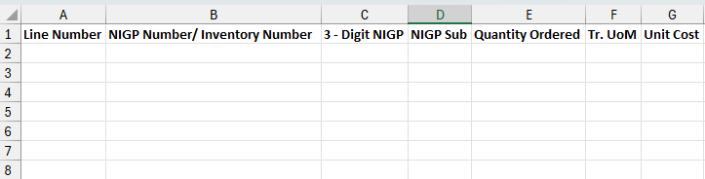
Spreadsheet ready to be used as template for import
Original Exported spreadsheet
To import data into the detail lines of a purchase order, follow steps 1 thru 3, and select the “Import Grid Data” option.
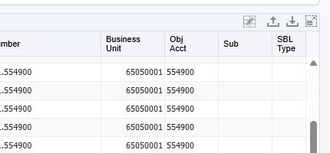
“Import Grid Data” Button
Select the “Browse” option.
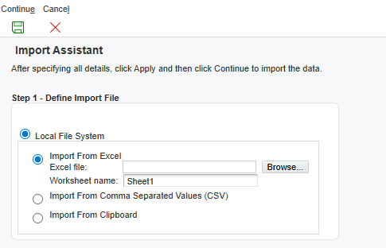
Click the “Choose File” option, select the Excel spreadsheet, and click the “Upload” button. Select the green Continue icon to continue.
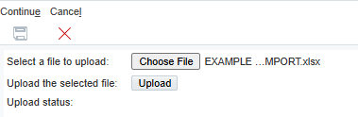
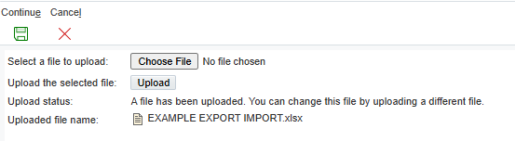
Next, select the starting/ending cells in the Excel document to be imported. Once the starting/ending cells are entered, click the “Apply” button.
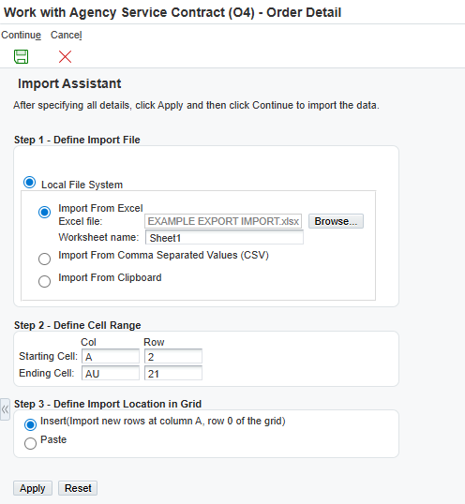
Check that the data pulled from the Excel sheet is correct, and click the green Continue icon.
NOTE: If the cell range needs adjusting, make the changes and click “Apply” to have E1 re-import the selections.
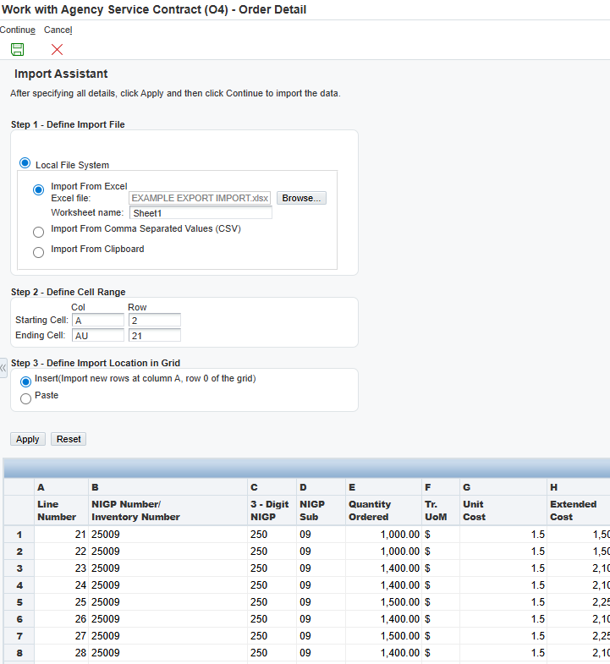
The newly imported lines will be populated in the purchase order. Click the green checkmark at the top of the screen to continue.
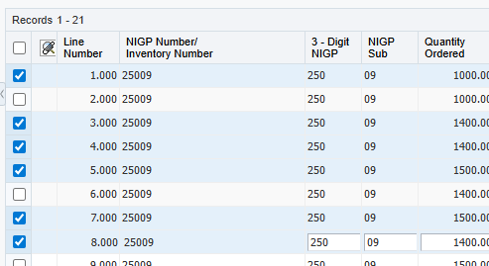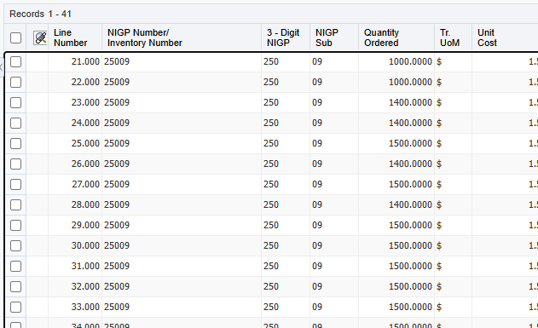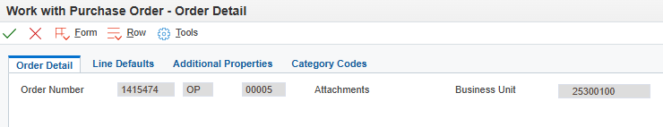
Ending line amount: 41
Starting line amount: 21
A text box will open. Enter the details describing all revisions made, date and initials showing who made the revision(s).

NOTE: It is crucial to note revisions as this allows for the most accurate tracking of revisions made over the life of the purchase order.
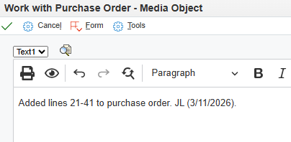
Import/Export Detail Lines in E1: Complete
Click the Red X to close.

