Printing

This guide will demonstrate different methods of printing pre-requisitions, requisitions, purchase orders, contract awards and contract amendments.

To view the steps of a specific process from the guide contents below, expand the steps by clicking the dropdown arrow. To collapse sections, click the dropdown arrow again.
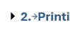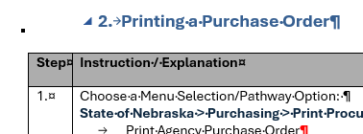
Collapse
Expand

- Printing a Requisition or Pre-Requisition
Step | Instruction / Explanation
Choose a Menu Selection/Pathway Option:
State of Nebraska > Purchasing > Print Procurement Documents > Print Requisition
- Print Requisition
- Print Requisition – Inventory/Floor Stock (ZR)

State of Nebraska > Purchasing > Pre-Requisitions
- Print Pre-Requisition (O7)

The process is the same for printing all requisition & pre-requisition doc types. This guide will demonstrate printing a commodity requisition (OR)
Click the “Data Selection” option and click the Submit button.
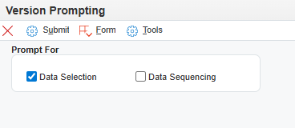
The Data Selection for printing is adjustable; however, default selections accomplish most requests.

NOTE: Further updates will be forthcoming to add newly developed document types that may be missing in the “Order Type” right operand. If the doc type being printed is listed, skip to step 6.
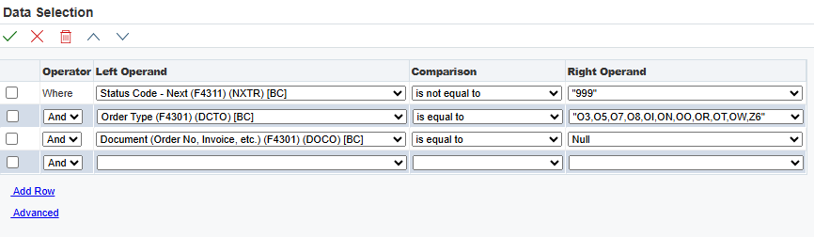
Default Requisition Print Settings
 | Click the Right Operand drop down menu in the Order Type row and select Literal.
Type in the order type to be added and click the green plus button. Click the green checkmark once additions are complete.
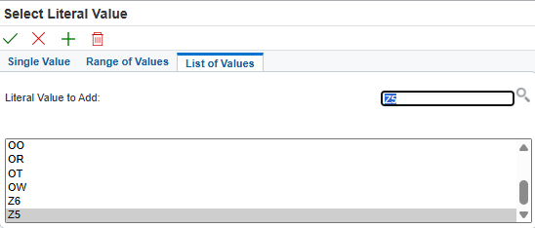
Click the Right Operand drop down in the Document (Order No) row and select Literal.
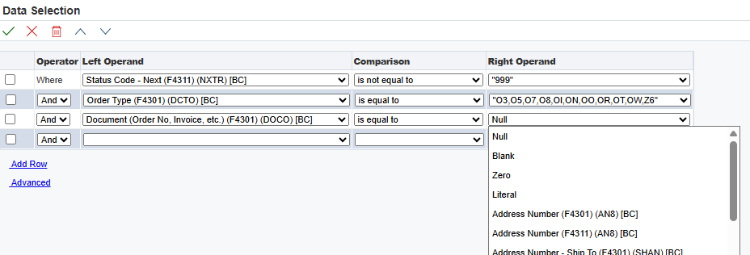
Type in the requisition number and click the green checkmark.
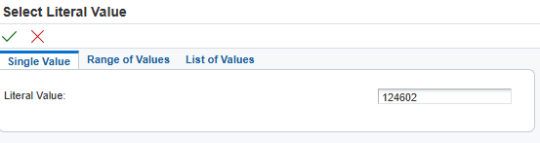
Confirm the correct document number has been entered and click the green checkmark.
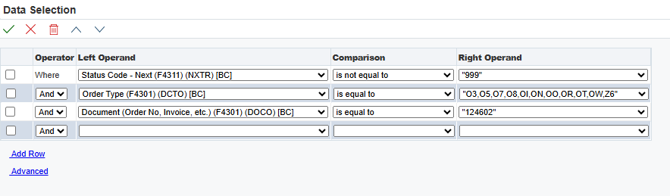
Click the green checkmark.
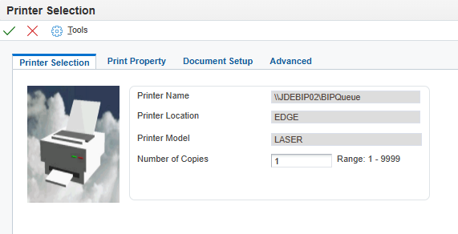
The status of the print job displays in the “Recent Reports” section. If the document is still processing, the graphic will be blue. When the graphic turns green, the document is ready for download. The status of the print job can be viewed by clicking on the order and looking in the “Status Details” field.
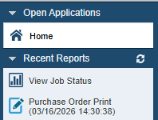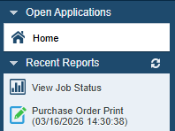
Ready
Processing
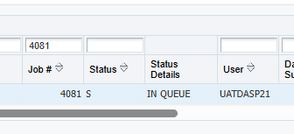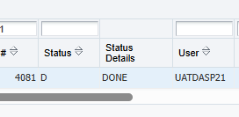
Ready
Processing

An email notification will be sent to the email that is associated with the E1 login executing the print when the print job is finishied processing.
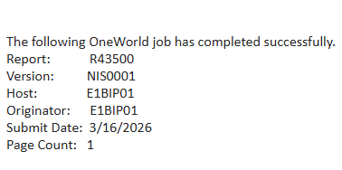
To download the printed document, click the icon in the “View Output” field.

Note: The document will download to the top right of the screen and can also be found in the “downloads” folder of the computer.
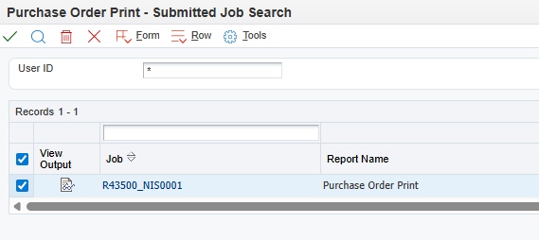
Printing a Requisition: Complete
Click the Red X to close.

- Printing a Purchase Order
Step | Instruction / Explanation
Choose a Menu Selection/Pathway Option:
State of Nebraska > Purchasing > Print Procurement Documents > Print Purchase Order Print Agency Purchase Order
- Print Agency Purchase Order - Change Order
- Print Agency Stock Purchase Order
- Print Agency Stock Purchase Order Change Order All Lines

THE FOLLOWING ARE ONLY VISIBLE TO SPB PERSONNEL:
- Print SPB Purchase Order
- Print SPB Purchase Order - Change Order
- Print SPB Stock Purchase Order
- Print SPB Stock Purchase Order - Change Order

The process is the same for printing all purchase order doc types. This guide will demonstrate printing a commodity purchase order (OP)
 | Click the “Data Selection” option and click the Submit button.
The Data Selection for printing is adjustable; however default selections accomplish most requests.

NOTE: Further updates are forthcoming to add newly developed document types that may be missing in the “Order Type” right operand. If the doc type being printed is listed, skip to step 6.
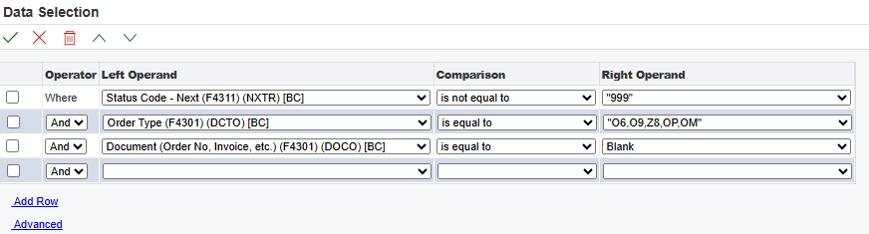
Default Purchase Order Print Settings
 | Click the Right Operand drop down menu in the Order Type row and select Literal.
Type in the order type to be added and click the green plus button. Click the green checkmark once additions are complete.
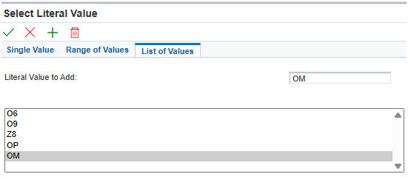
Click the Right Operand drop down menu in the Document (Order No) row and select Literal.
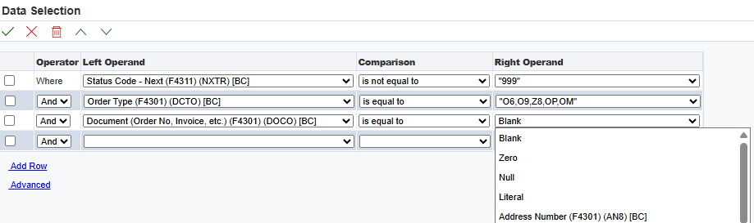
Type in the purchase order number and click the green checkmark.
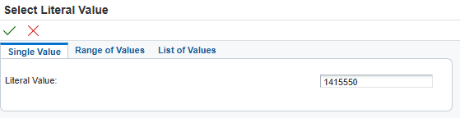
Confirm the correct document number has been entered and click the green checkmark.
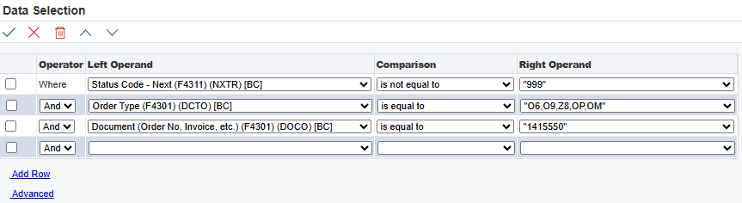
 | Click the green checkmark.
The status of the print job displays in the “Recent Reports” section. If the document is still processing, the graphic will be blue. When the graphic turns green, the document is ready for download. The status of the print job can be viewed by clicking on the order and looking in the “Status Details” field.
Ready
Processing
Ready
Processing
 | An email notification will be sent to the email that is associated with the E1 login executing the print when the print job is finishied processing.
To download the printed document, click the icon in the “View Output” field.

NOTE: The document will download to the top right of the screen and can also be found in the “downloads” folder of the computer.
Printing a Purchase Order: Complete
Click the Red X to close.

- Printing a Contract Award
Step | Instruction / Explanation
Choose a Menu Selection/Pathway Option:
State of Nebraska > Purchasing > Print Procurement Documents > Print Purchase Order
- Print Agency Contract Award

THE FOLLOWING ARE ONLY VISIBLE TO SPB PERSONNEL:
- Print SPB Contract Award

The process is the same for printing all contract doc types. This guide will demonstrate printing an agency service contract (O4) award.
 | Click the “Data Selection” option and click the Submit button.
The Data Selection for printing is adjustable; however, default selections accomplish most requests.
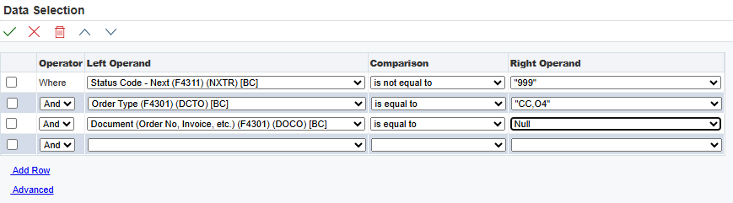
Default Contract Print Settings
Click the Right Operand drop down in the Document (Order No) row and select Literal.
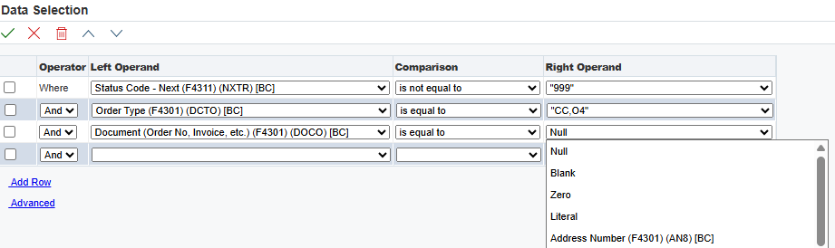
Type in the contract number and click the green checkmark.
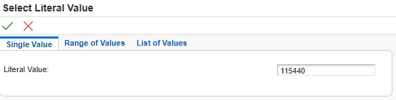
Confirm the correct document number has been entered and click the green checkmark.
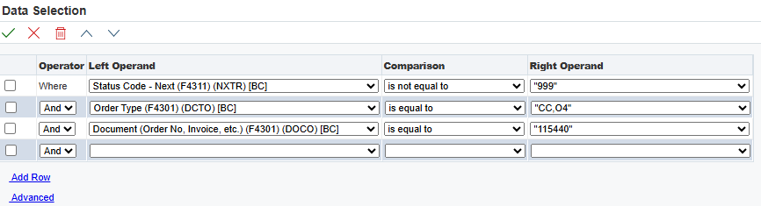
 | Click the green checkmark.
The status of the print job displays in the “Recent Reports” section. If the document is still processing, the graphic will be blue. When the graphic turns green, the document is ready for download. The status of the print job can be viewed by clicking on the order and looking in the “Status Details” field.
Ready
Processing
Ready
Processing
 | An email notification will be sent to the email that is associated with the E1 login executing the print when the print job is finishied processing.
To download the document, click the icon in the “View Output” field.

NOTE: The document will download to the top right of the screen and can also be found in the “downloads” folder of the computer.
Printing a Contract Award: Complete
Click the Red X to close.

- Printing a Contract Amendment
Step | Instruction / Explanation
Choose a Menu Selection/Pathway Option:
State of Nebraska > Purchasing > Print Procurement Documents > Print Contract
- Print Agency Contract Amendment

THE FOLLOWING ARE ONLY VISIBLE TO SPB PERSONNEL:
- Print SPB Contract Amendment

The process is the same for printing all contract doc types. This guide will demonstrate printing an agency service contract (O4) amendment
 | Click the “Data Selection” option and click the Submit button.
 | Click the Right Operand drop down in the Document (Order No) row and select Literal.
Type in the contract number and click the green checkmark.

NOTE: Contract structure determines the complexities on what contract lines to print for an amendment. If printing all open lines and there is no unique structure forcing a line by line custom print then proceed to step 10.
To print specific contract lines, select the left operand drop down and select “Line Number.” Click the comparison drop down, select “is equal to,” and click the Right Operand drop down and select “Literal.”
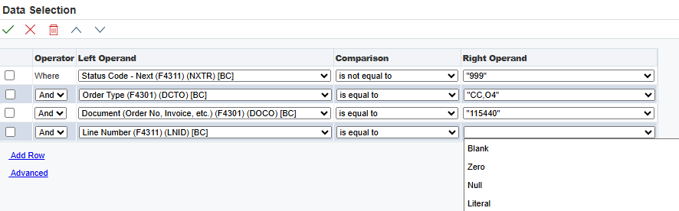
Click the “List of Values” tab.
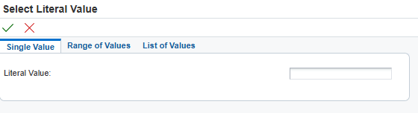
Input the line numbers (one at a time) to be populated in the “Literal Value to Add” field and click the green plus to add them to the “List of Values.” Once all desired lines are populated to the list, click the green checkmark.
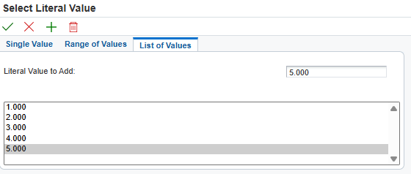
List of Line Numbers
Click when finished
Click to add to list
Input numbers here
 | Confirm the correct document number has been entered and click the green checkmark.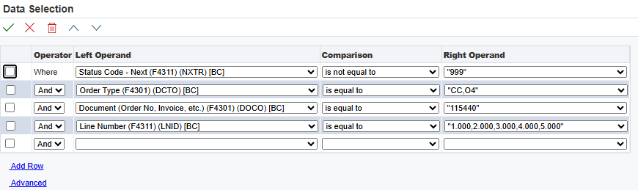
 | Click the green checkmark.
The status of the print job displays in the “Recent Reports” section. If the document is still processing, the graphic will be blue. When the graphic turns green, the document is ready for download. The status of the print job can be viewed by clicking on the order and looking in the “Status Details” field.
Ready
Processing
Ready
Processing

 | An email notification will be sent to the email that is associated with the E1 login executing the print when the print job is finishied processing.
To download the document, click the icon in the “View Output” field.

NOTE: The document will download to the top right of the screen and can also be found in the “downloads” folder of the computer.
Printing a Contract Amendment: Complete
Click the Red X to close.

