

Generating a Master Lease Purchase Order (ML)
from a Copied Contract (ZC)

- Overview
The following information outlines the process in E1 for creating a Master Lease, which includes: copying a contract, revising the copied contract, then generating the Master Lease purchase order. The example below uses an OC contract for copying, however O4 contracts may also be used for this process.
An ML order type approval route will need to be added for the order creator prior to generating the Master Lease Purchase Order. Approval routes should be requested through the State Purchasing Bureau at AS.MaterielPurchasing@nebraska.gov.

You will need the following information to begin:

- Tranche #
- Vendor
- Order # of the OC Contract you will be copying
- Cancel Date of the OC Contract you will be copying
- Business Unit
- Object Code (ML documents use a fixed asset object code, or a capital outlay object code beginning with 58)

- Copy the OC Contract to Make a ZC
- From the E1 navigator, select the following menu path:
State of Nebraska > Master Lease – Agency > Master Lease Process > Copy Blanket ZC from Contract > Copy Blanket (ZC) from SPB Commodity Contract (OC)
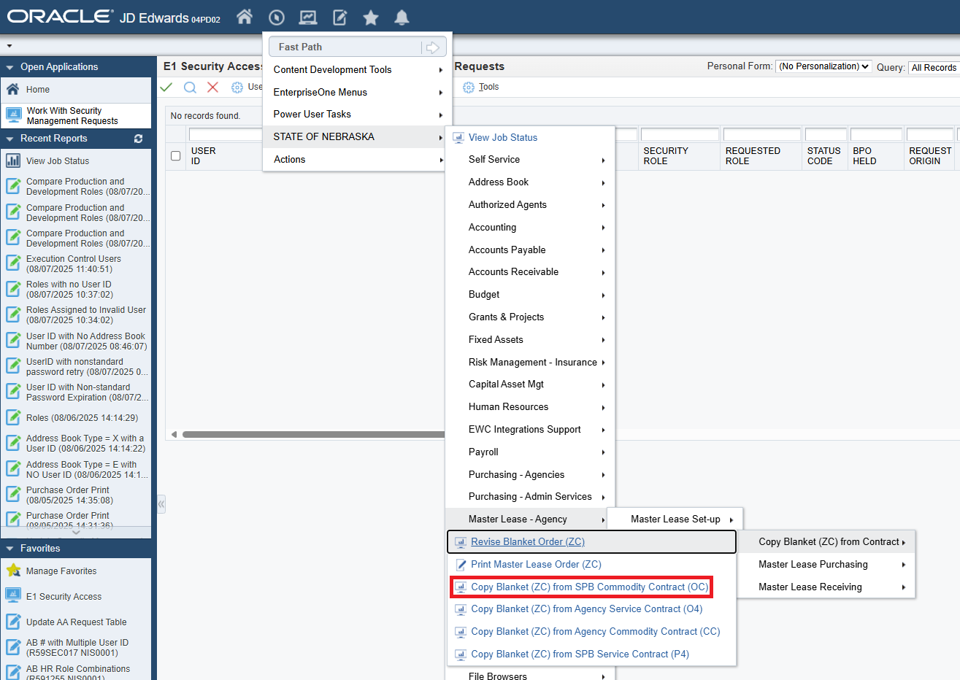

- Select Copy Blanket (ZC) from Contract (OC/O4)
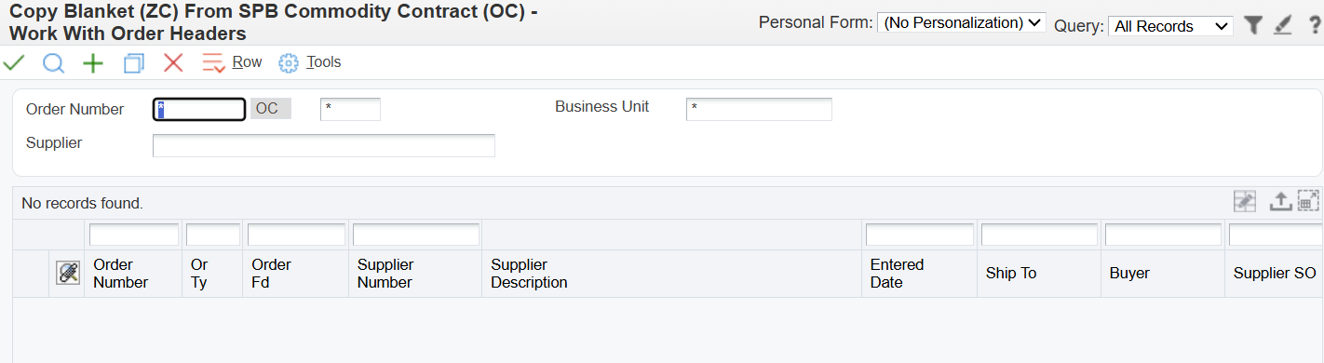
- In the Order Number field, enter the Contract # that will be copied
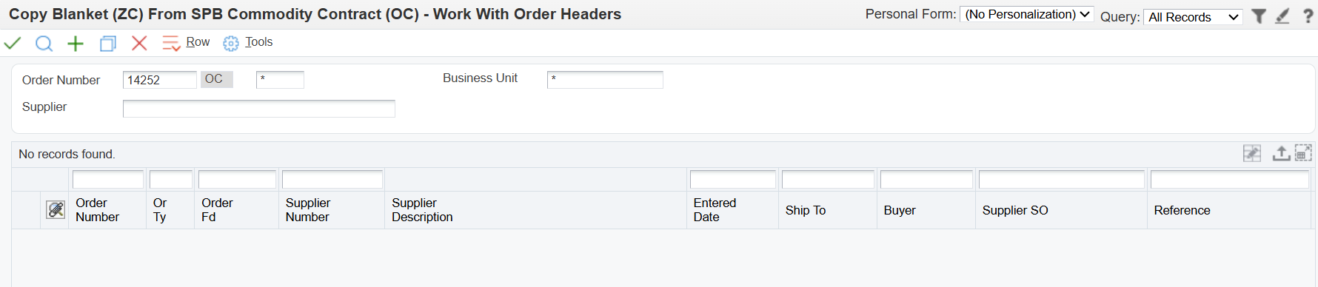
- Click the magnifying glass icon to search
  - If more than one record, select the appropriate contract you wish to copy
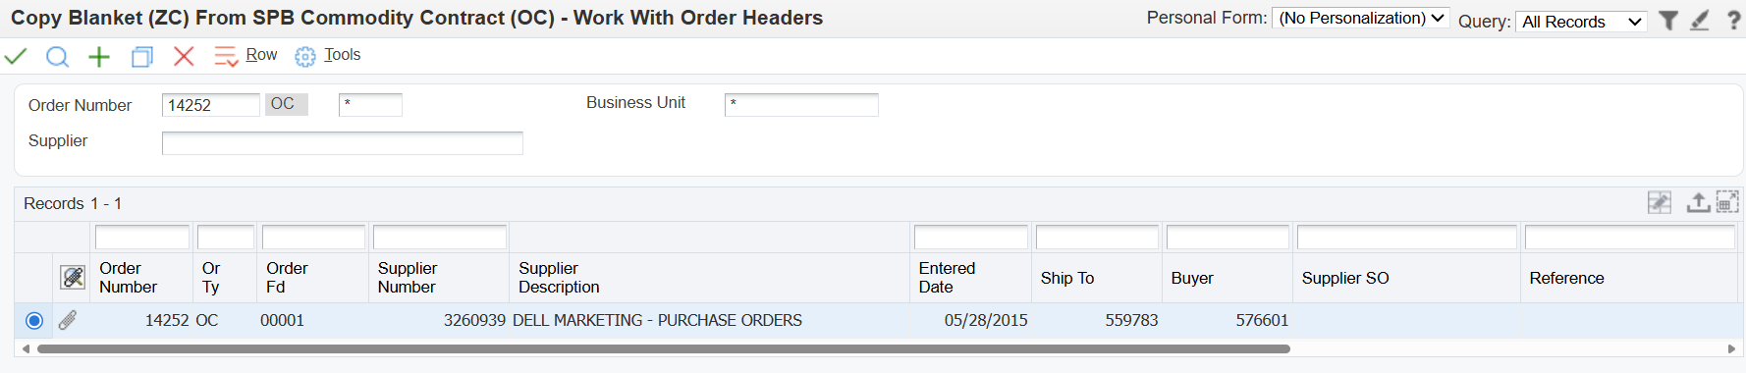
- Click the green checkmark icon
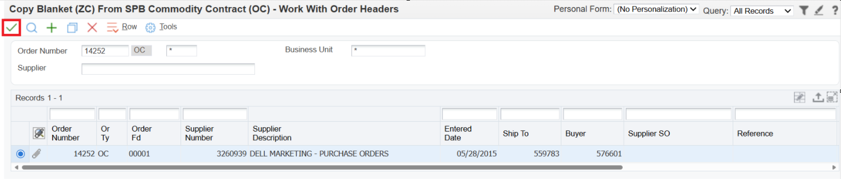
- Review the header information of the contract and make a note of the contract end date
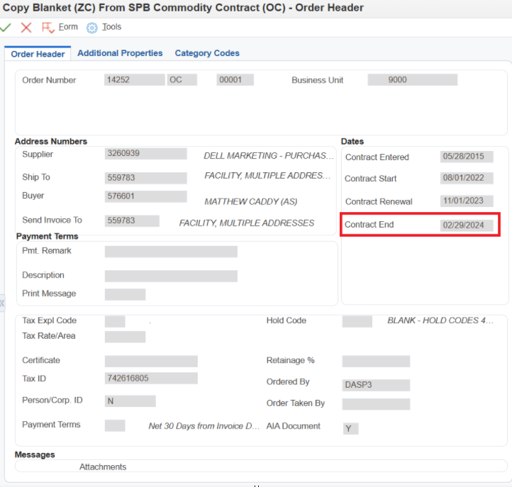
- Click the green checkmark icon to review the detail lines of the contract
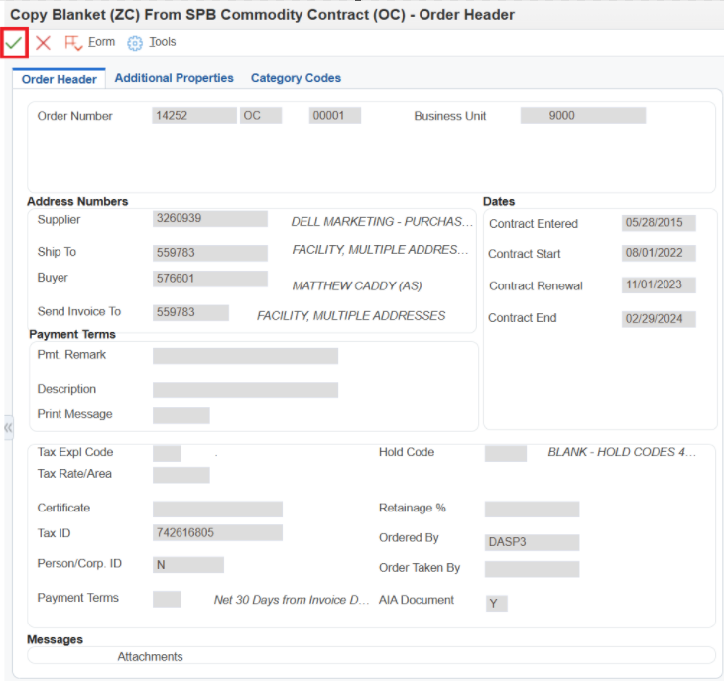
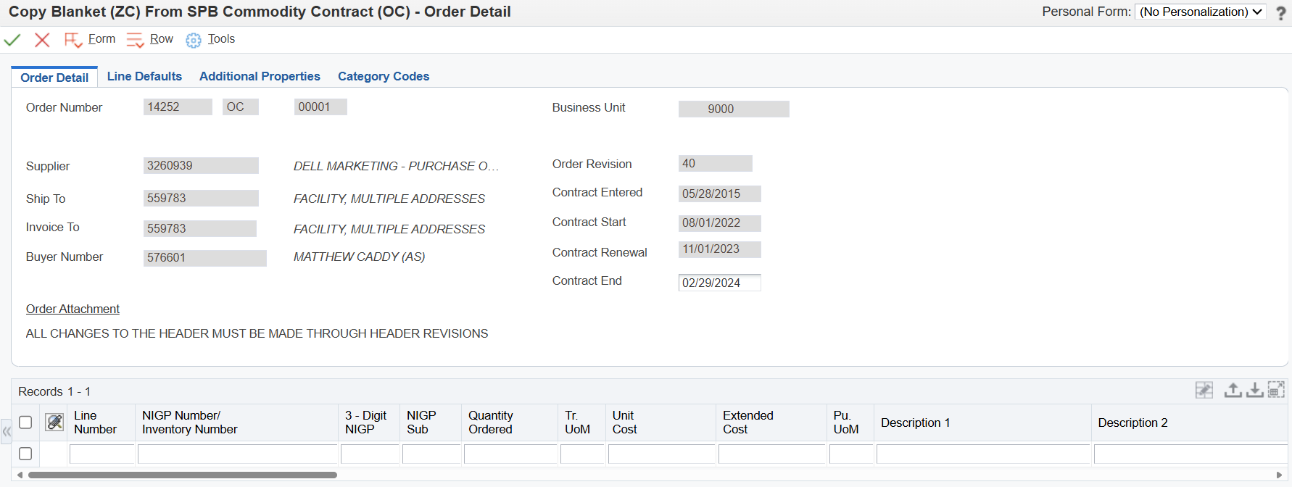
- Click the Red X icon to return to the contract copying screen
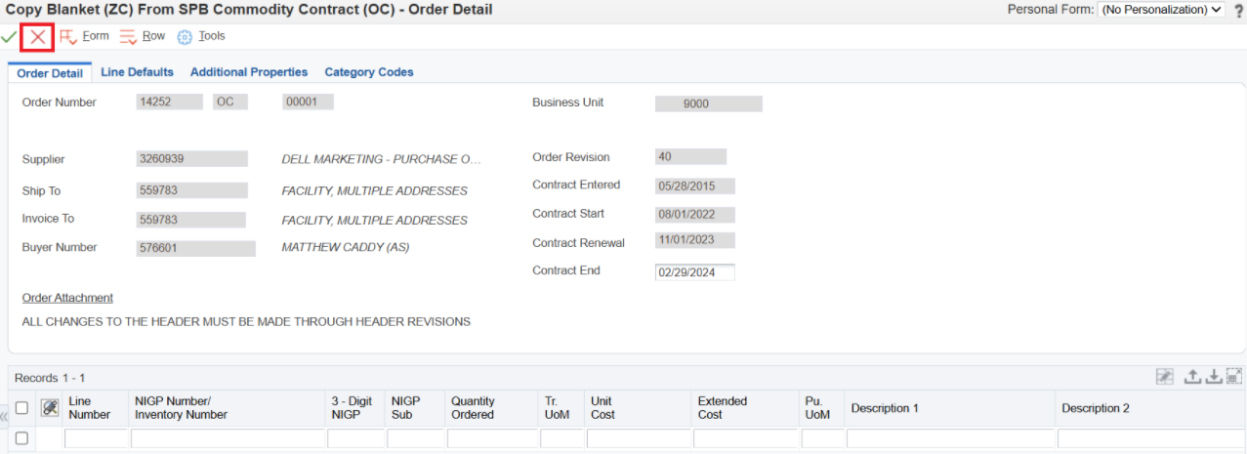
- Select the appropriate contract record again (should already be selected)
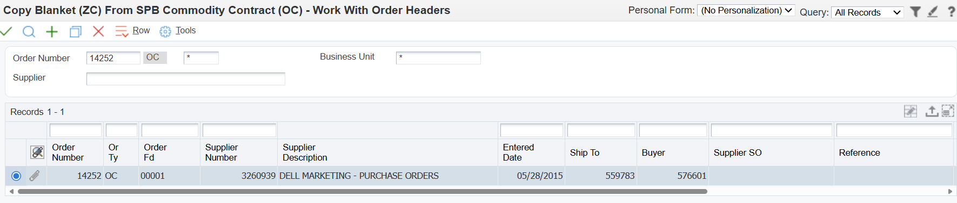
- Click the Copy icon
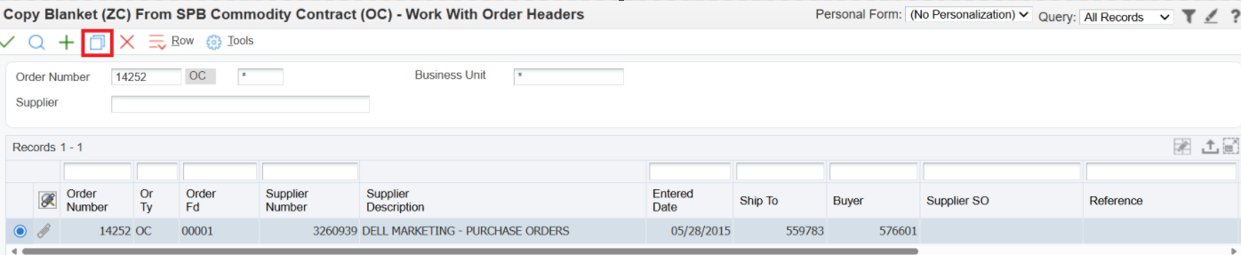
- In the Order Detail tab, enter the following information (there will be no changes to the Line Defaults or Category Codes tabs):
  - Order Number: Leave blank
  - Business Unit
  - Ship To AB#
  - Invoice To AB#
  - Buyer AB#
  - Contract Dates – do not change
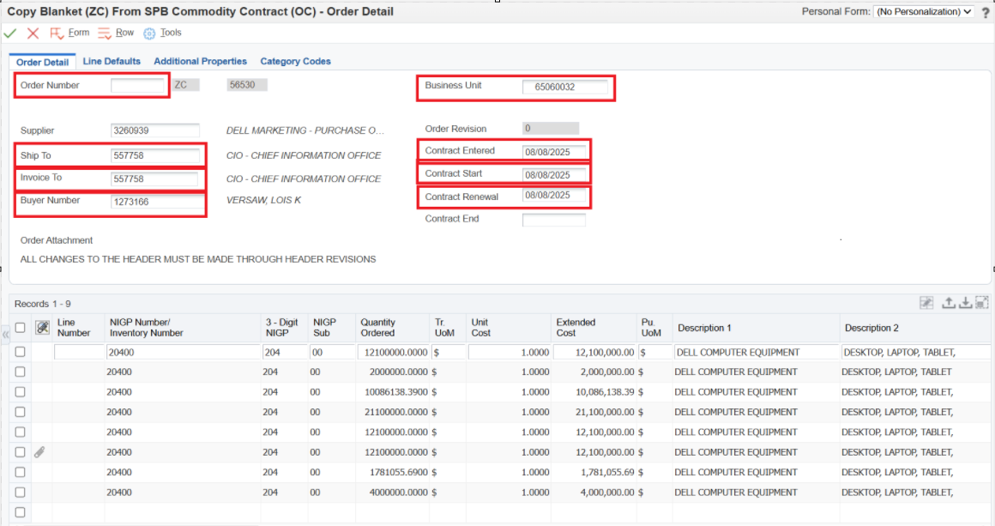

- Select the Additional Properties Tab and enter the following information:
  - Document Description: Blanket Order for Master Lease
  - Document Location AB #
  - Document Contact AB #
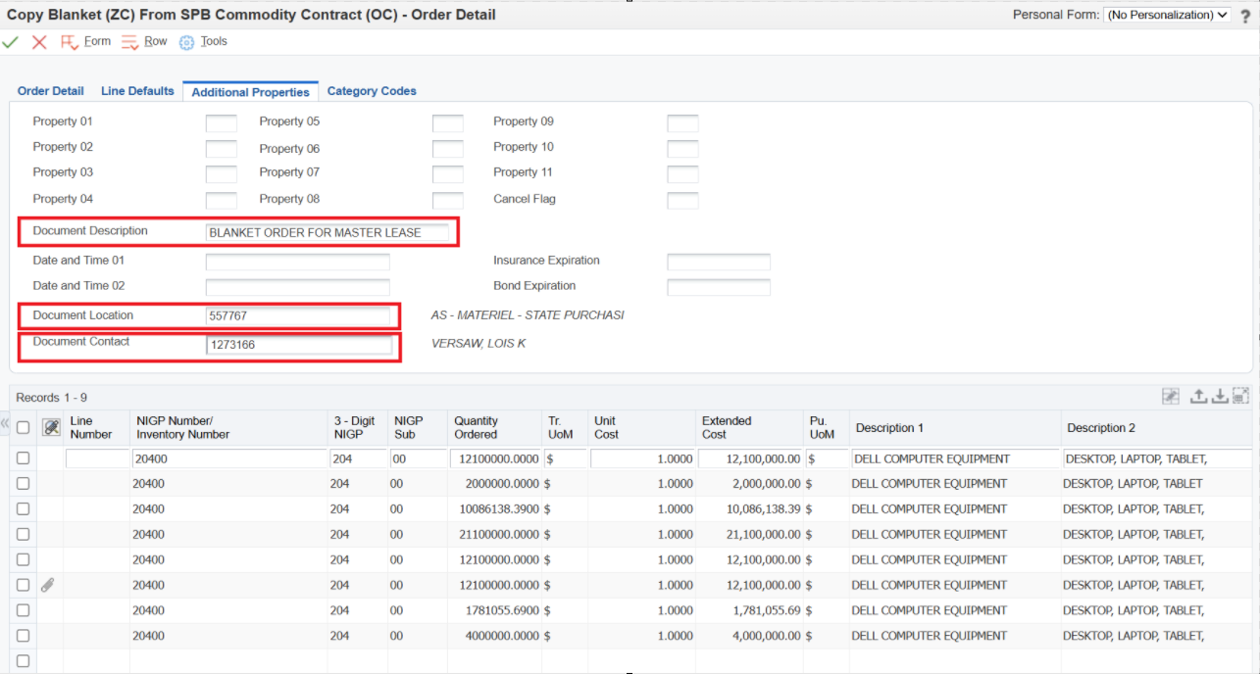
- Return to the Order Detail Tab of the document. Do not click the green checkmark yet.
Reminder: do NOT use the Tab key for the remainder of the Section II instructions. You will need to point and click into each field you wish to edit.
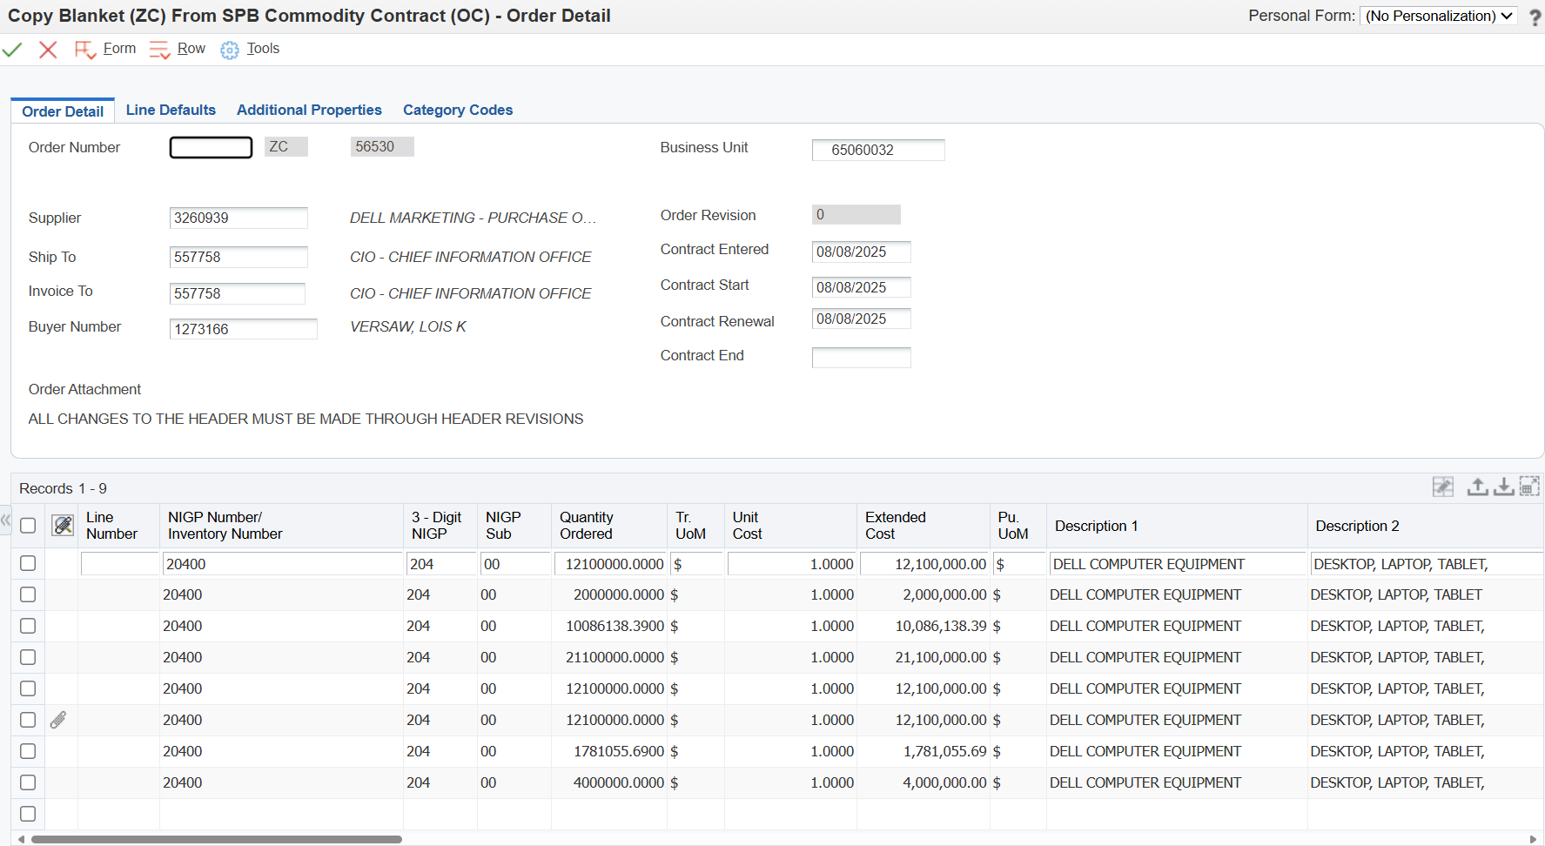

- You will now make changes to the detail lines of the contract.
Do not click out of the detail line you are working with until you have made all necessary changes. You will not be able to revise all fields once you have clicked away from your current line.

- Make a note of the 5-digit NIGP number.
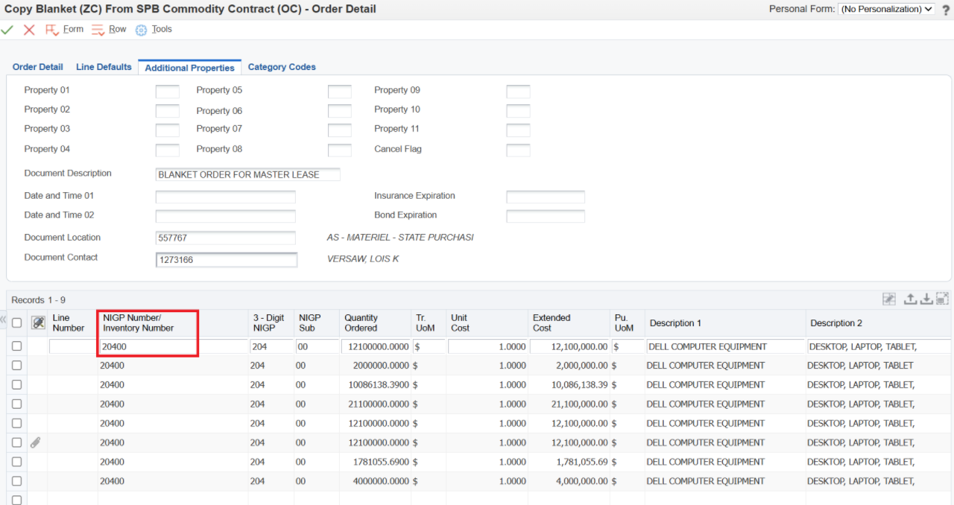
- In the first 5-digit NIGP number field, replace the current NIGP code with the Master Lease Tranche number. (Ex. 2025B.1.1)
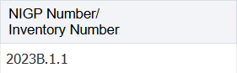
- Revise the two and three-digit NIGP sub fields to match the NIGP codes that were previously in these fields before entering the tranche # in the previous step.

The system will default the two-digit NIGP Sub to ML, it will only let you change the 3-digit NIGP here. You will need to change it to “00” or the corresponding sub that matches the 5-digit NIGP when generating a ML PO.

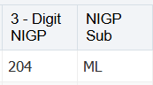

- In the Quantity Ordered field, enter the value of your purchase.

If this is a commodity purchase, make sure the dollar amount entered is $1 greater than total amount of your order.
If you will be generating multiple POs for the same vendor and using the same tranche, you may enter an estimated dollar amount that will cover future orders. Multiple PO’s can be generated from the same ZC.
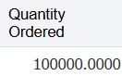
- Delete the information in the following fields, if not already blank:
  - Extended Cost
  - Descriptions 1 & 2
  - Account Number
  - Business Unit
  - Object Code
  - Sub
  - SBL Type
  - Subledger

- In the Line Type field, change the Line Type from a “J” to an “N”
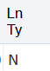
- In the Exception Request field enter “SW” for statewide
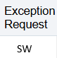

- Delete the information in the following fields, if not already blank:
  - Report Code 4
  - Tag Number
  - Invoice To
  - Ship To
  - Buyer Number
  - Contract Entered Date
  - Contract End Date
  - G/L Date

- Click on the detail line below to apply all changes

- Take note of the new ZC order number
- Click on the green checkmark icon to save your ZC

- Revise the New ZC Contract
- From the E1 navigator, select the following menu path:
State of Nebraska > Master Lease – Agency > Master Lease Process > Blanket (ZC) from Contract (OC or O4) > Revise Blanket Order (ZC)
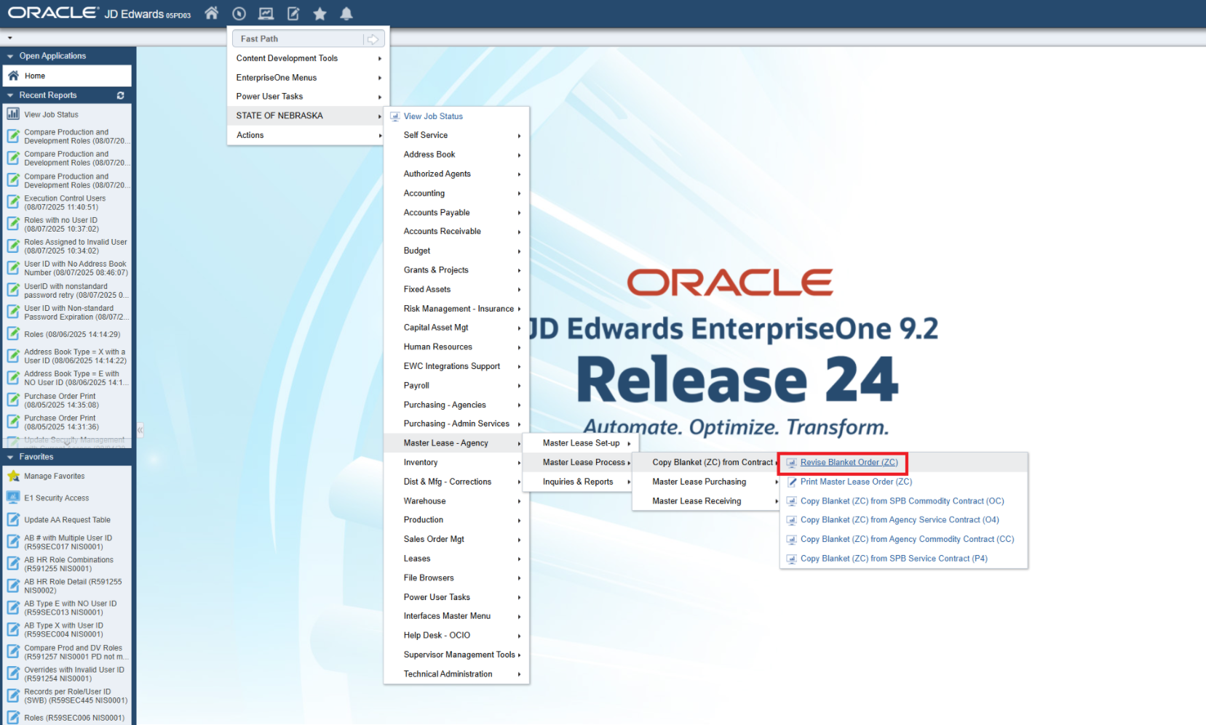

- Enter the new ZC number in the Order Number field
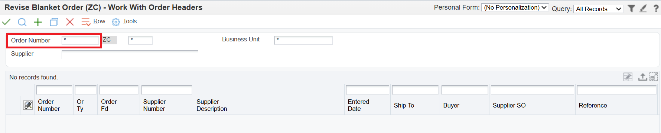
- Click on the magnifying glass icon to search
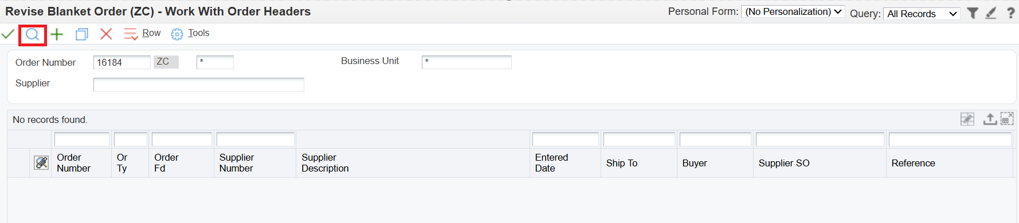
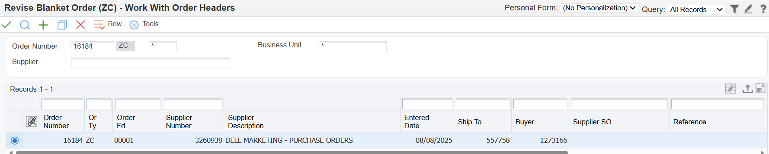

- Select the new ZC, and click the green checkmark icon to view the Header of the ZC contract
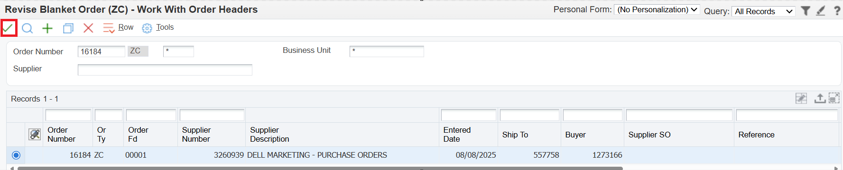

- In the Order Header tab enter the following information:
  - Supplier number (this will not be changed unless you are purchasing from an authorized 3rd party vendor)
  - Contract Entered & Start Date – this will default to today’s date
  - Contract Renewal Date – leave blank
  - Contract End date – use Contract End Date from original contract
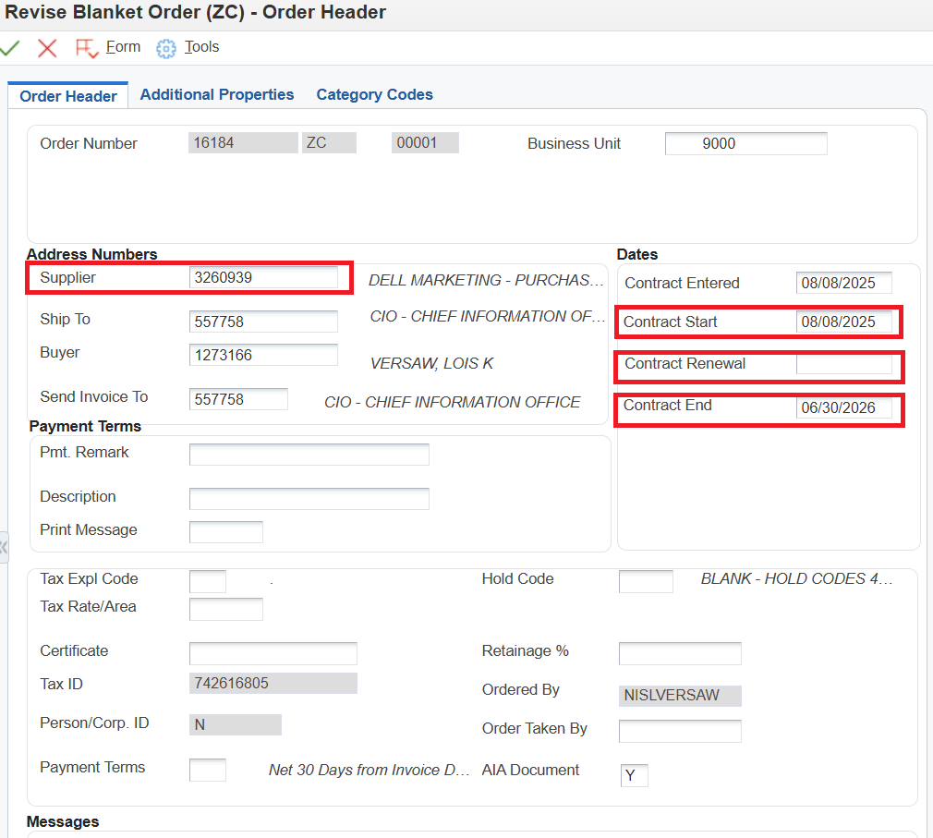

- In the Additional Properties tab enter the following information:
  - In the Document Description field, enter:
“Master Lease Tranche 20##.X.#.#”
Example: Master Lease Tranche 2023B.1.1
  - Document Location – enter OCIO AB# 557758
  - Document Contact – enter buyer AB#
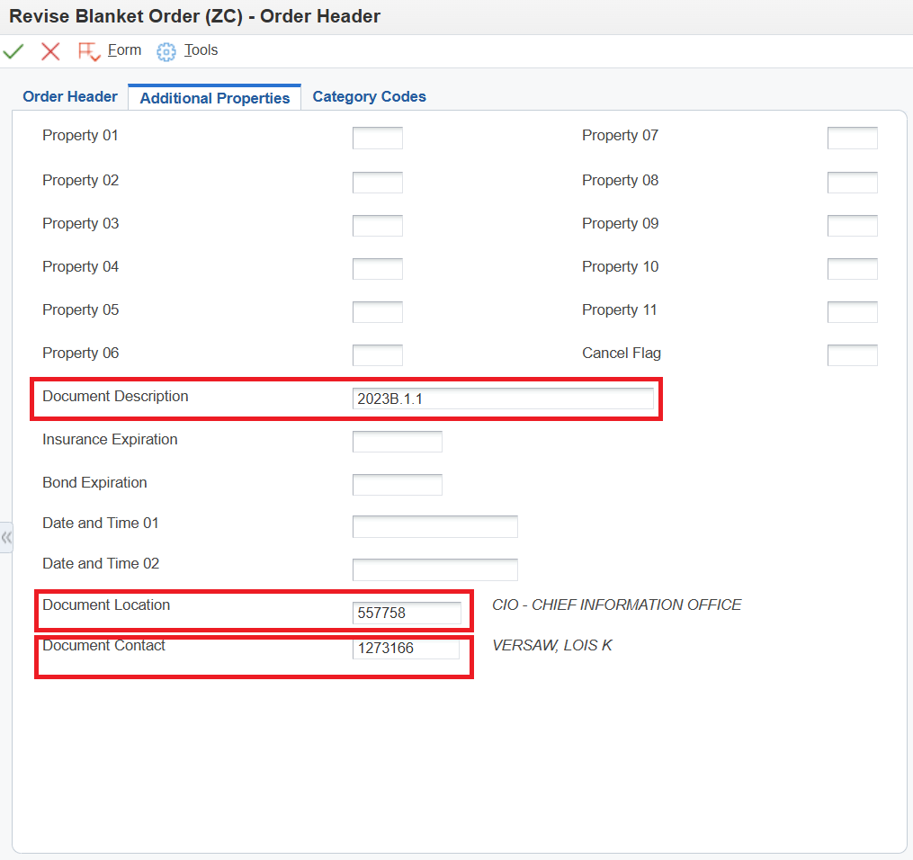
- Click on the green checkmark icon to view the detail lines of your ZC
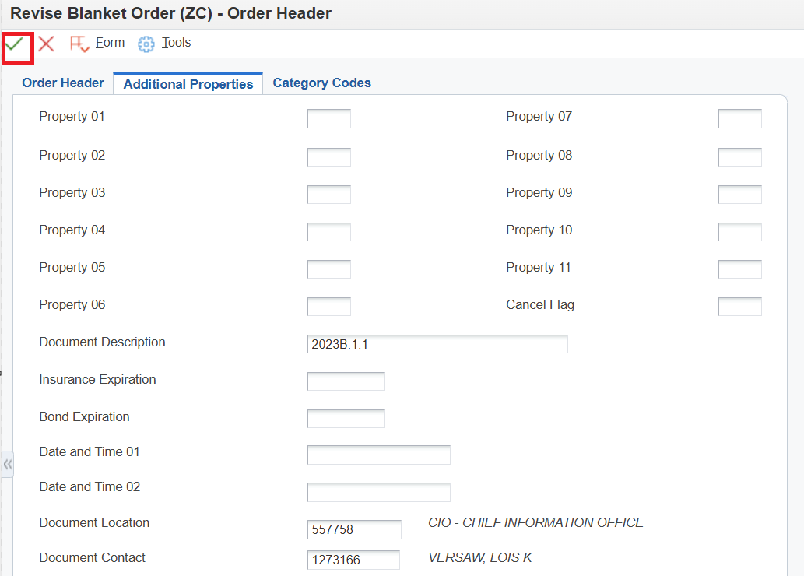

- If the copied contract has multiples lines, cancel the unnecessary lines by selecting each line, then click on Row at the top and choose Cancel Line from the drop-down menu.
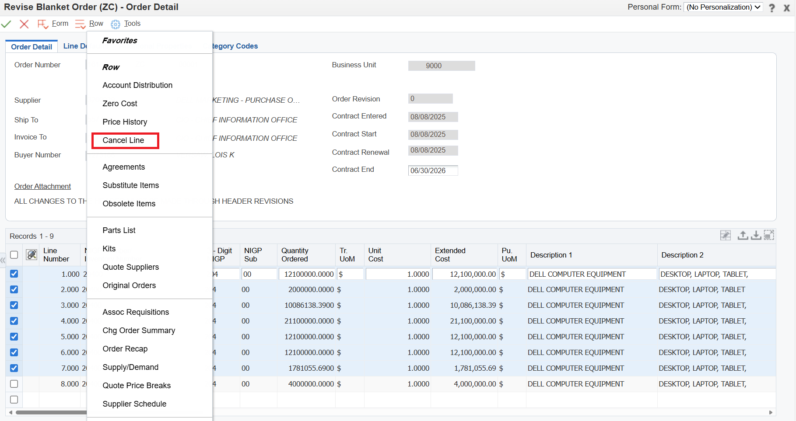

- Click on the green checkmark icon to save the changes to the ZC.
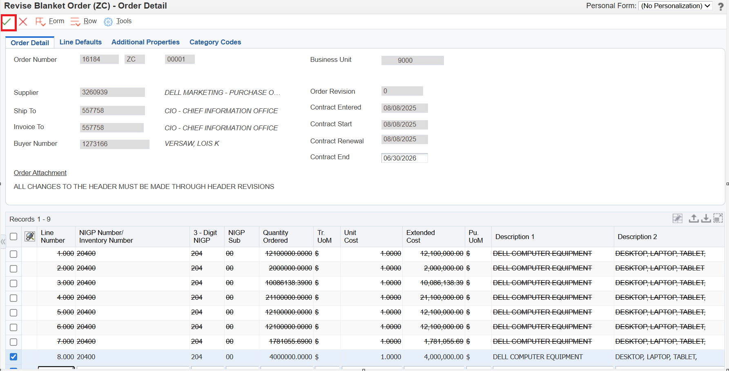

- Document the changes made in the “Media Object” box that opens. Include your initials and the date.
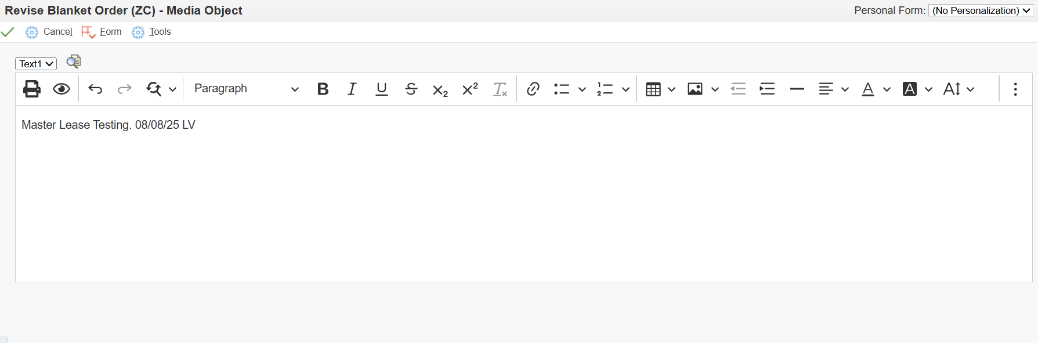

- Click the green checkmark icon to save your order revision comments.
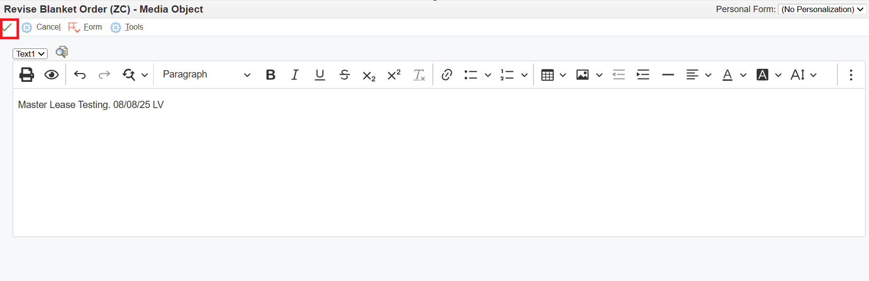

- Generate the Master Lease (ML) Purchase Order
- From the E1 navigator, select the following menu path:
State of Nebraska > Master Lease – Agency > Master Lease Process > Master Lease Purchasing > Gen Master Lease (ML) from Contract (ZC)
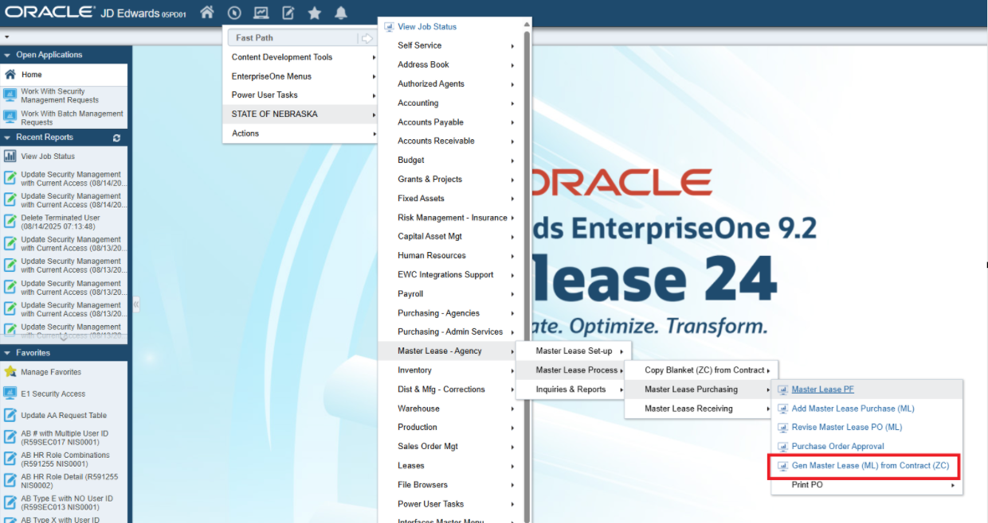

- Enter your ZC in the Order Number field
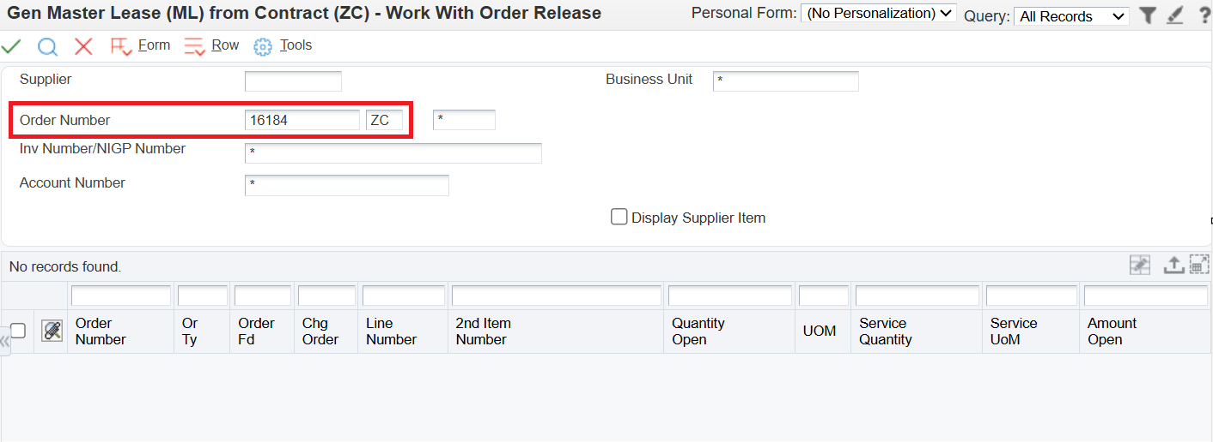

- Click the magnifying glass icon to search
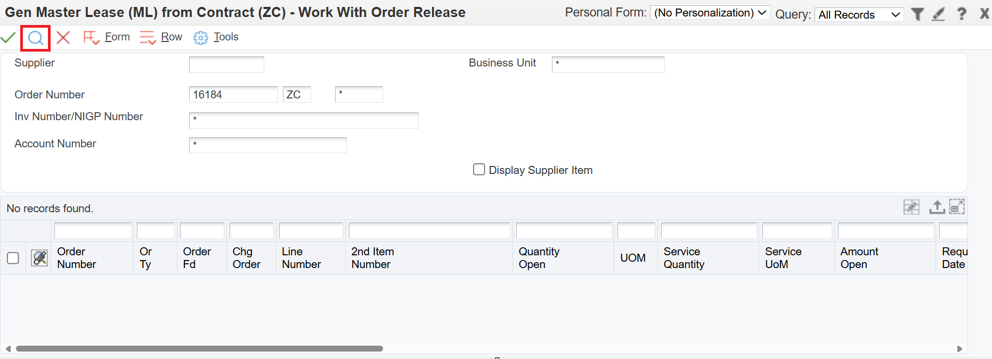
- Click the green checkmark icon to release from ZC contract line
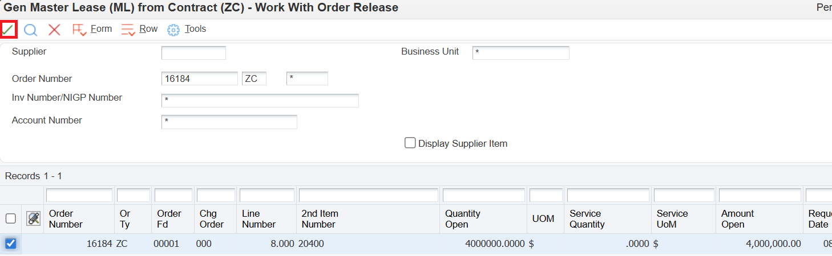

- Enter the appropriate Buyer, Ship To and Business Unit
Most of this will populate from the information you entered in the Order Detail tab while in the process of copying the OC contract. You may need to add the ship to AB# back in.
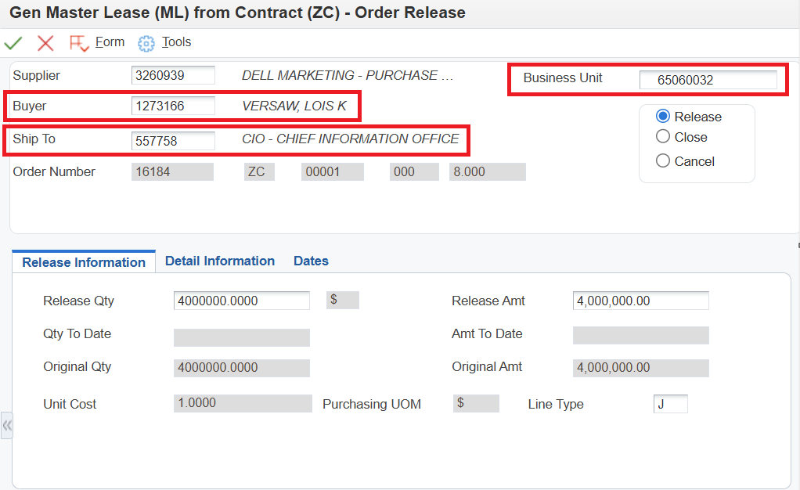

- Review the Release Qty field.
This should match the amount you entered for your Quantity Ordered when you were in the process of copying the OC contract. If generating multiple orders from the same ZC, you will want to change the Release Qty to match the individual quote you are basing your current order on.
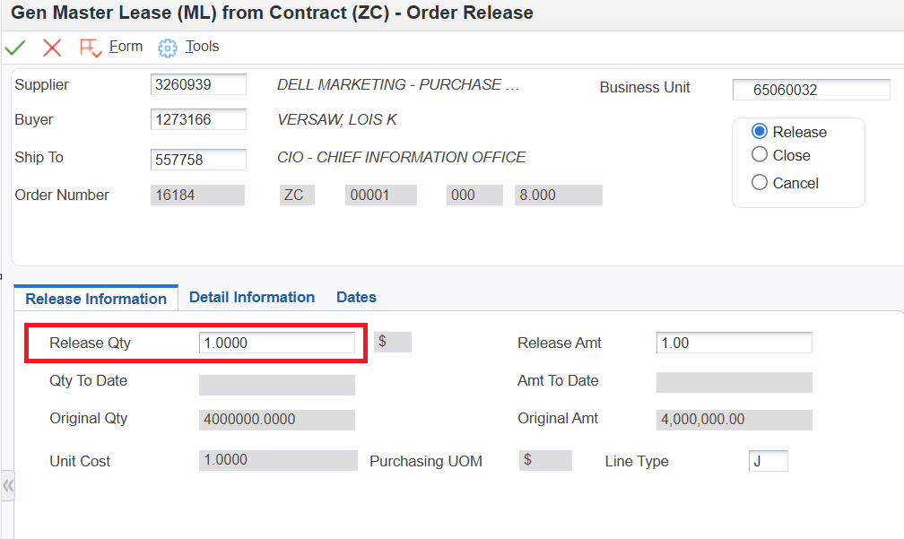

- Click the Detail Information tab
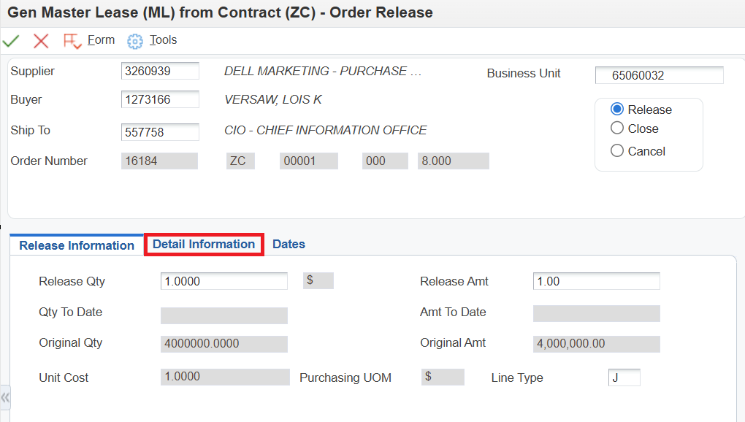

- In the Account Number field, enter: Business Unit.Object Code
Example: 65060032.554900
When purchasing with ML funds, all items purchased must be considered capital assets and should be coded accordingly with a capital outlay object that begins with a “58”
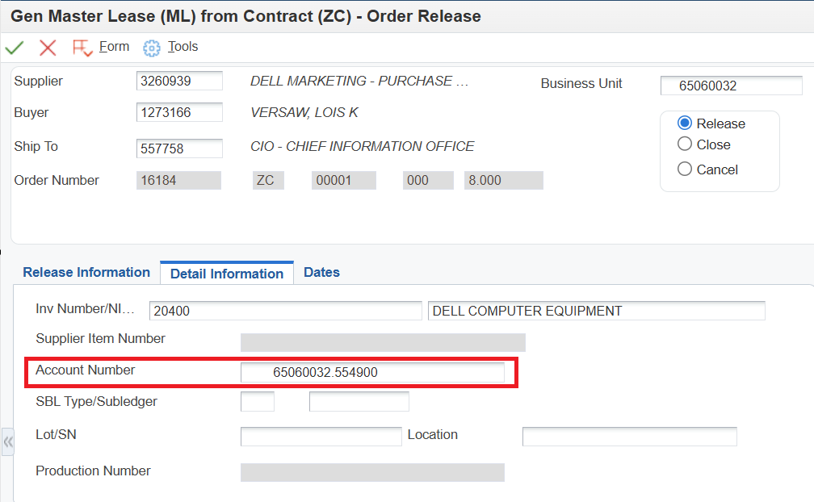

- Click the Dates tab, and remove the Cancel Date if not already blank
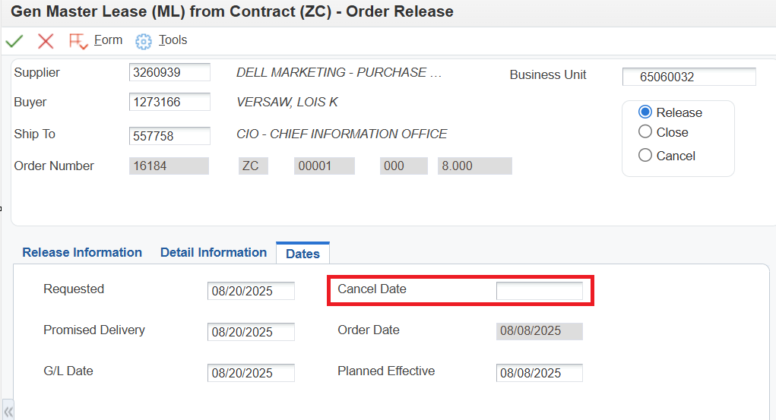
- Review & confirm release information

- Click the green checkmark icon to save order release
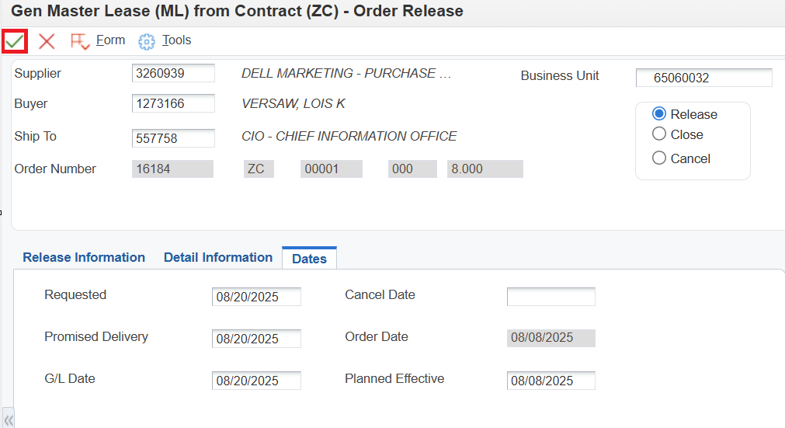
- You will then return to the initial Work with Order Release screen
- Click on Form
- If you want to confirm your BU.OBJ and/or amount was entered correctly click on Review Order, otherwise click on Generate Order
- The Generated Purchase Orders screen will open - take note of your PO number
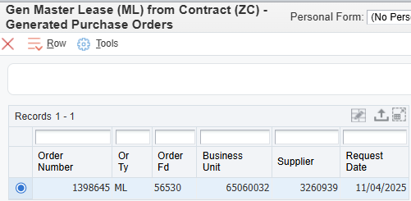
- Close out of the application by clicking the red X icon on the left-hand side

- Revise the New PO
- From the E1 navigator, select the following menu path:
State of Nebraska > Purchasing – Agencies > Print Procurement Documents – Agency > Work with Purchase Order
- Enter the new ZC number in the order number field
- Click the green checkmark icon
- Click on the Header Revisions button
- Remove the Cancel date
- Select Form, then Order Addresses
- Select the radio button for Ship To
- Enter any changes needed to the shipping address
- Click on the green checkmark icon
- Select Form, then Attachments
- Select the File attachment icon and upload your quote
- Select the Text attachment icon and enter the following text:
“Per Terms and conditions of contract ##### XX”
(insert the OC or contract number and type you copied)
“Per Quote# #######” (insert your vendor quote number)
“ML Tranche# 20##.X.#.#” (insert your tranche number)”
- Click on the green hard disk icon to save the text attachment
- Revise any header information if necessary - specifically the Supplier (if purchasing from a reseller or authorized dealer for the vendor of the copied contract) Ship to, Buyer and Send Invoice to fields
- Click on the green checkmark icon to save changes to the header and go to the detail revisions screen
- Leave the tranche number in the 5-digit NIGP field, but change the 3- and 2-digit numbers back to the original numbers used on the contract
  - If you have multiple lines to enter, you will be required to change the line type from “J” to “N” for every additional line after line 1. The first line will populate with the “N”
- Click on the green checkmark icon to save changes to the detail lines
- Document the changes made in the “Media Object” box that opens - include your initials and the date
- Click on the green checkmark icon to save your order revision comments
- Print your PO by clicking on Print Document button

