Contracts

Before purchasing a commodity or service, please ensure you are familiar with the Procurement Manual and Policies on the AS Materiel Division, State Purchasing Bureau website to determine what processes and restrictions may apply to your procurement.

This guide will go over the process of generating a contract from different document types and how to make edits and changes to the generated contract.

NOTE: The original requisition or contract that is being generated from MUST be fully approved in the system prior to generation of the new contract. Any edits or changes made to a requisition or contract will resend the document for approvals.

To view the steps of a specific process from the guide contents below, expand the steps by clicking the dropdown arrow. To collapse sections, click the dropdown arrow again.
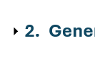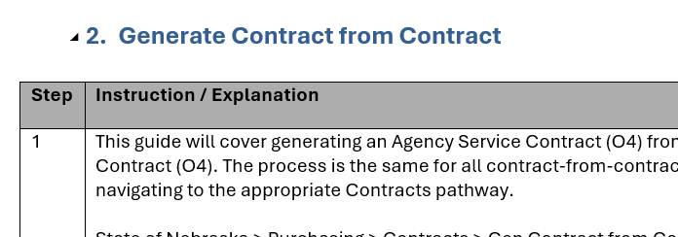
Expand
Collapse

- Generate Contract from Requisition
Step | Instruction / Explanation
Choose a Menu Selection/Pathway Option:
State of Nebraska > Purchasing > Contracts > Gen Contract from Requisition
- Gen Agency Service Contract (O4) from Agency Processed RFP (O3)
- Gen Agency Service Contract (O4) from SPB Processed RFP (O5)
- Gen Agency Service Contract (O4) from Service Exempt Requisition (Z6)
- Gen Agency Service Contract (O4) from IT Commodity/Service Requisition (ON)
- Gen Agency Service Contract (O4) from Exception Request (O8)
- Gen Agency Commodity Contract (CC) from Commodity Requisition (OR)
- Gen Agency Commodity Contract (CC) from Commodity Exempt Requisition (Z5)
- Gen Agency Commodity Contract (CC) from IT Commodity/Service Requisition (ON)
- Gen Agency Commodity Contract (CC) from Exception Request (O8)

THE FOLLOWING ARE ONLY VISIBLE TO SPB PERSONNEL:
- Gen SPB Service Contract (P4) from Agency Processed RFP (O3)
- Gen SPB Service Contract (P4) from SPB Req (O5)
- Gen SPB Service Contract (P4) from Service Exempt Requisition (Z6)
- Gen SPB Service Contract (P4) from IT Commodity/Service Requisition (ON)
- Gen SPB Service Contract (P4) from Exception Request (O8)
- Gen SPB Commodity Contract (OC) from Commodity Requisition (OR)
- Gen SPB Commodity Contract (OC) from Commodity Exempt Requisition (Z5)
- Gen SPB Commodity Contract (OC) from IT Commodity/Service Requisition (ON)
- Gen SPB Commodity Contract (OC) from Exception Request (O8)

The process is the same for all contract-from-requisition document types. This example will demonstrate generating an agency service contract (O4) from an agency processed RFP (O3)

NOTE: For instructions on how to add attachments to a contract see Adding Attachments to Contract
Enter the Requisition number into the order number field and click the “Find” button (magnifying glass).
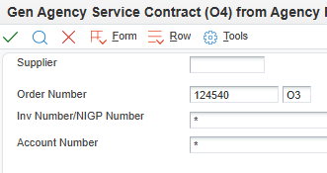
If the requisition has multiple lines, be sure to select all appropriate lines and click the green checkmark.

NOTE: If there are more than 10 lines, all lines must be expanded. If all lines are not expanded, clicking the “select all” option will only select the lines visible on screen, and will not pull from the unexpanded lines.

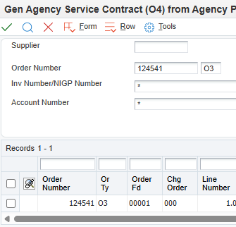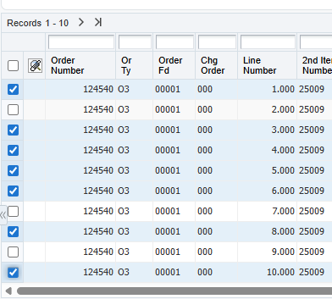
Select All
Expand all lines
Multiple Lines
Single Line
Review and update Header Information as necessary.
- Supplier - Enter the Address Book number (AB#) of the vendor being purchased from.
  - Should typically be a “V” (Vendor), “AG” (Agency), or “VP” (Political Subdivision) Address Book type.
  - NOTE: This should NEVER be an “E” or “FD” Address Book type.
- Ship To – Enter the Address Book number of the address where items are to be delivered or services are to be performed.
  - The Ship To Address Book number will automatically populate the Send Invoice To field.
  - Should typically be an “F” Address Book type.
- Buyer - Enter the Address Book number for the individual primarily responsible for the contract at the Agency.
- Business Unit- Enter the Business Unit responsible for the contract.

NOTE: Additional Header Information, including dates, may need to be updated through the appropriate Work with Contract pathway after generation.

Example of Header Information
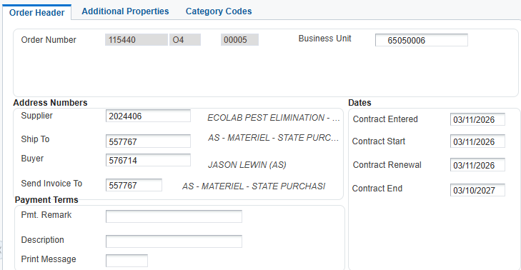

Check the release quantity to ensure it lists the correct amount to be released from the requisition. By default, the entire amount on the line will release unless adjusted.
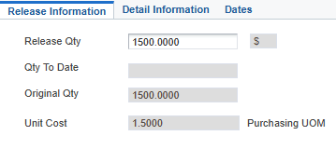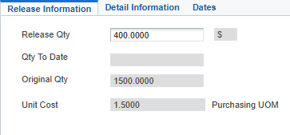
Full Amount
Adjusted Amount
Once you have adjusted the quantity (if needed), click the green checkmark.

If releasing multiple lines, adjust the quantity amounts as necessary and click the green checkmark for each individual line. The next line’s “release” screen will automatically cycle from line to line when the green checkmark has been clicked until all selected lines have been released.
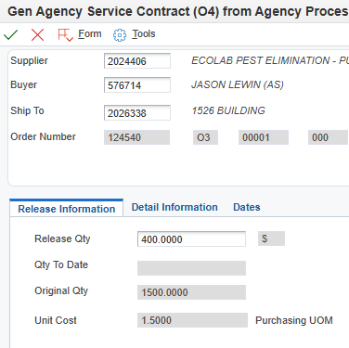
NOTE: It is recommended to make updates to the Header Information through the appropriate Work with Contract pathway after generation.
To review the order, Click the “Form” tab, and click the “Review Order(s)” option.
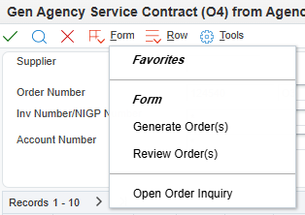
Next, click the “Row” tab, and click the “Details” option.
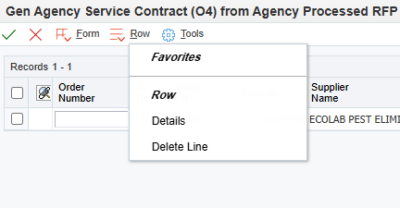
Review the quantities and adjust if necessary. Once the review is complete and any adjustments are made, click the green checkmark.

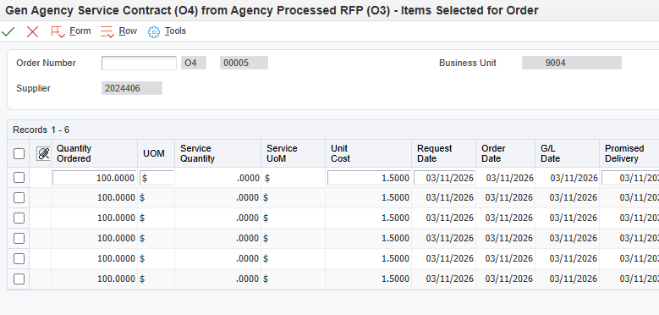
Click the “Form” tab and click “Generate Order(s).”
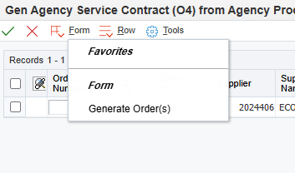
Make note of the newly created contract number.
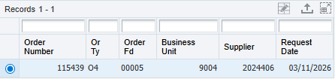
Generate Contract from Requisition: Complete
Click the Red X to close.
- Generate Contract from Contract
Step | Instruction / Explanation
Choose a Menu Selection/Pathway Option:
State of Nebraska > Purchasing > Contracts > Gen Contract from Contract
- Gen Agency Service Contract (O4) from SPB Service Contract (P4)
- Gen Agency Service Contract (O4) from Agency Service Contract (O4)
- Gen Agency Commodity Contract (CC) from SPB Commodity Contract (OC)
- Gen Agency Commodity Contract (CC) from Agency Commodity Contract (CC)

THE FOLLOWING ARE ONLY VISIBLE TO SPB PERSONNEL:
- Gen SPB Service Contract (P4) from Agency Service Contract (O4)
- Gen SPB Service Contract (P4) from SPB Service Contract (P4)
- Gen SPB Commodity Contract (OC) from Agency Commodity Contract (CC)
- Gen SPB Commodity Contract (OC) from SPB Commodity Contract (OC)

The process is the same for all contract-from-contract document types. This example will demonstrate generating an agency service contract (O4) from an agency service contract (O4)

NOTE: For instructions on how to add attachments to a contract see Adding Attachments to Contract
Enter the contract number into the Order Number field and click the “Find” button (magnifying glass).
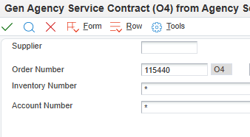
If the contract has multiple lines, be sure to expand all lines to view all available lines on the contract. Select the line or lines from which the contract is to be generated from and click the green checkmark.

NOTE: If all lines are not expanded, clicking the “select all” option will only select the lines visible on screen, and will not pull from the unexpanded lines.

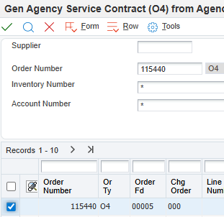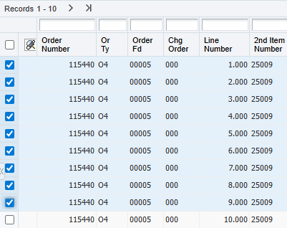
Select All
Expand all lines
Multiple Lines
Single Line
Review and update Header Information as necessary.
- Supplier - Enter the Address Book number (AB#) of the vendor being purchased from.
  - Should typically be a “V” (Vendor), “AG” (Agency), or “VP” (Political Subdivision) Address Book type.
  - NOTE: This should NEVER be an “E” or “FD” Address Book type.
- Ship To – Enter the Address Book number of the address where items are to be delivered or services are to be performed.
  - The Ship To Address Book number will automatically populate the Send Invoice To field.
  - Should typically be an “F” Address Book type.
- Buyer - Enter the Address Book number for the individual primarily responsible for the contract at the Agency.
- Business Unit- Enter the Business Unit responsible for the contract.

NOTE: Additional Header Information, including dates, may need to be updated through the appropriate Work with Contract pathway after generation.

Example of Header Information

Check the release quantity to ensure it lists the correct amount that you want to release from the contract. By default, the entire amount on the line will be released unless adjusted.
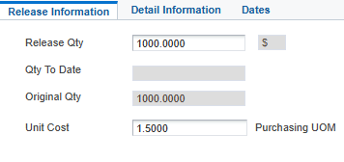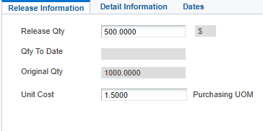
Adjusted Amount
Full Amount
Once the quantity is adjusted (if needed), click the green checkmark.

If releasing multiple lines, adjust the quantity amounts as necessary and click the green checkmark for each individual line. The next line’s “release” screen will automatically cycle from line to line when the green checkmark has been clicked until all selected lines have been released.
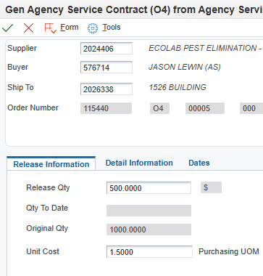
To review the order, Click the “Form” tab, and click the “Review Order(s)” option.
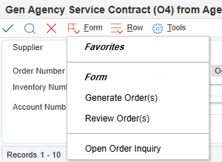
Next, click the “Row” tab, and click the “Details” option.
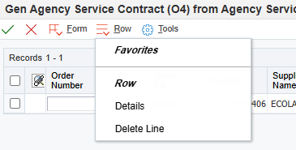

Review the quantities and adjust if necessary. Once the review is complete and any adjustments are made, click the green checkmark.
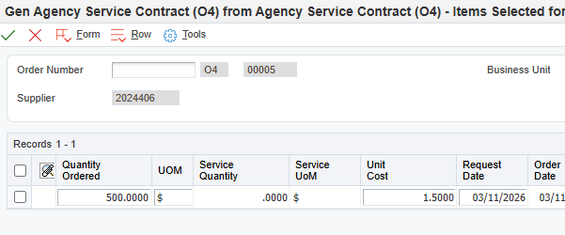
Click the “Form” tab and click “Generate Order(s).”
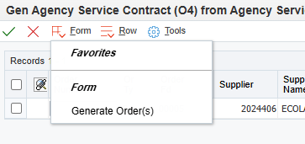
Make note of the newly created contract number.
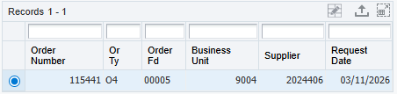
Generate Contract from Contract: Complete
Click the Red X to close.

- Contract Status Change
Step | Instruction / Explanation
Choose the Menu Selection/Pathway Option:
State of Nebraska > Purchasing > Contracts > Service Contract Management
- Agency Service Contract (O4) Status Update 214 -> 215
- Agency Service Contract (O4) Status Update 215 -> 214
State of Nebraska > Purchasing > Contracts > Commodity Contract Management
- Agency Commodity Contract (CC) Status Update 214 -> 215
- Agency Commodity Contract (CC) Status Update 215 -> 214

THE FOLLOWING ARE ONLY VISIBLE TO SPB PERSONNEL:
State of Nebraska > Purchasing > Contracts > Service Contract Management
- SPB Service Contract (P4) Status Update 214 -> 215
- SPB Service Contract (P4) Status Update 215 -> 214
State of Nebraska > Purchasing > Contracts > Commodity Contract Management
- SPB Commodity Contract (OC) Status Update 214 -> 215
- SPB Commodity Contract (OC) Status Update 215 -> 214

The contract line status change process is the same for all contract document types.
215 > 214: Contract line open for release (215) to line not ready for release (214).
NOTE: This may be for lines established for future renewal periods, or lines that should not be available to release from, but are not canceled.
214 > 215: Contract line not ready for release (214) to line open for release (215).
This example will demonstrate updating contract line status from 215 to 214 from an O4 contract.
NOTE: For a full list of Status Codes, see the Status Codes reference guide found in the Procurement section of the E1 Training Guides webpage.
Enter the Contract number into the order number field and click the “Find” button (magnifying glass).
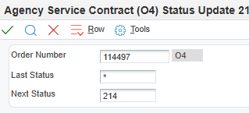
The Next Status field shows the current status of the contract line. The Next Status – Update To shows the status the contract line will be converted to. Select the line you wish to convert, and click the green check. You can convert multiple lines at once by selecting all lines that need to be updated.

NOTE: If there are more than 10 lines, all lines must be expanded. If all lines are not expanded, clicking the “select all” option will only select the lines visible on screen, and will not update the unexpanded lines.

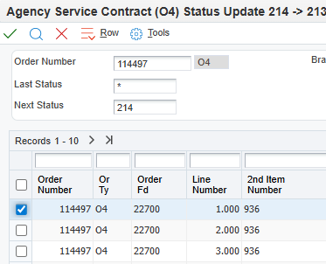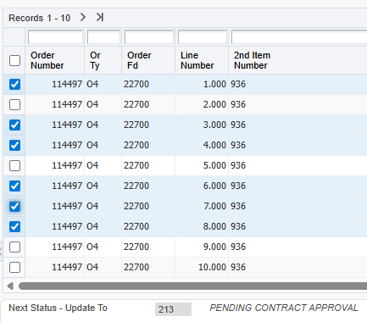
Expand all lines
Single Line
Multiple Lines

Contract Status Change: Complete
Click the Red X to close.
Select All

- Work with Contract
Step | Instruction / Explanation
Choose the Menu Selection/Pathway Option:
State of Nebraska > Purchasing > Contracts >
- Service Contract Management > Work With Agency Service Contract (O4)
- Commodity Contract Management > Work With Agency Commodity Contract (CC)

THE FOLLOWING ARE ONLY VISIBLE TO SPB PERSONNEL:
- Service Contract Management > Work With SPB Service Contract (P4)
- Commodity Contract Management > Work With SPB Commodity Contract (OC)

The process is the same for all contract document types. This example will demonstrate how to work with an Agency Service Contract (O4).

NOTE: For instructions on how to add attachments to a contract see Adding Attachments to Contract
Enter the contract number you would like to work with in the Order Number field and click the “Find” button (magnifying glass).
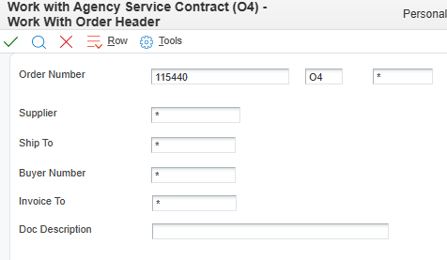
To make updates to the Order Header, such as changing the “Ship To,” “Buyer,” “Send Invoice to,” or any Date fields, click the “Header Revisions” button.

The “Additional Properties” and “Category Codes” tabs of the Header can also be viewed from this selection.

NOTE: To make updates to the Detail Lines only, click the “Detail Revisions” button, and go to step 10.
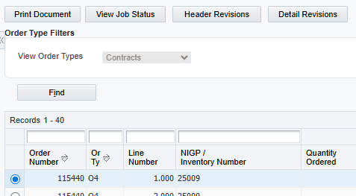
Make edits to the fields as necessary.
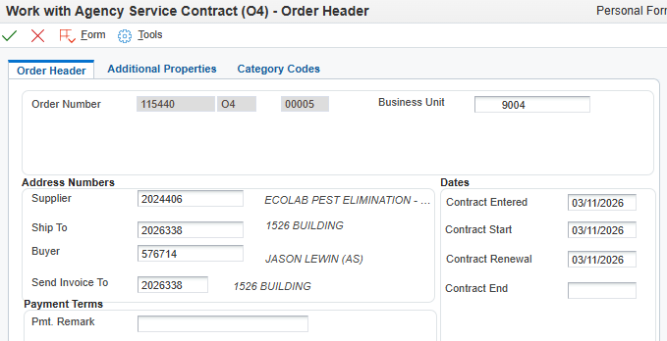
To have any changes made to the header fields populate to all detail lines of the contract, click the “Form” tab, select “Header to Detail,” and click “Populate.”
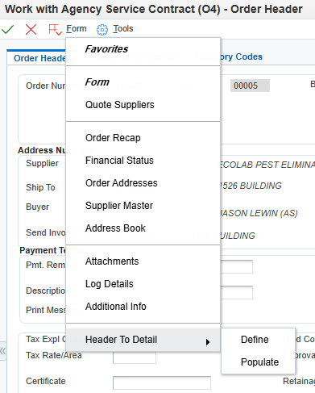
The Additional Properties tab allows changes to the document such as the Document Description, the Document Location, and the Document Contact.
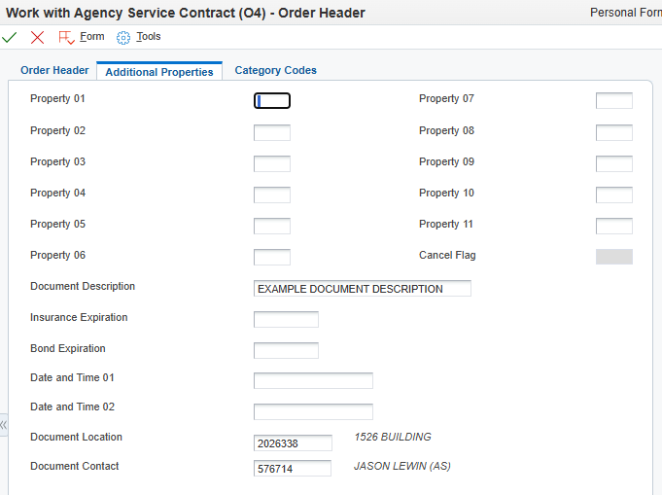
The Category Codes tab allows changes to the available fields.
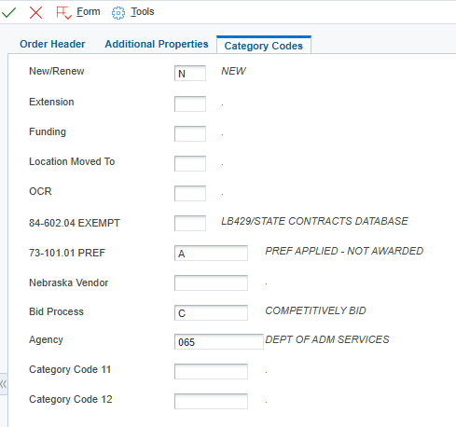
Click the green checkmark to continue to the “Detail Revisions” screen.

ERROR NOTE: An “Evaluated Receipt Error” may display if changing a supplier from “Best Source” (999999) to another Supplier number.
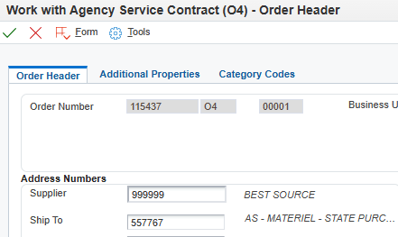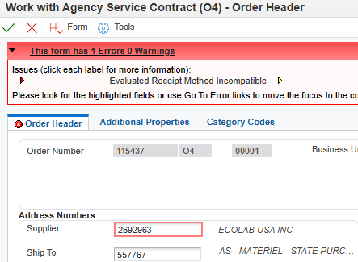
“Evaluated Receipt Error”
999999 “Best Source”
In this situation, email nis.security@nebraska.gov to resolve the Evaluated Receipt Error:
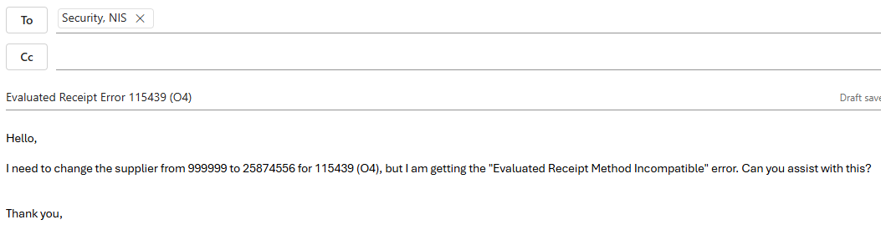
Click the green checkmark to save Header Revisions and continue to Detail Revisions.

NOTE: If making no detail revisions, click the green checkmark again to return to the “Work With Contract” home screen.
ERROR NOTE: If making edits to detail lines from previous fiscal years, an error may result regarding the G/L (General Ledger) date.

To resolve this error, change the G/L Date field to the day the edits were made.
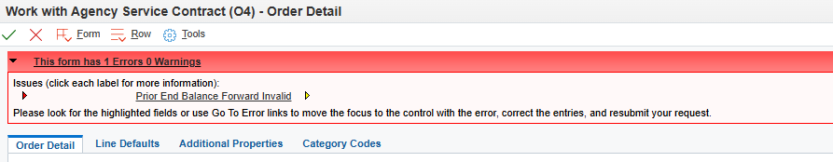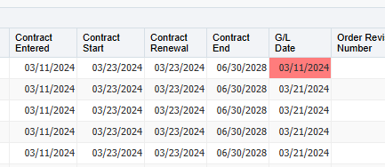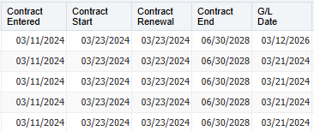
“Prior End Balance Forward Invalid” Error
G/L Date Error Resolved
G/L Date Error Unresolved
 | Click the green checkmark to save revisions.
A text box will open. Enter the details of what was “revised” since the original generation, followed by the date and initials of the person who made the revision(s).

NOTE: It is crucial to note revisions as this allows for the most accurate tracking of revisions made over the life of the contract.
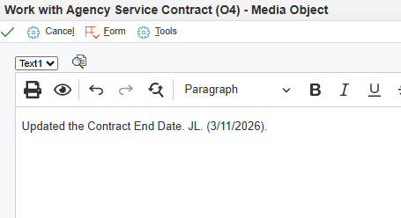
Work with Contract: Complete
Click the Red X to close.

- Adding Attachments to Contract
Step | Instruction / Explanation
1. | Choose the Menu Selection/Pathway Option:  State of Nebraska > Purchasing > Contracts >  - Service Contract Management > Work With Agency Service Contract (O4)  - Commodity Contract Management > Work With Agency Commodity Contract (CC)  THE FOLLOWING ARE ONLY VISIBLE TO SPB PERSONNEL:  - Service Contract Management > Work With SPB Service Contract (P4)  - Commodity Contract Management > Work With SPB Commodity Contract (OC)  The process is the same for all contract document types. This example will be adding a file and a text attachment to an Agency Service Contract (O4). For adding a line attachment, follow steps 1 and 2, then jump to step 10.
2. | Enter the contract number to which attachments will be added in the Order Number field, the doc type in the blank field to the right of the Order Number field, and click the “Find” button (magnifying glass).  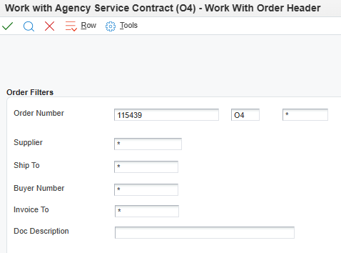
3. | Next, select the contract.  - To add attachments to the header, either click the green checkmark, or click the “Header Revisions” button, to get to the Order Header screen.  - To add attachments to a detail line, click the “Detail Revisions” button and skip to step 10.  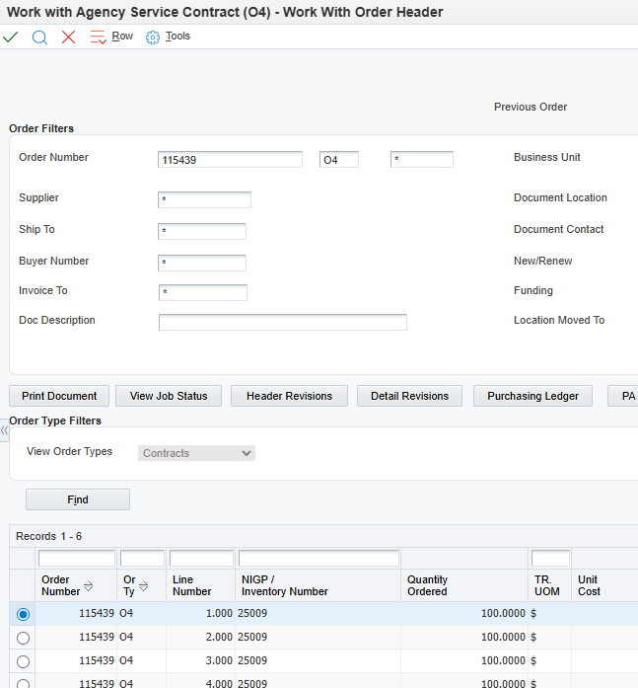
4. | The Order Header screen will open. Click the “Form” tab and choose the “Attachments” option.  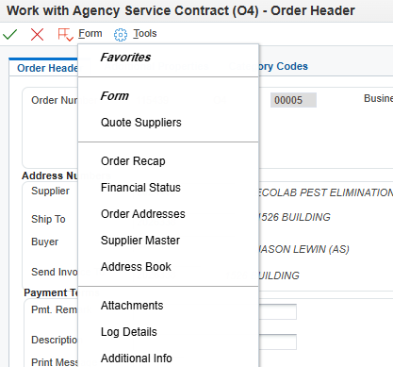
5. | To attach a document, click the “File” icon. To add a Text Attachment, click the “Text” icon.  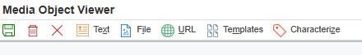
6. | Text attachments are free-text fields that can include any additional information for the contract. The first text attachment (and only the first) will print out on the contract header.  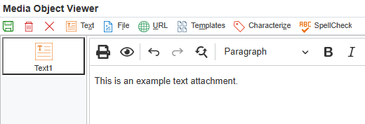  To attach a file or document, drag the file to be attached into the “drop file here” area rectangle, or search for the document by clicking the “Choose File” option.  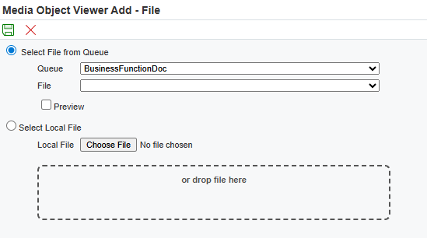  Once the text is completed or the document has been selected, click the green save button.  ERROR NOTE: File names with punctuation in them will result in an Administrator error. To avoid this, use naming conventions that do not include punctuation.  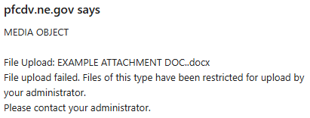
7. | Verify the text or file attachment and click the green save button.  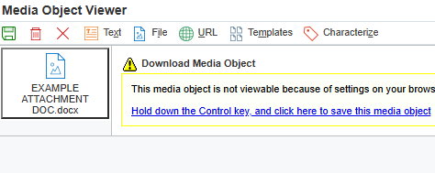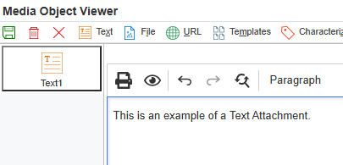  Document that has been added will show here  Text Attachment  Attached Document
8. | To add additional attachments, repeat steps 4 thru 7.
9. | Click the green checkmark to continue to the Detail Revisions screen.  NOTE: If making no detail revisions, click the green checkmark again to return to the “Work With Contract” home screen.
10. | The only difference between adding a line attachment and a header attachment is where the attachment is placed.  For any row or line, click the blank space in the column under the “paperclip” icon to add an attachment or click the “Row” button and click the “Line attachments” option. Follow steps 5 thru 7 to add an attachment.  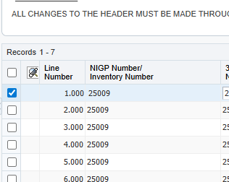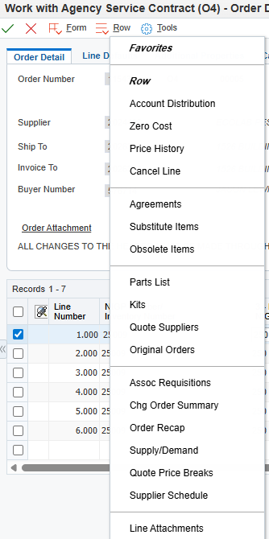  Click here
Adding Attachments to Contract: Complete
Click the Red X to close.
- Import/Export Detail Lines
Step | Instruction / Explanation
1. | Choose the Menu Selection/Pathway Option:  State of Nebraska > Purchasing > Contracts >  - Service Contract Management > Work With Agency Service Contract (O4)  - Commodity Contract Management > Work With Agency Commodity Contract (CC)  THE FOLLOWING ARE ONLY VISIBLE TO SPB PERSONNEL:  - Service Contract Management > Work With SPB Service Contract (P4)  - Commodity Contract Management > Work With SPB Commodity Contract (OC)  The process is the same for all contract document types. This example demonstrates importing/exporting detail lines to an Agency Service Contract (O4).  State of Nebraska > Purchasing > Contracts > Service Contract management > Work With Agency Service Contract (O4)
2. | Enter the contract number you would like to work with in the Order Number field, the doc type in the blank field to the right of the Order Number field, and click the “Find” button (magnifying glass).
3. | Select the “Detail Revisions” tab.  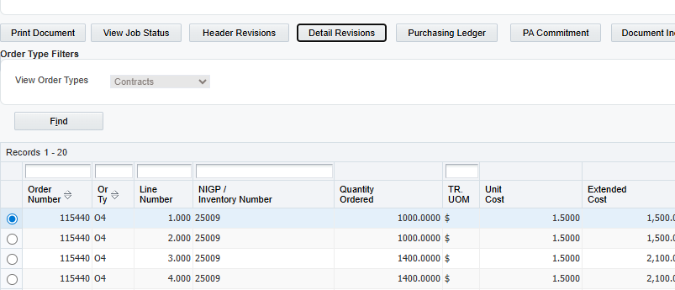
4. | Expand the lines if necessary, select the lines to be exported, and click the “Export Grid Data” button.  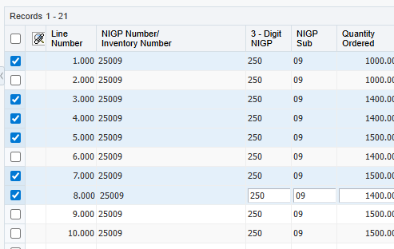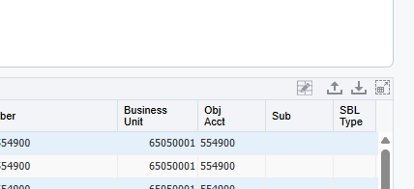  “Export Grid Data” Button  Selected lines
5. | Data can be exported in 4 ways: To an Excel spreadsheet, to a Word document, to a CSV document, or to the clipboard. This example will show exporting to Excel. If choosing a Word or Excel file, the document will pop up in the downloads of the browser (upper right corner).  Once selected, click the “Continue” button.  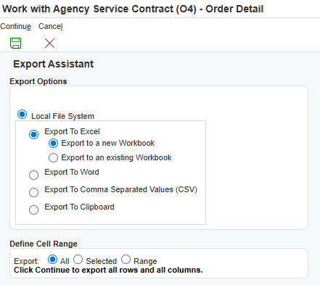
Matching Header Columns from Export for use of Import.
If the header row of the spreadsheet to be imported does not match E1 exactly when importing, E1 will not be able to correctly import any data from the spreadsheet. The best practice to avoid importing issues is to export a line from the desired document, delete the line info, and use the spreadsheet headers as a template. This will ensure the headers match exactly.
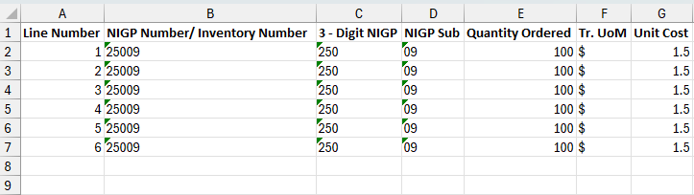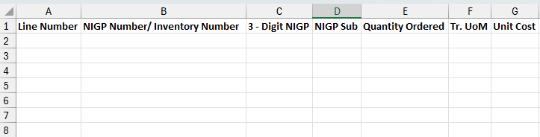
Original Exported spreadsheet
Spreadsheet ready to be used as template for import
6. | To import data into the detail lines of a contract, follow steps 1 thru 3, and select the “Import Grid Data” option.  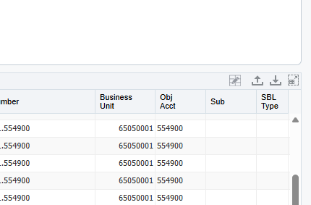  “Import Grid Data” Button
7. | Select the “Browse” option.  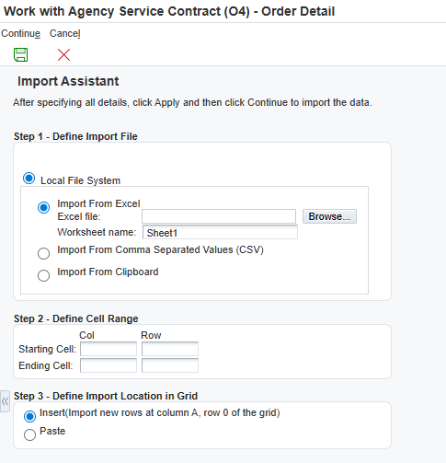
8. | Click the “Choose File” option, select the Excel spreadsheet, and click the “Upload” button. Select the green Continue icon to continue.  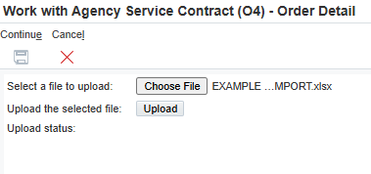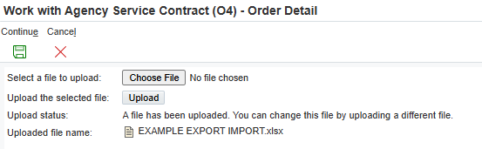
9. | Next, select the starting/ending cells in the Excel document to be imported. Once the starting/ending cells are entered, click the “Apply” button.  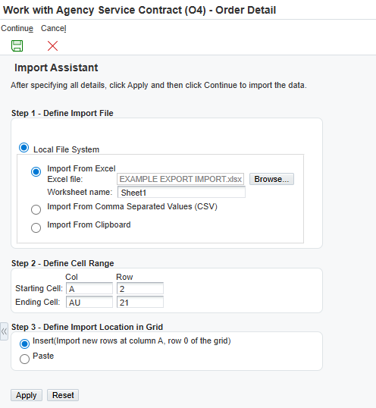
10. | Check that the data pulled from the Excel sheet is correct, and click the green Continue icon.  NOTE: If the cell range needs adjusting, make the changes and click “Apply” to have E1 re-import the selections.  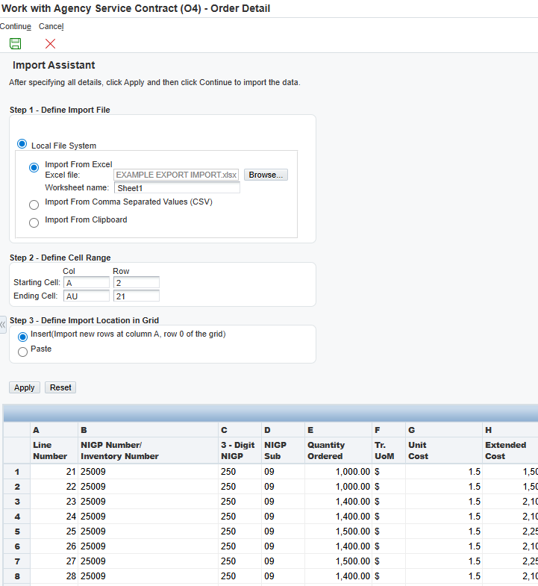
11. | The newly imported lines will now be populated in the contract. Click the green checkmark at the top of the screen to conitnue.  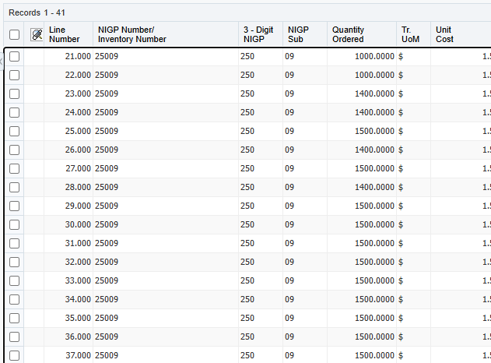  Ending line amount: 41  Starting line amount: 21  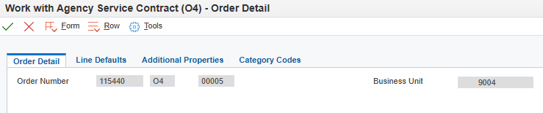
12. | A text box will open. Enter the details describing all revisions made, date and initials showing who made the revision(s).  NOTE: It is crucial to note revisions as this allows for the most accurate tracking of revisions made over the life of the contract.  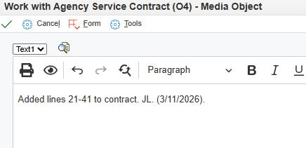
Import/Export Detail Lines in E1: Complete
Click the Red X to close.

