**Commission on Asian American Affairs**

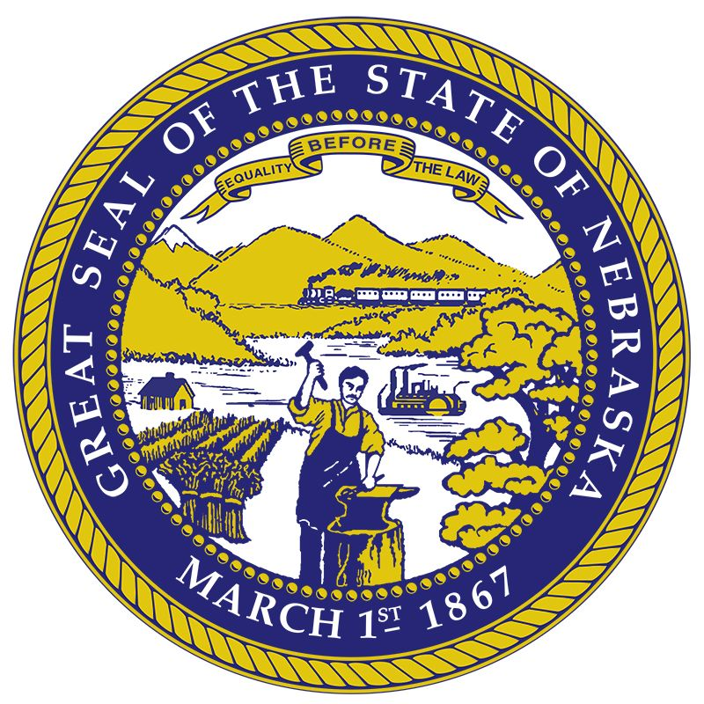

**Open Meeting**

301 Centennial Mall South, Lower Level – Lancaster Hearing Room

July 29, 2024

9:30 a.m. – 12:00 p.m.

****************************************************************************** AMERICANS WITH DISABILITIES ACT NOTICE The State of Nebraska wants to ensure that State meetings are accessible to persons with disabilities. If any individual needs special assistance or accommodations in order to participate in this meeting, please contact the Nebraska ADA Coordinator/Employee Relations Representative at (402) 471-3048 or [nebraska.ada.coordinator@nebraska.gov](mailto:nebraska.ada.coordinator@nebraska.gov) in advance so accommodations can be made.

******************************************************************************

**Agenda**

1. Welcome by Governor Jim Pillen
2. Call to Order / Introductions
3. Review of Agenda and Documents
4. Oaths of Office
5. Record Roll
6. Election of Chairperson and Executive Board Members
   1. Chairperson
   2. Four Executive Board Members
7. Responsibilities under the Nebraska Open Meetings Act and the Role of the Nebraska Attorney General’s Office – Ryan Baker, Assistant Attorney General
8. Department of Administrative Services
   1. State Budget Division – Lee Will, State Budget Director
   2. Accounting Division – Phil Olsen, State Accounting Administrator
   3. DAS Human Resources Shared Services – Kevin Halvorson, HR Specialist Manager
   4. Office Space – Michael Donley, JD, MBA, DAS General Counsel
9. Public Comment Period
10. Optional Closed Session
11. Adjournment