Process Identification Guide
This document can help determine essential business processes, identify requirements to complete those processes, define deliverables & strategize how they will be meet your team’s needs in the coming weeks.
STEP 1 – Identify Key Business Processes
- Name of team or team leader (example: division/section/unit, or division head, or section head).
- Determine the logical work types or groupings of work within the specific division, section, or team.
- If applicable, determine the sub-units of work or people.
- Determine the business processes that are used by each sub-unit listed above.

Example
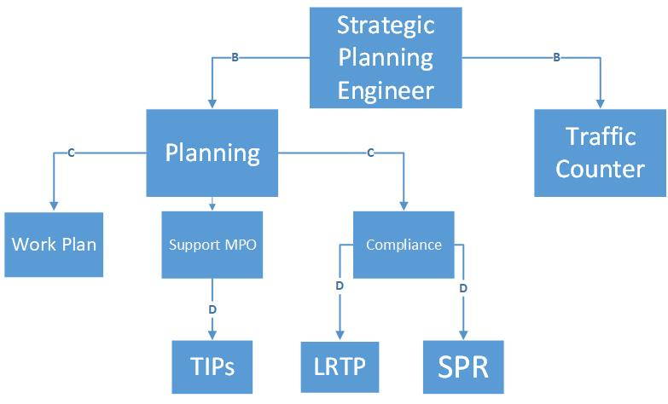

STEP 2 – Prioritize Business Processes

From the flow chart above identify critical business processes. Based on guidance from director’s office Priority #1 are processes that directly deal with Public Safety.

Other considerations to help guide you to narrowing down what are critical processes (essential):
- Continued construction
- Project delivery
- Customer service
- Time sensitivity of project
- Key projects identified by director’s office

STEP 3 – Mapping the Prioritized Processes

This high level process map tool helps you identify key teammates/customers, main business process steps, and what is required to complete the business process.

- Who Starts the Process? Who is responsible for initiating the business process steps?
- Process Step - What happens at a high level – main steps - 5 max.
Example: Step 1 - Go to the store, Step 2 - Select food, Step 3 - Pay for food, Step 4 - Load vehicle, Step 5 -Go home.
- Who does it go to? Who is next in the process to receive the input/output of the process step?
- Tools/Supplies needed – Is there specific equipment, technology needed for this process step?
Example: Computer, form, signature, program & internet access

Example Below:
Who Starts the Process? | Process Steps | Who does it go to? | Tools/Supplies Needed
Employee | Request | HR | VPN Access, Laptop
Supervisor | Review Request | HR | Laptop
HR | Discussion | Employee | WebEx or Skype, Phone line
Employee | Approve/Deny | Supervisor | VPN Access, Laptop, Access to Program
HR | Finalize Form | HR | VPN Access, Laptop

Additional Resources
NDOT Work Plan Template
Utilize the attached Teammate Work Plan to track tasks assigned to the team and as an accountability tool to ensure tasks are completed in a timely manner.

Electronic Huddle Boards Template
Consider using the attached electronic huddle board to help your team communicate & focus on required tasks.

For questions or support regarding the use of the tools and templates, please contact Linsey Sousek at 402-432-1244 or Linsey.Sousek@nebraska.gov

STEP 4 – Complete the Process Identification Worksheet

List Key Business Processes:

List the Business Processes in order of priority:

List Key Deliverables (timelines) of those priorities:

Key Considerations:

Possible Barriers:

Projected degradation of work level if working remotely:

